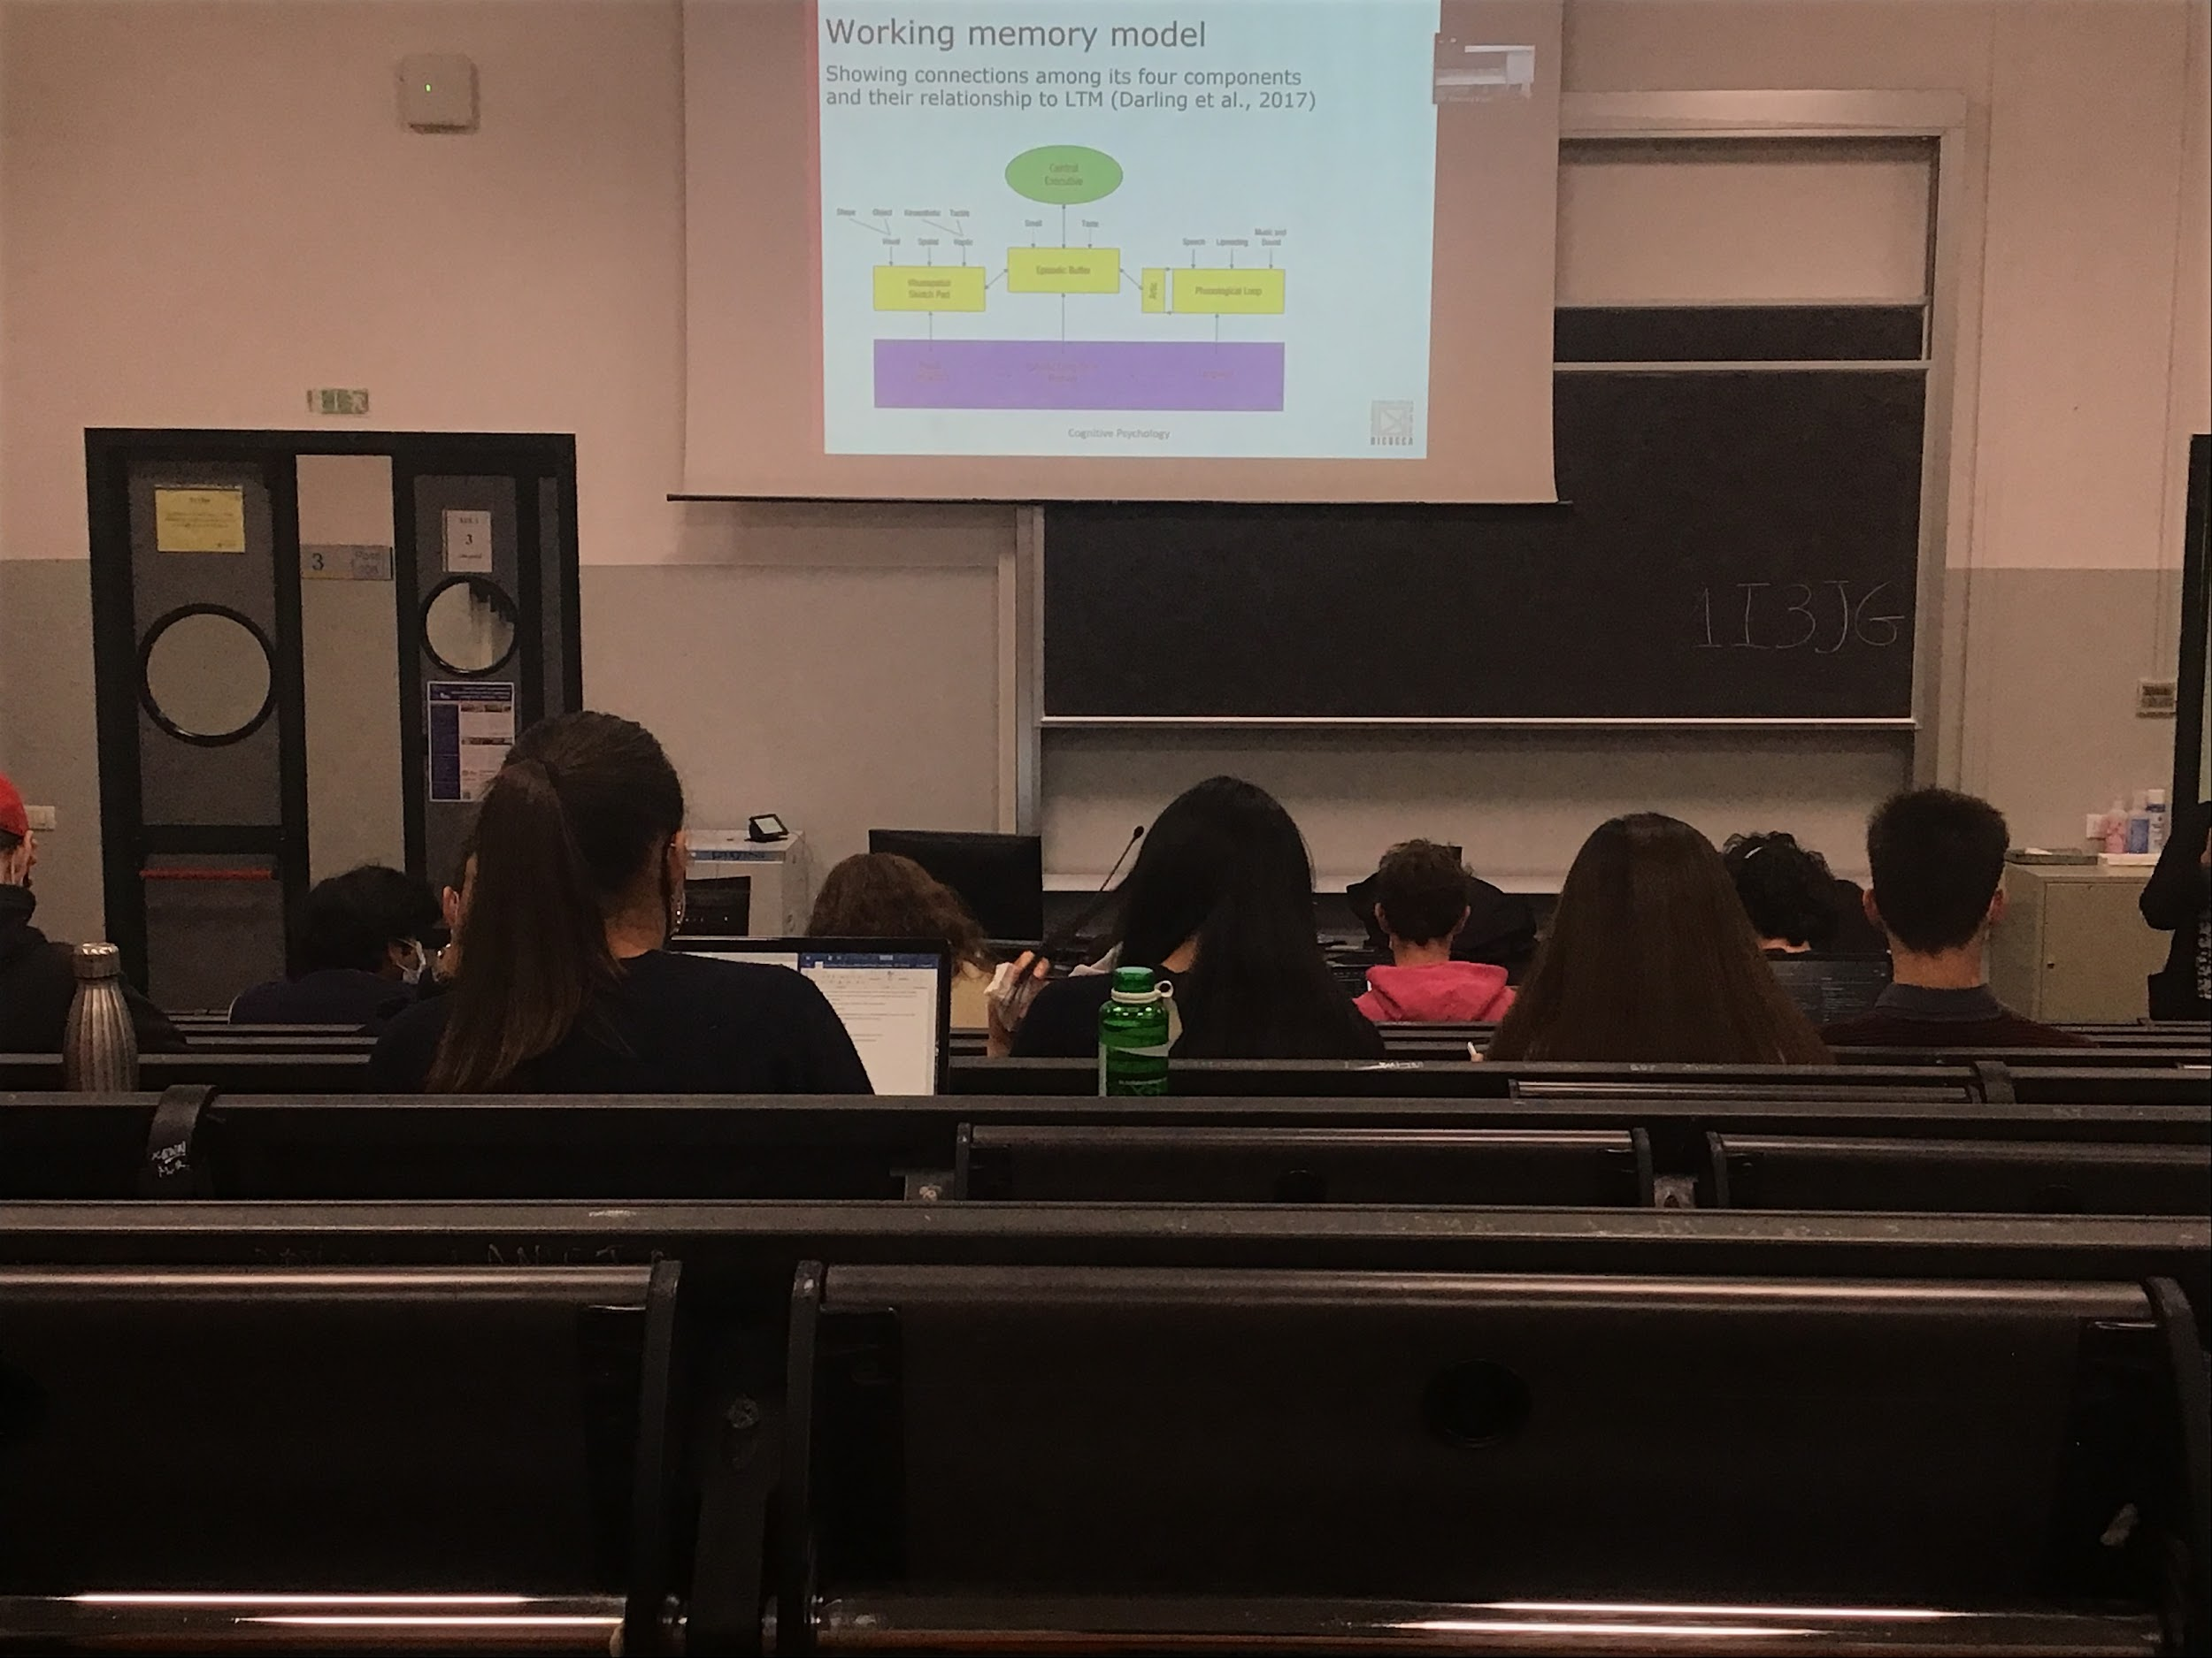

Multi-store model of memory: memory is not an unitary thing

3 components of memory:

* Short time memory (**working memory**): Has storage 7 ± 2
* Long time memory: Capacity is huge, duration for long time (we sometimes forget)
* Sensory memory: when we learn new information it comes through the senses. It has very high capacity and short term

Original idea: short time memory is a storage where information is saved and is maintained inside the short time memory only with reversal

Modern idea (1970): short time memory is a much more complex system in reality. Place where not only we save information for a short time before sending it to the long time memory, but also a **place for reasoning** to **get information not only from the senses but also from the long term memory**. Place where we make decisions. using short term memory to listen, filter information, decide what to write…

All the decision we make go through working memory

Original presentation

Working memory: 3 different components

* visual-spatial sketchpad: where we save visual and spatial information
* Phonological loop: place where we elaborate phonological language information
* Central executive: system that decides what informations goes where, what kind of elaboration to do

In the new version also episodic buffer: help to combine all the information from the other store

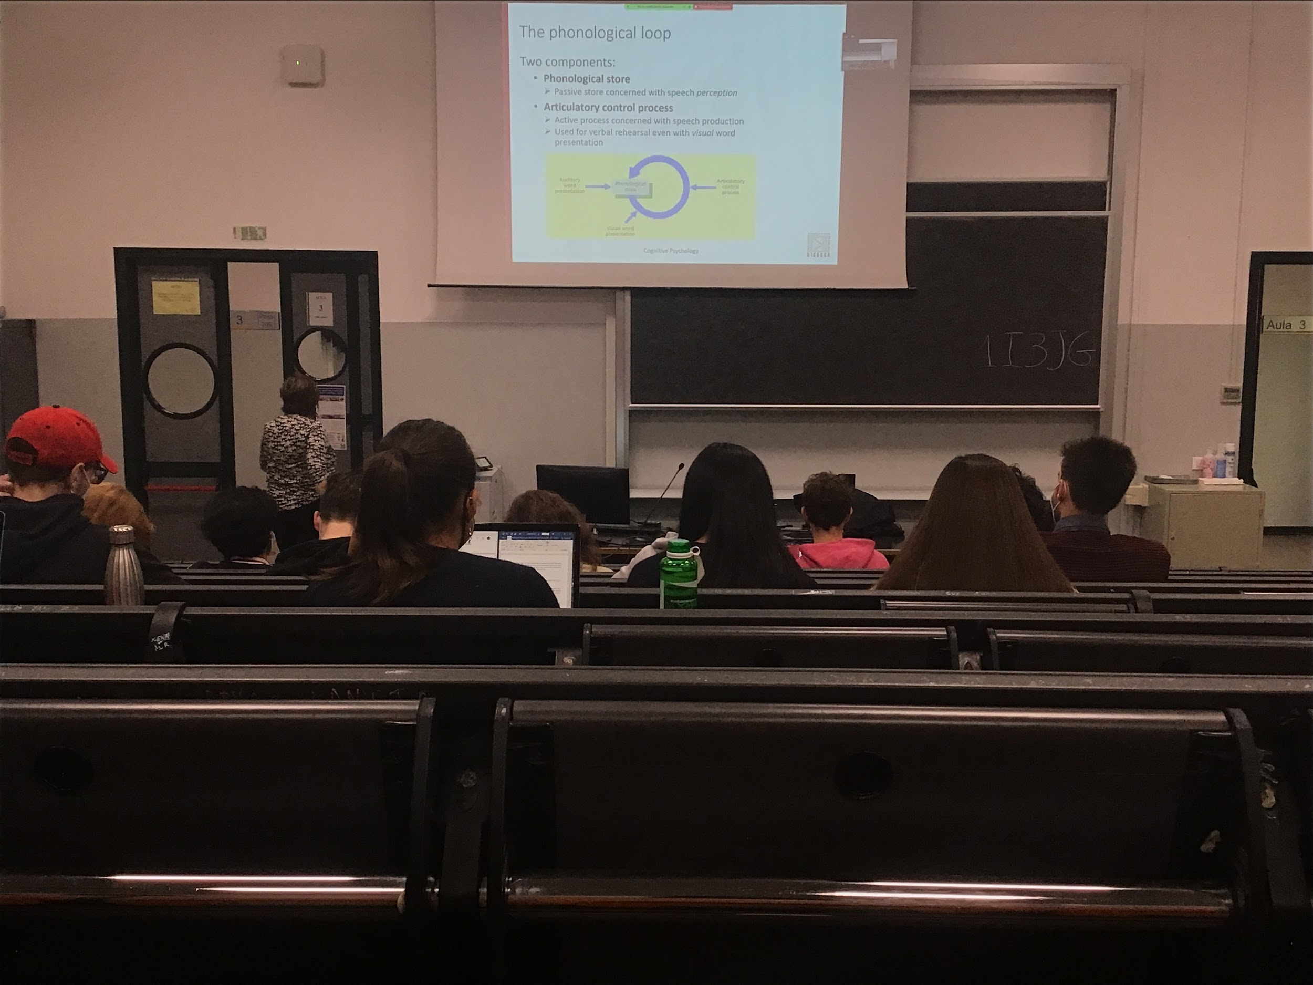

Phonological loop: made of two components

* real store: place where we **save** information
* Articulatory control process: use when we produce and when we hear people talking, we store information that we get from our ears and we save from some time to process it

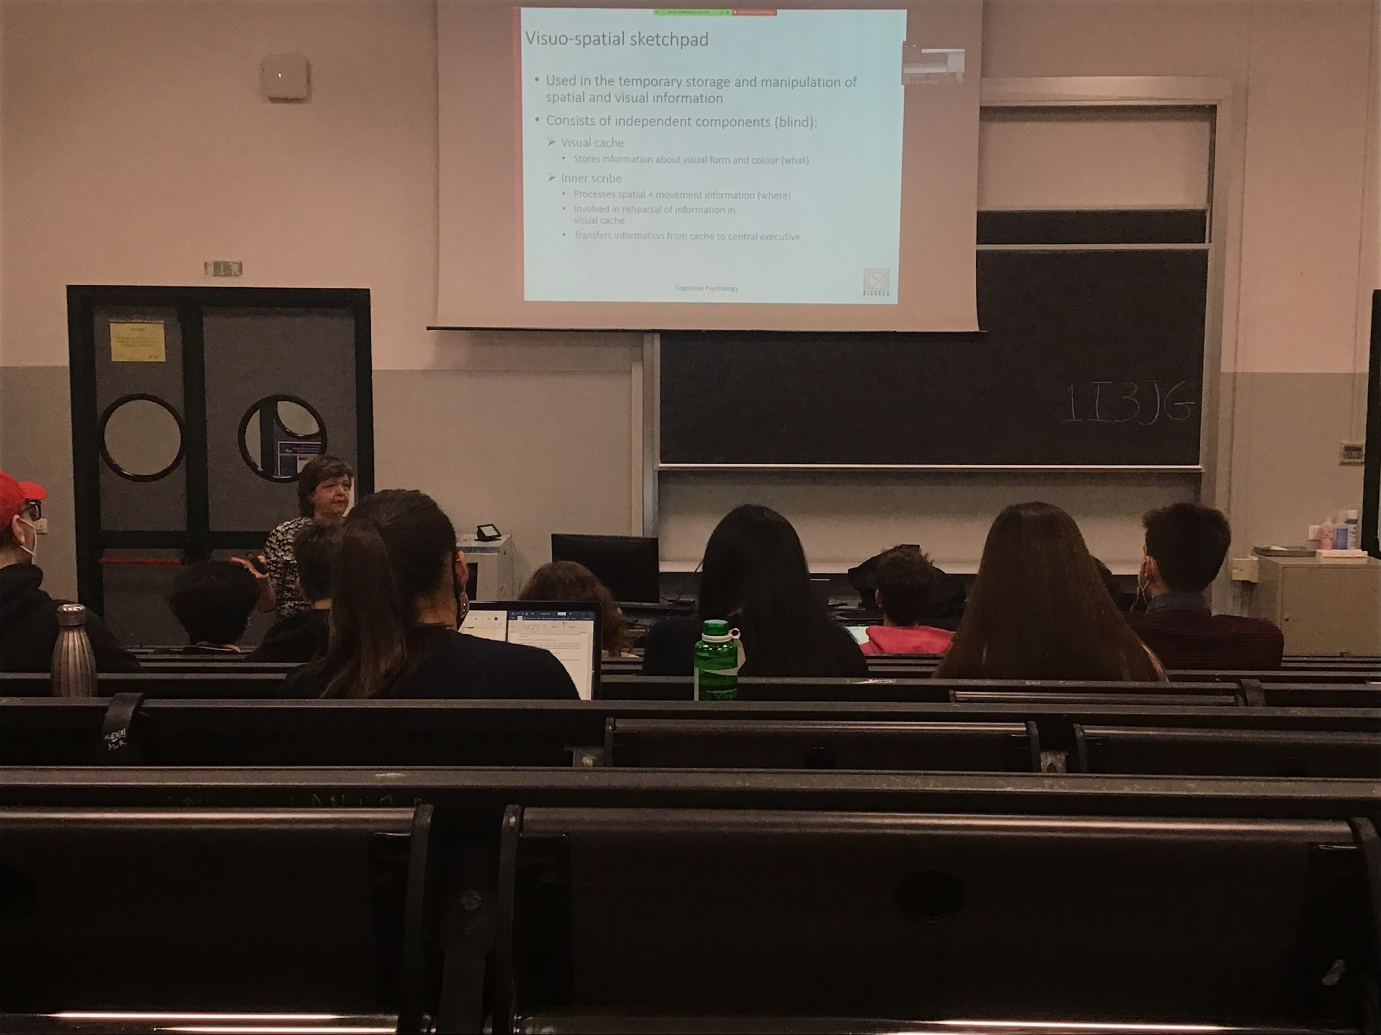

Second component: storage system, deal with visual and spatial information.

There are independent components that are visual and spatial are saved and elaborate in different areas of the brain is confirmed by experiment with blind people

Blind people can do the same spatial transformation and reasoning that people do even without seeing an object.

Mental rotation done in the visual spatial sketchpad, can do the same thing with a blind person

They represent in their mind space as we do, they can do in the same way from touch using the same part of visual working memory

Use more the inner scribe that can process spatial information and movement

Inner scribe also transfer information under the rules of the central executive

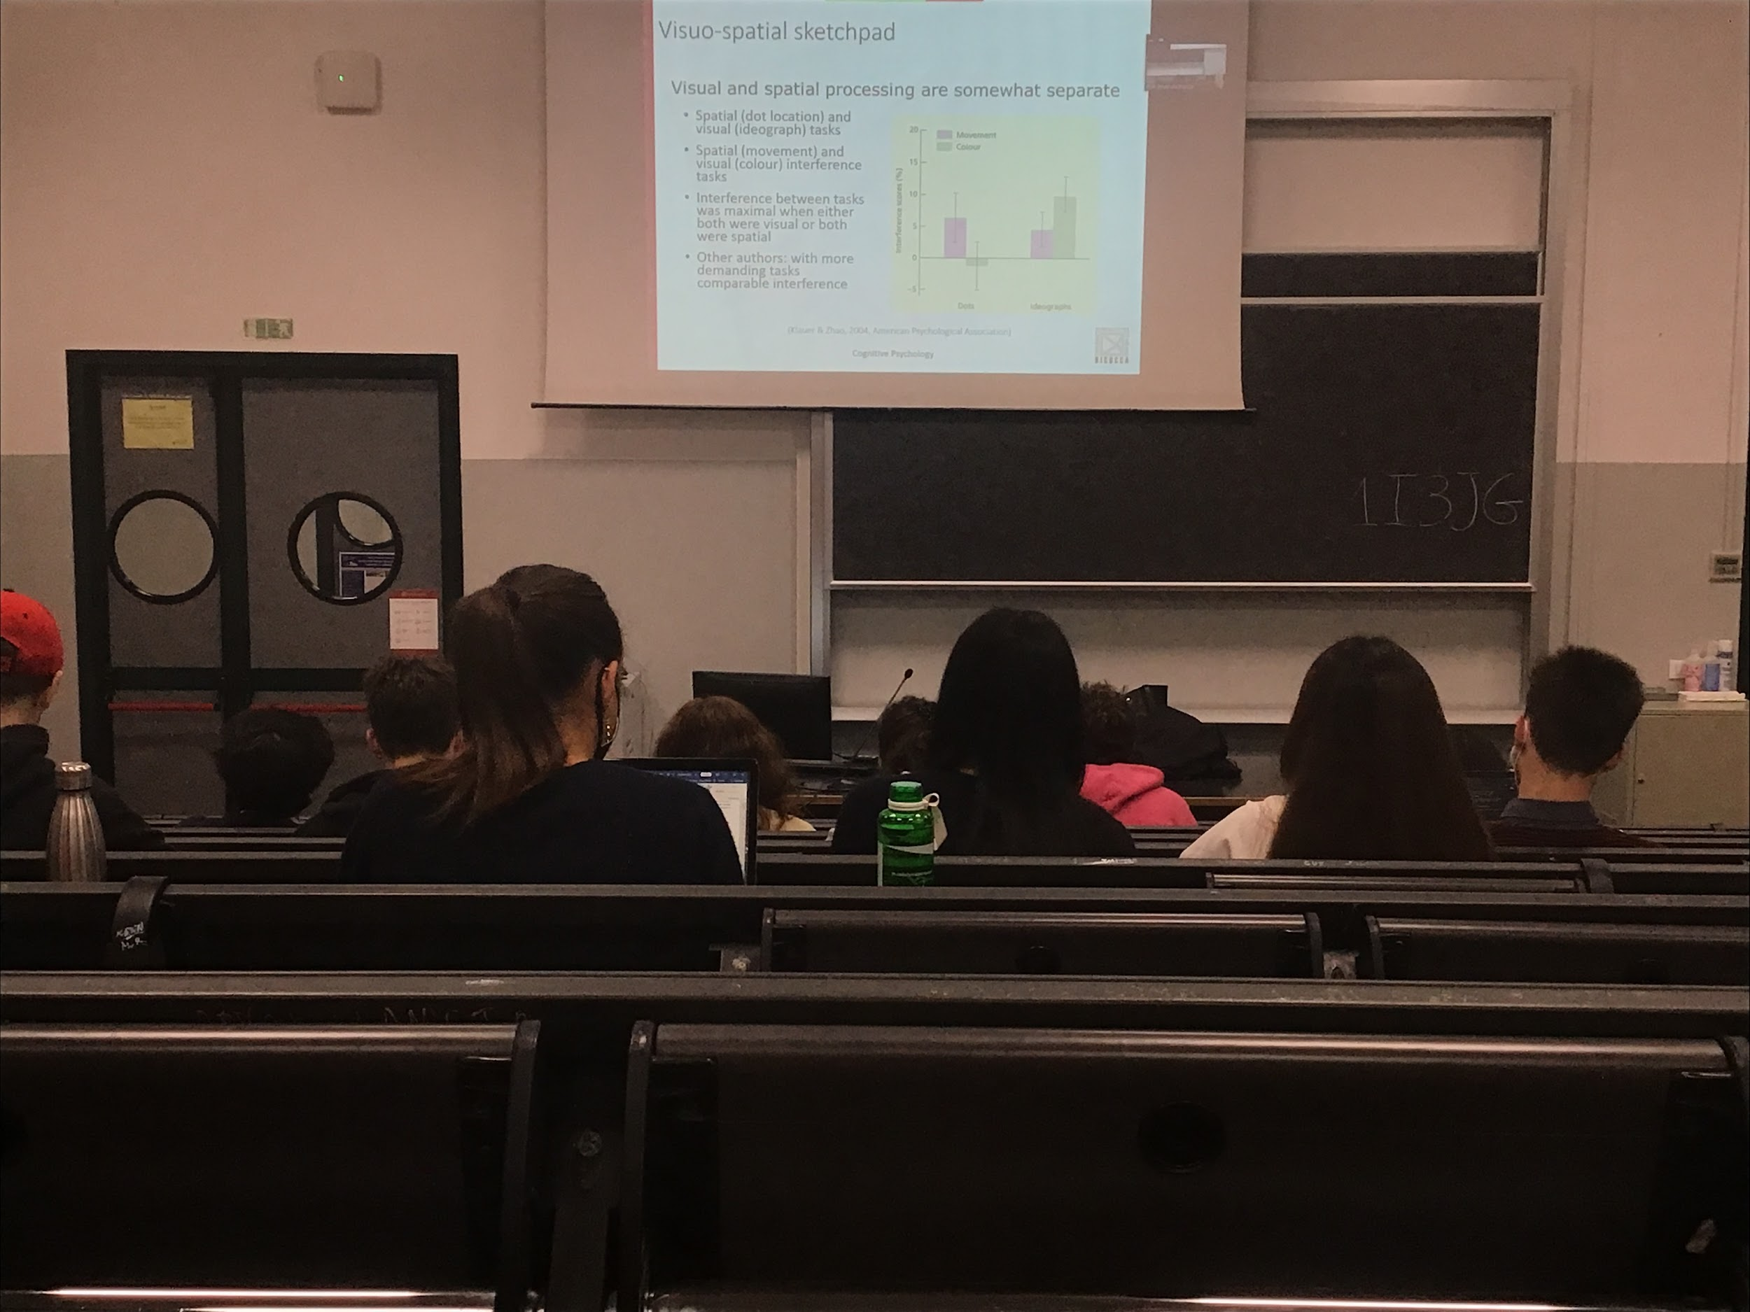

Experiment:

People doing two different task:

* **Spatial task**. Dots appear on a screen and you have to **remember the location of the dots**, have to reconstruct spatially the stimulus
* Memorise some Chinese ideograms. **Visual task**

**To demonstrate that the visual and spatial sketchpad are separated you have to show that when you are doing two spatial tasks at the same time your performance is lower**. You have interference (same for two visual tasks, lower performance). At the same time you have other task, tapping a given order or identify a colour of an object

You see that the spatial task have no interference where the other task is colour (visual task) but interference with the movement (both are spatial task)

——-

We try to show the independence of visual and spatial tasks. Two different tasks are using the same resource, they interfere. When we are using two tasks in the same part of the visual spatial sketchpad we have interference. When we have **two tasks** (**one visual and one spatial** at the same time) they **can work together, no interference**.

The two resources are separate and independent

There are exception, when there is many more complex tasks

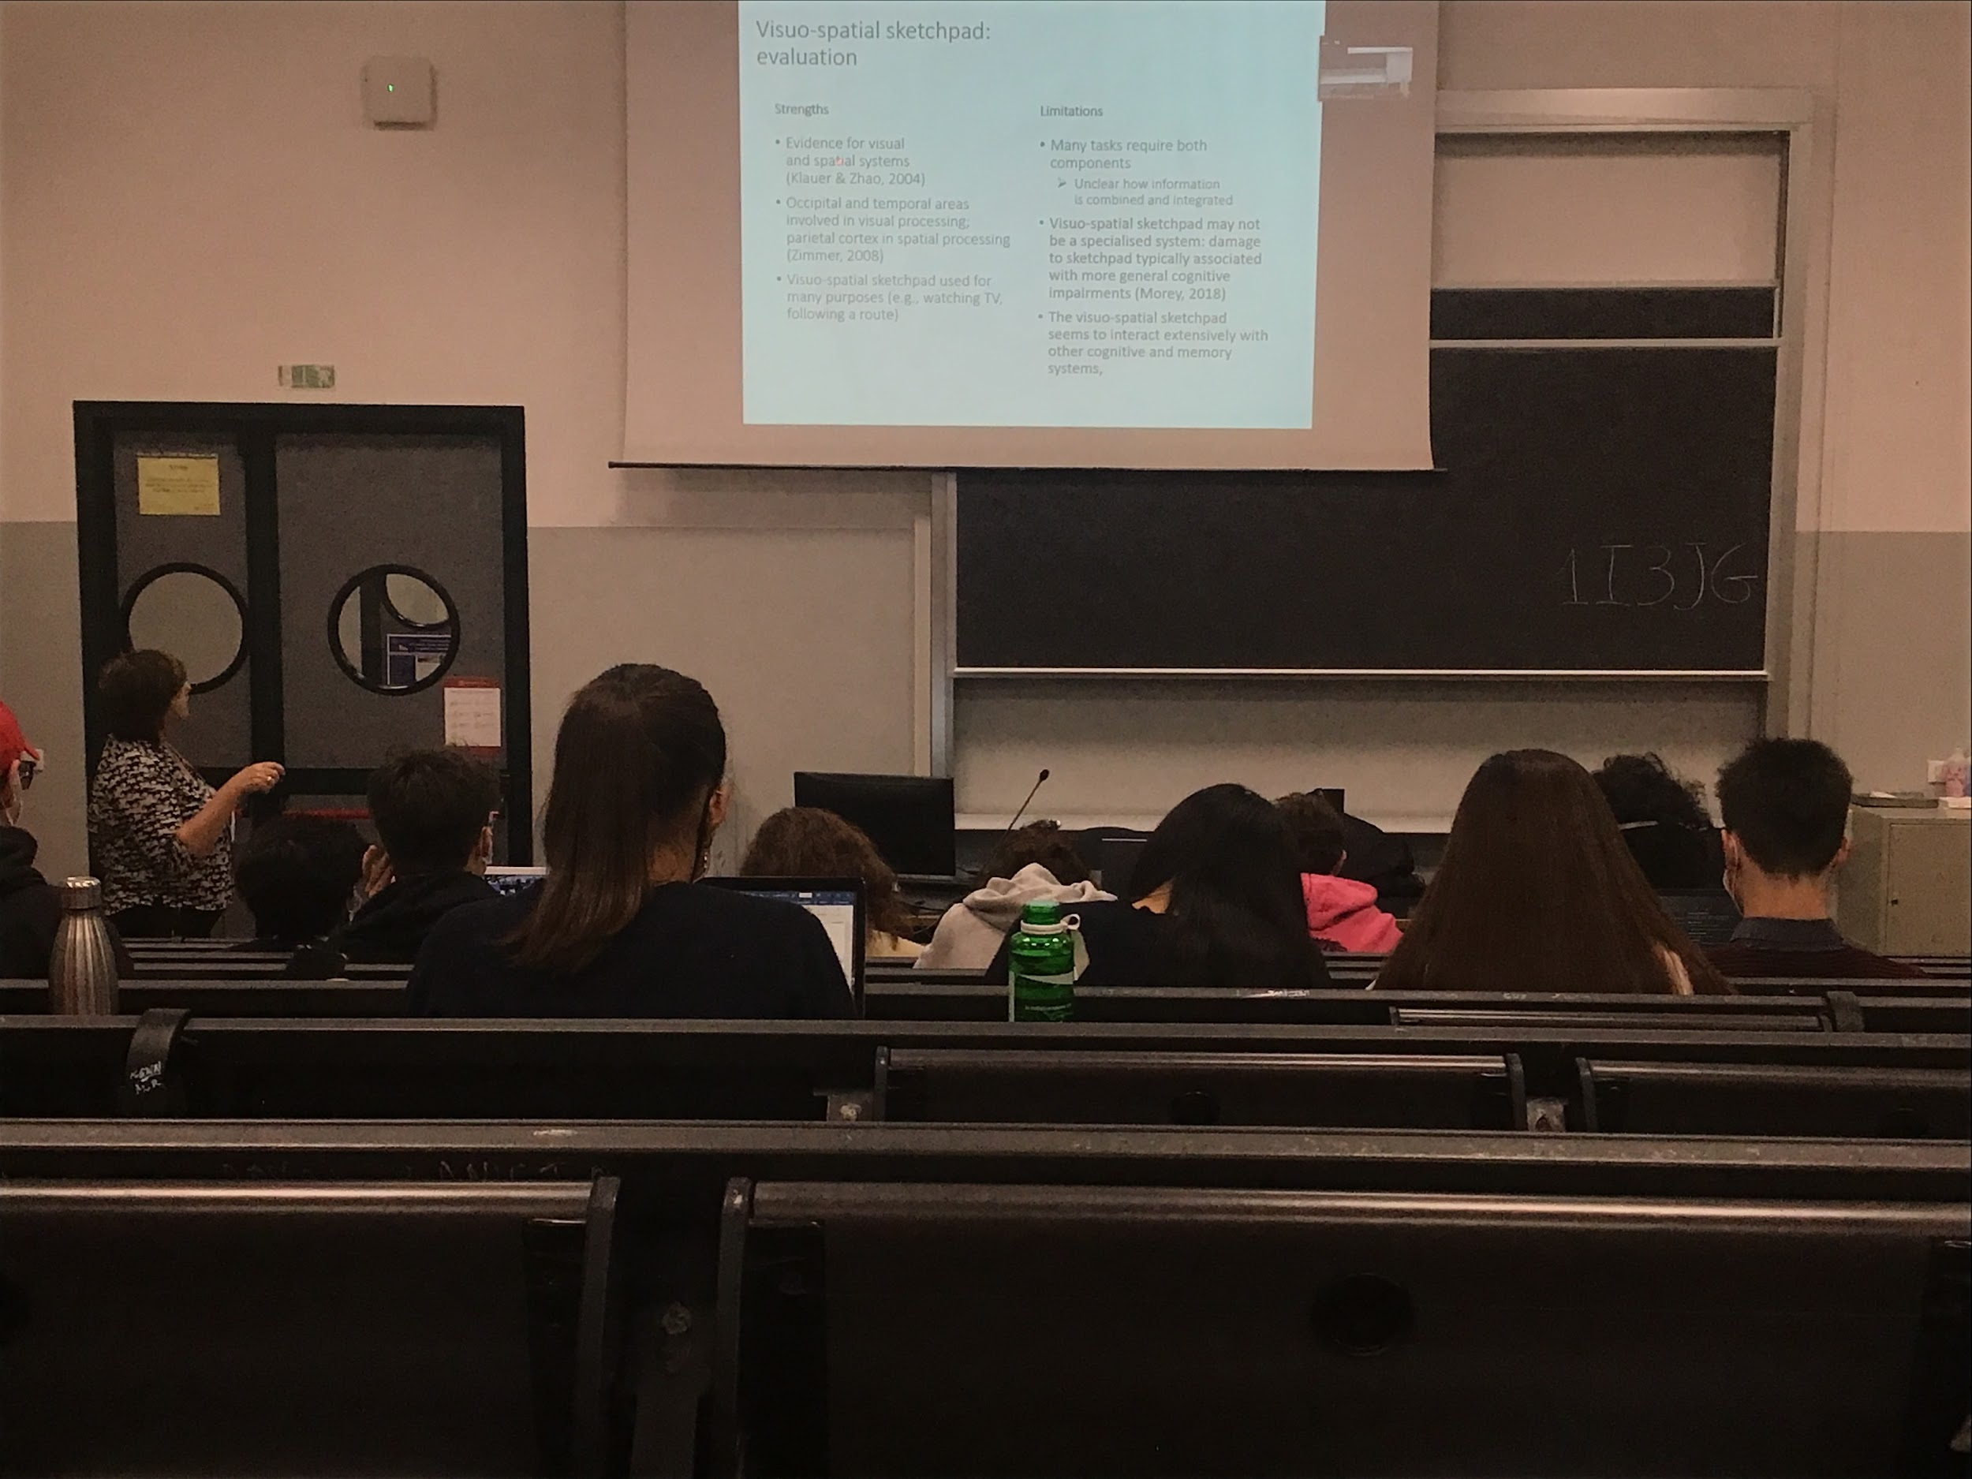

Evidence for a visual and spatial system

Different areas involved in visual and spatial processing

Most tasks need both components

Not clear how they interact with each other

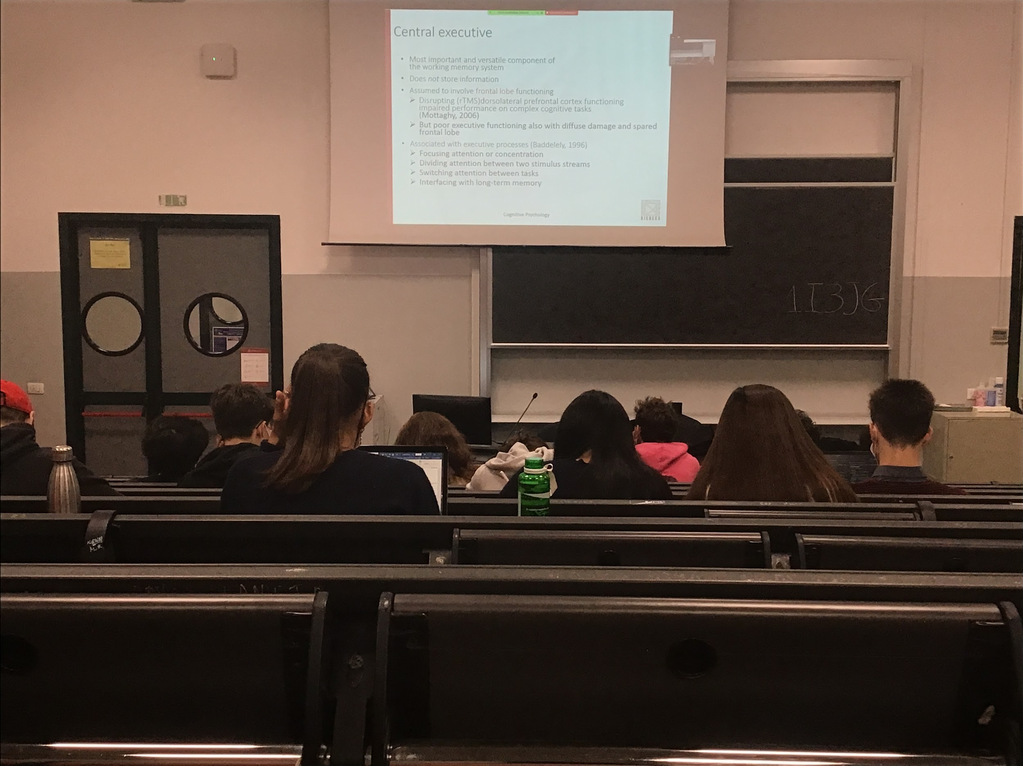

The most important component is the **central executive**. In the central executive there is no information store. Not a place where we save information (even temporally), is the **component that decides and chooses what kind of information goes** into the phonological loop, what goes in the visual-spatial sketchpad, what kind of reversal and transformation is done and the sequence of operations.

It is associated with many executive processes

Very connected with attention, decided on what to focus attention and regulates the division of attention in two different streams

Central executive usually associated with frontal lobe function. If you use TMS your performance in complex tasks becomes much lower. If you have a frontal lobe lesion you have problems with the central executive. But you can have the same problem with a lesion in another part of the brain

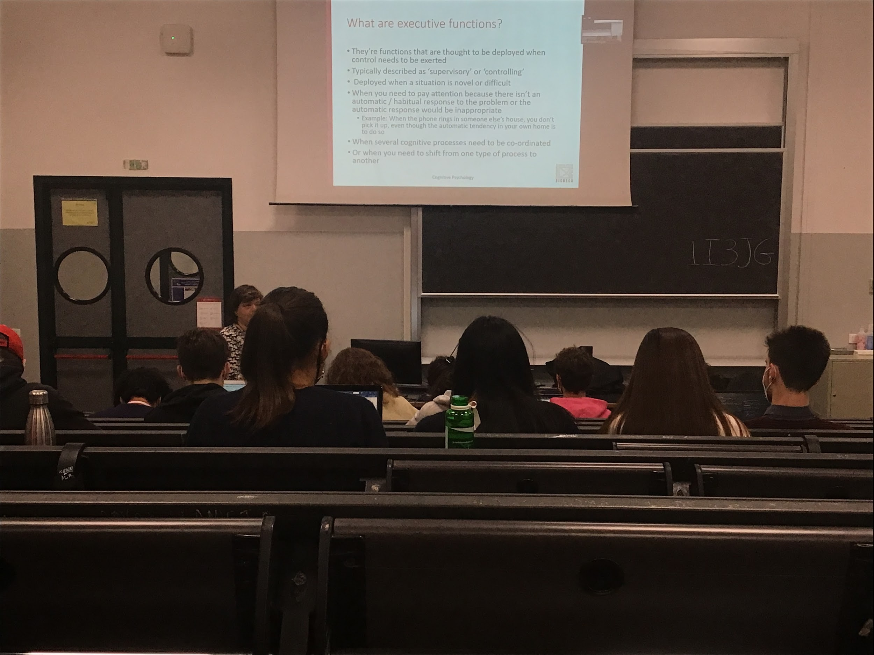

Central executive: every time we need to control a process to perform a task we need a reflective process. **Supervision of the different steps of a given task**. Use when we encounter a complex or new situation something that to deploy some kind of steps. Every time we have to stop automatic responses. When the phone of your house rings you go and answer. When you are with friends and their phone rings you don't answer. You stop your activity

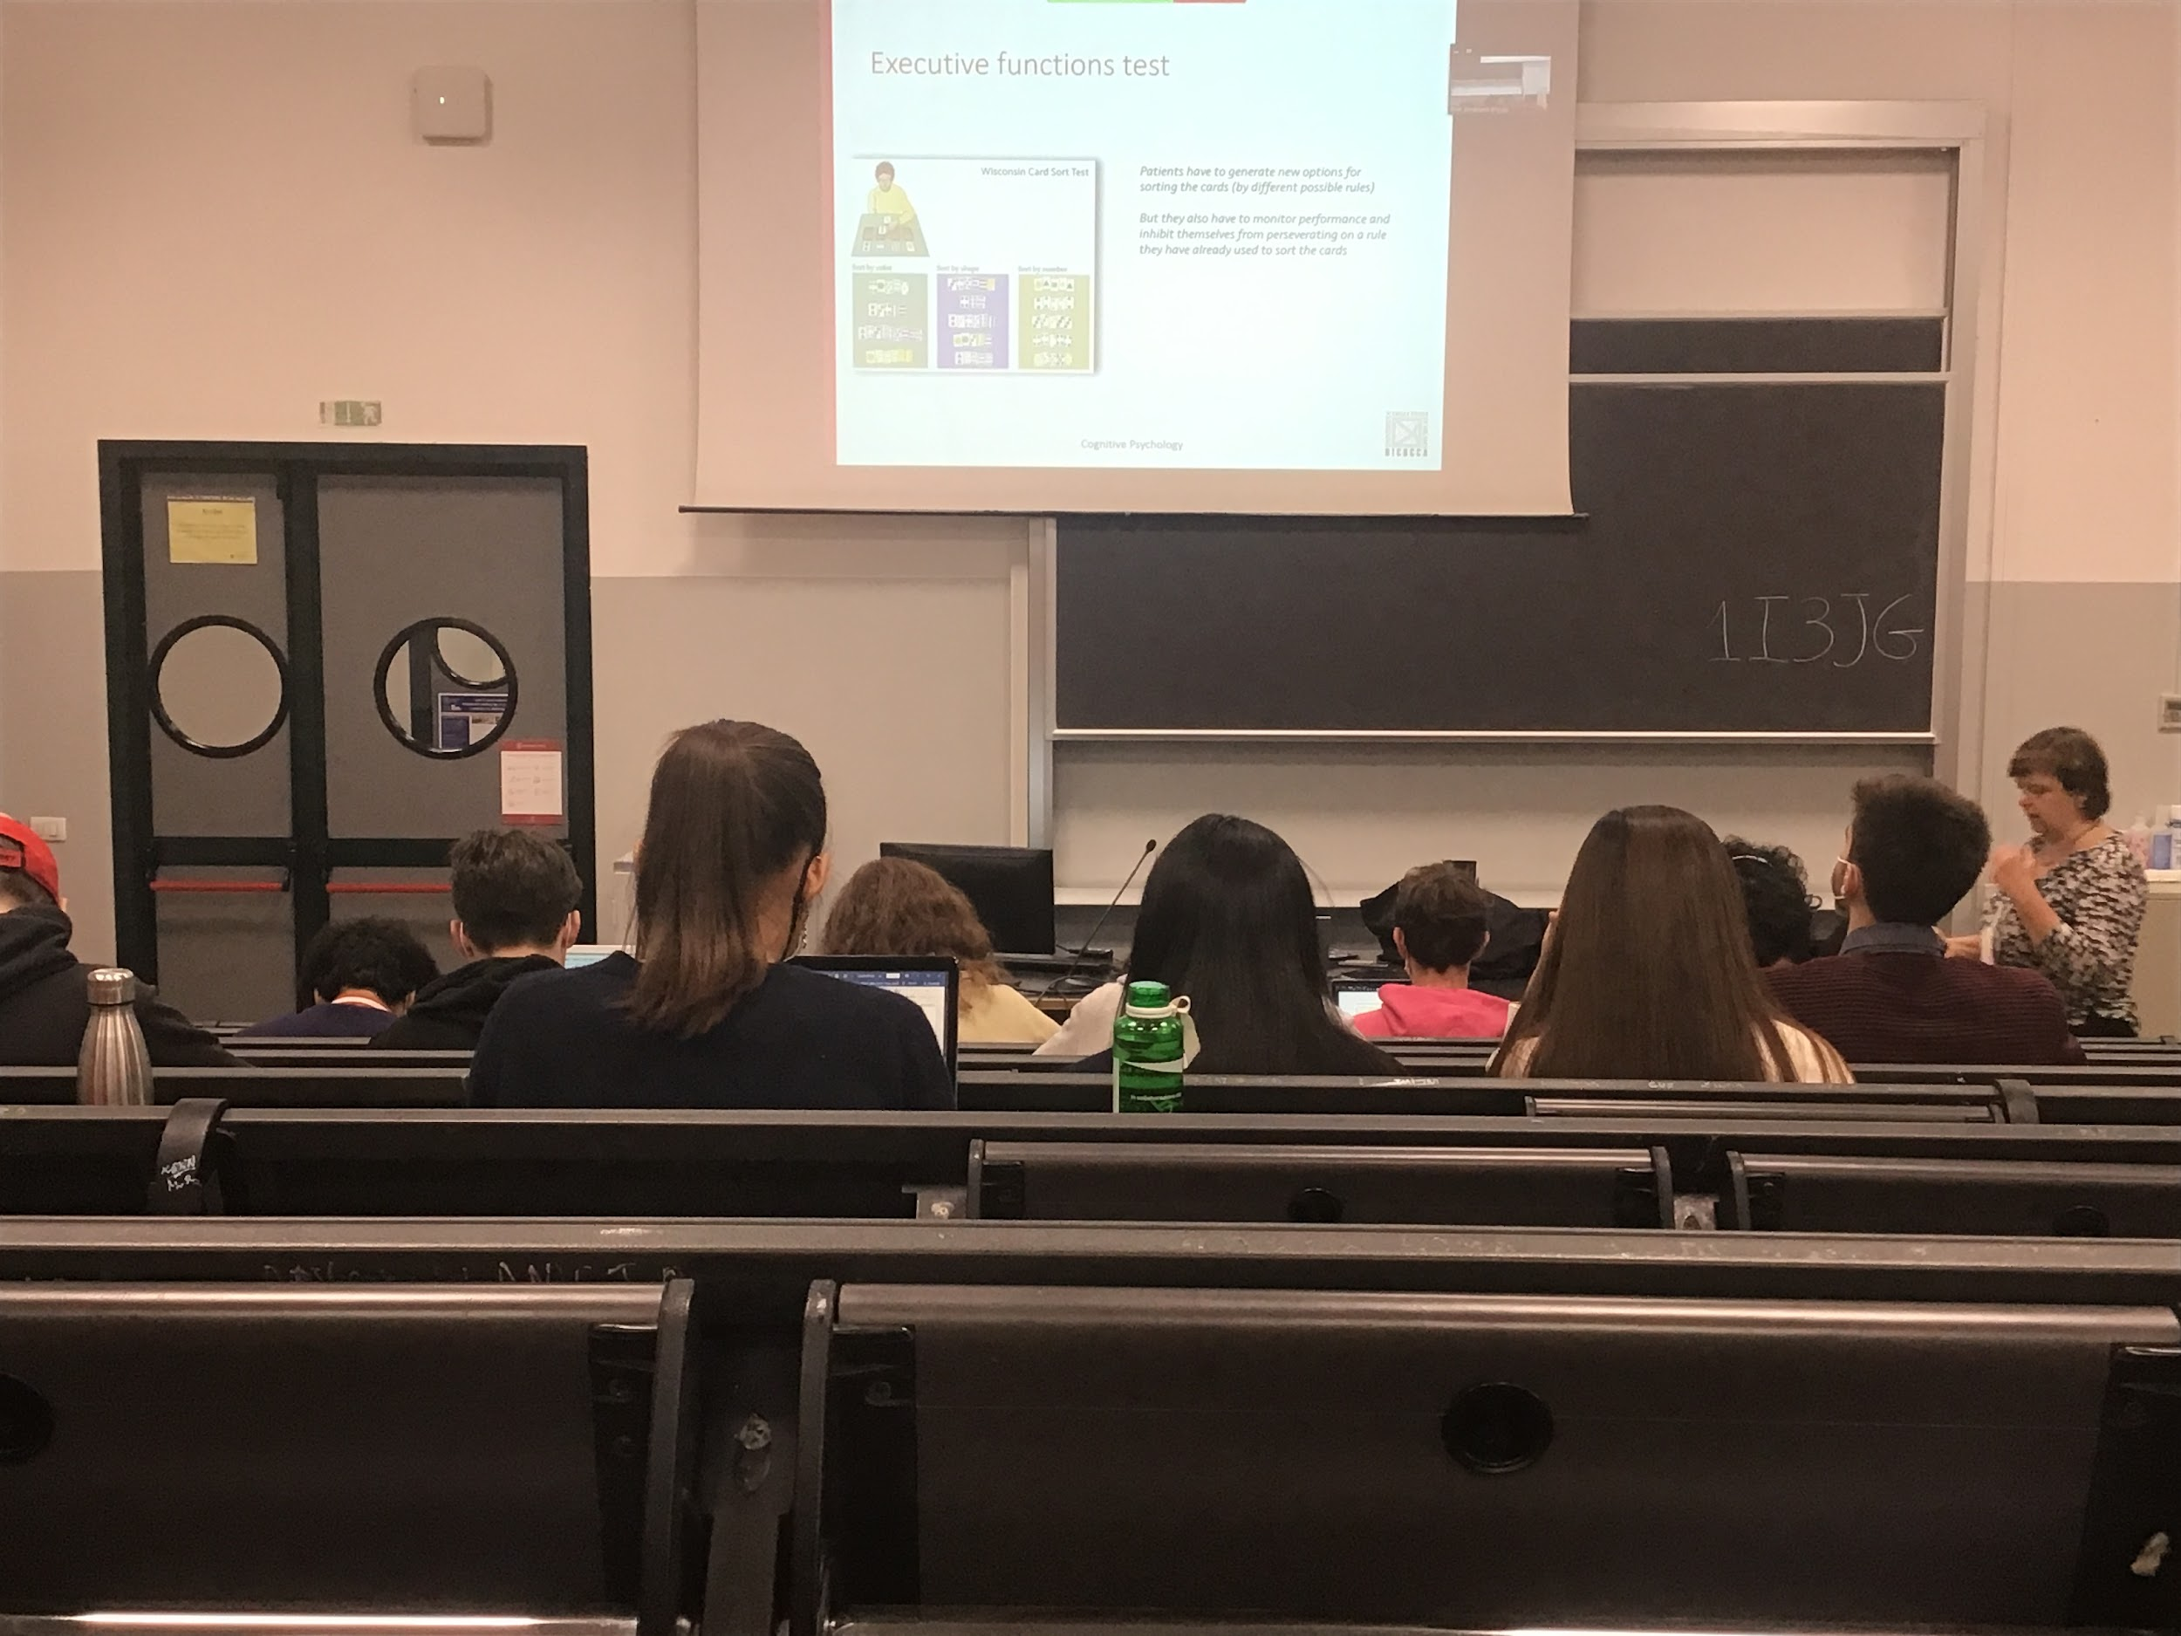

Experiment to test executive functions:

**Wisconsin card sort test**

4 piles of cards with different characteristics (4 colour, 4 shape, 4 items, 4 numbers…) you turn one card of the times and you have to assign it to the right group. You **don’t know the rules**

Every time you associate a card to one of the 4 piles you have feedback (yes is correct or no) you don’t know the rules. Have to try to understand if you have to pile them by colour, shape, number and items. You have to reason what you did before, why I say no…

If you try and I say no you have to switch. The central executive decides to stop using that rule and instead try to find another one. Patients with **frontal lobe lesions are unable to do this task**. Keep doing the same association. After a while I change the rule, you have to find a different rule. You are able to switch. Patients with frontal lobe deficit are unable to switch

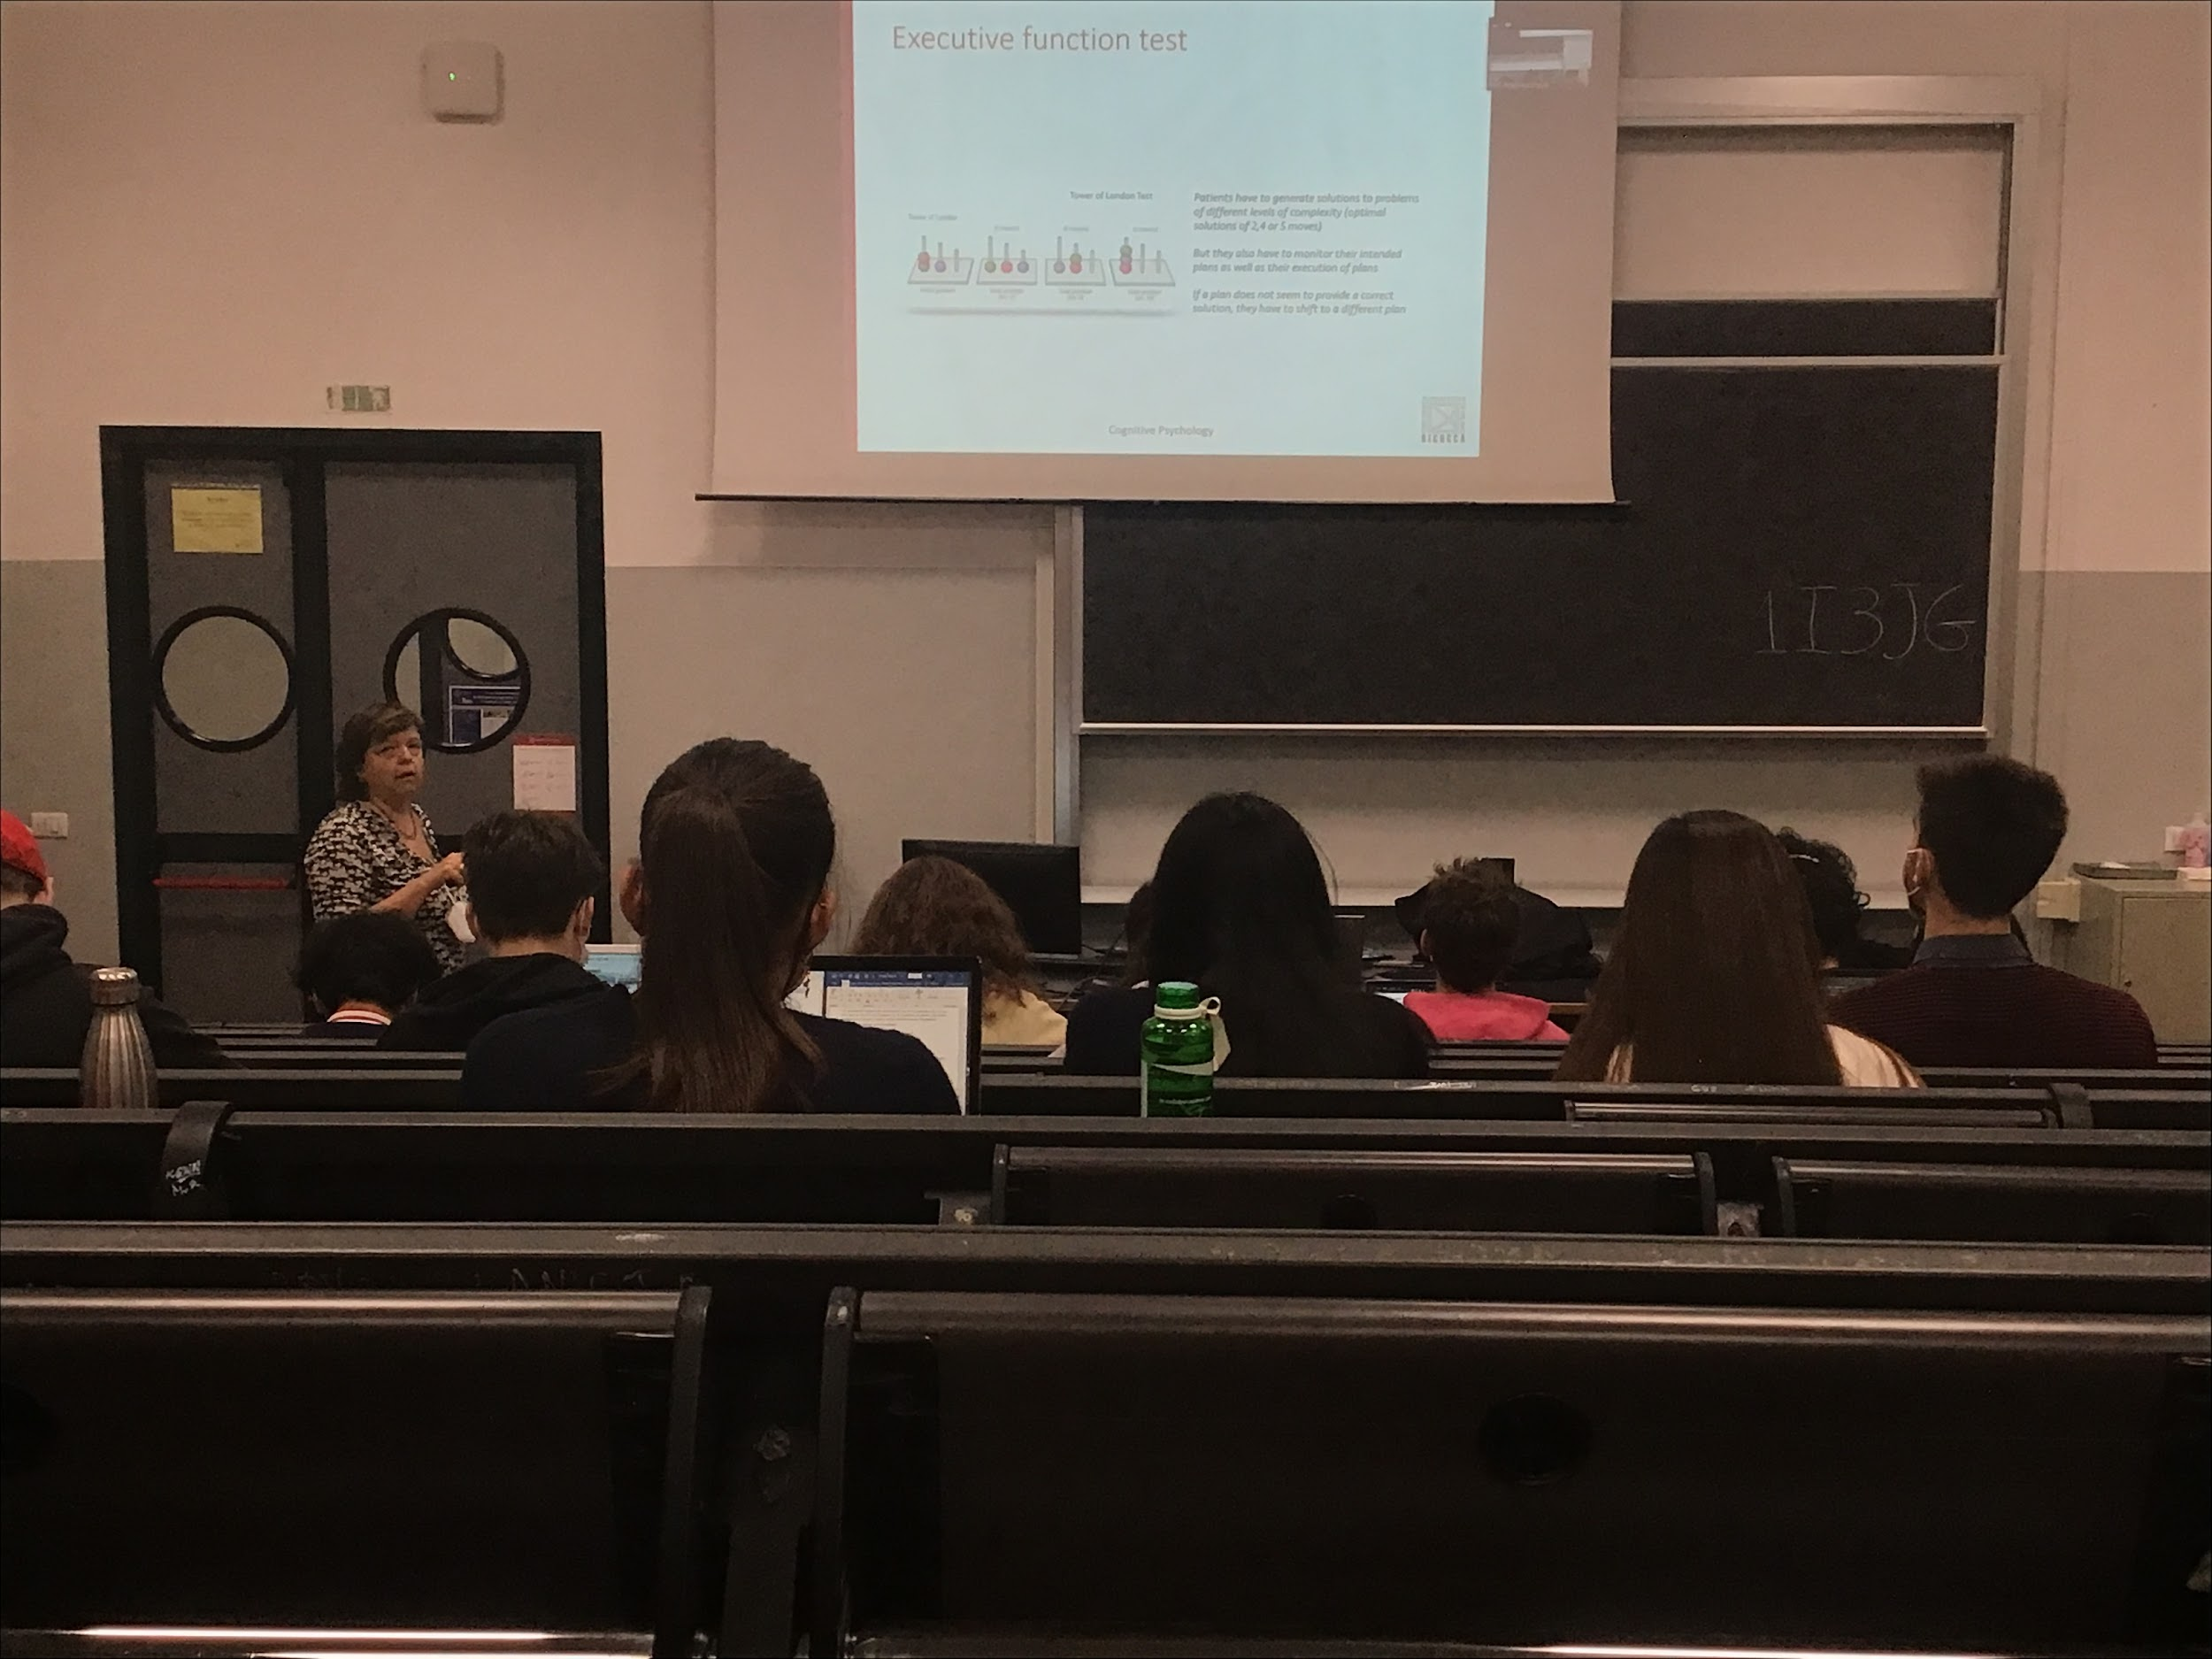

Tower of London test:

Have to get the 3 balls on the stick to reach a final position, you can move one ball at the time to get to the final position. See how many steps to get to the final combination. Being able to predict what your next move is and which sequences of movement is the central executive

Fontal damage and its consequences:

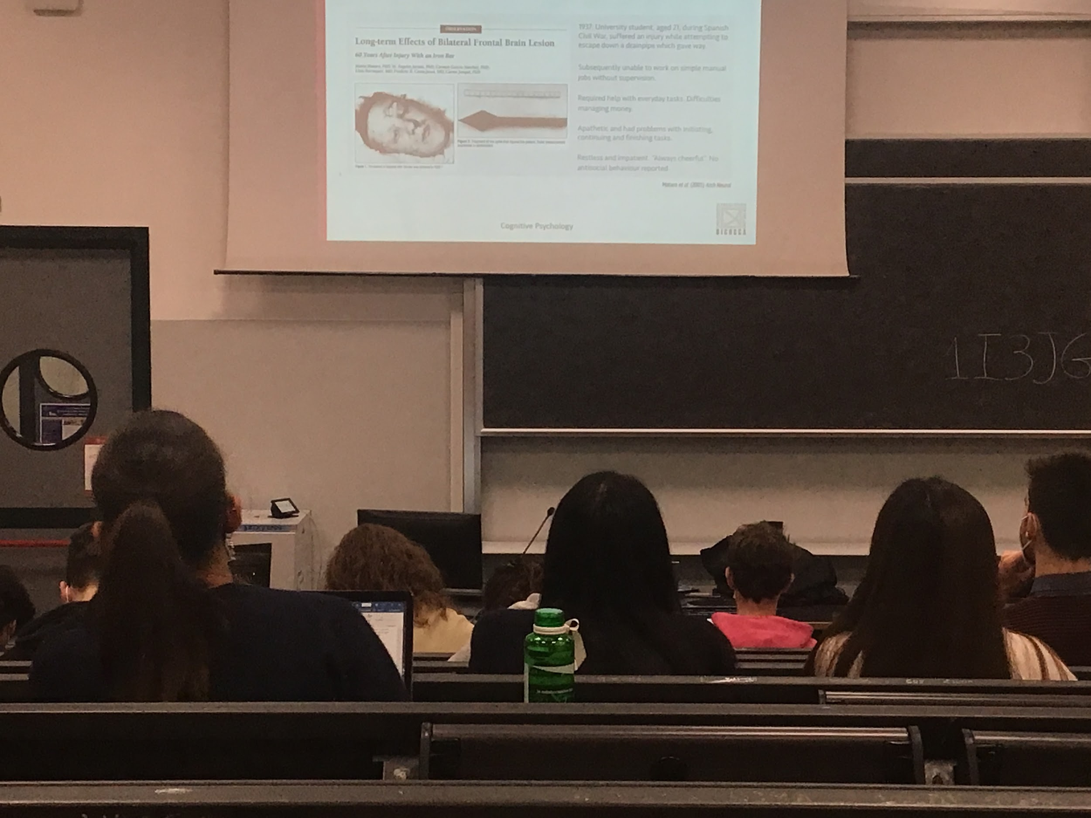

Man working with dynamites for the railway, one metal road went through his eyes up in the head. Fontal damage and its consequences

**Complete disruption of the frontal lobe**, in the front there are not many vital parts. They are in the old part of the brain

Disruption of the frontal lobe unable to make choices, without supervision can not do complex work, do not remember correct sequence. Become also very apathetic, don’t start to do things

Changes completely the personality (more calm) and cancelling their ability to do spatial sequence

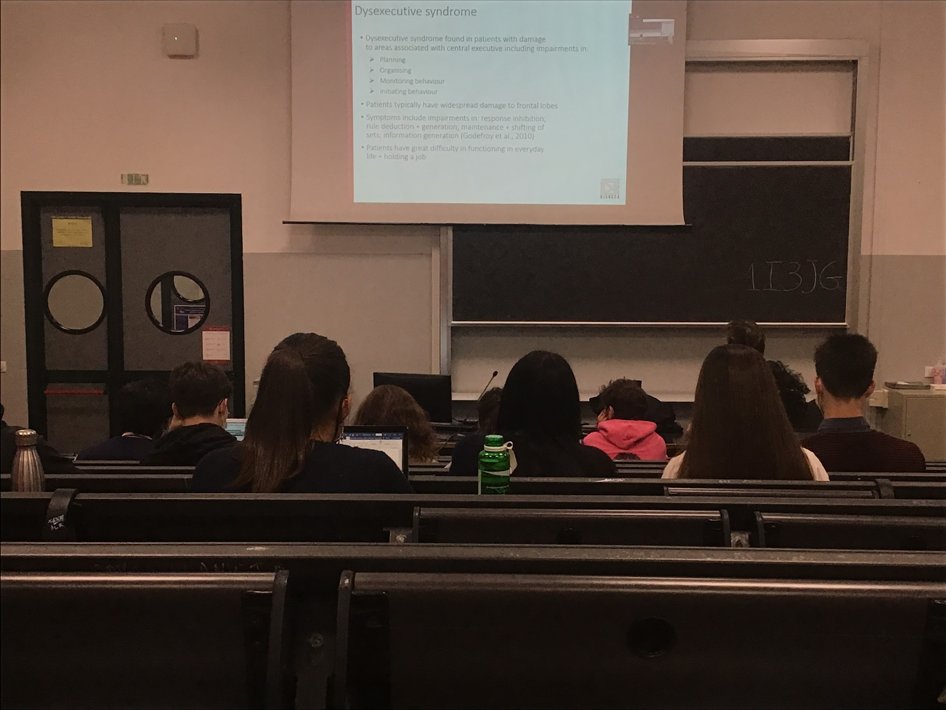

Having damage into the frontal robe

**Dysxecutive syndrome: inability to use the central executive**

Impared, difficult in planning. No stop giving the same responses, can not generate new rules, maintaining information, can not generate new information. Even if they are very calm, they have difficulty in organising. Can no only simple things

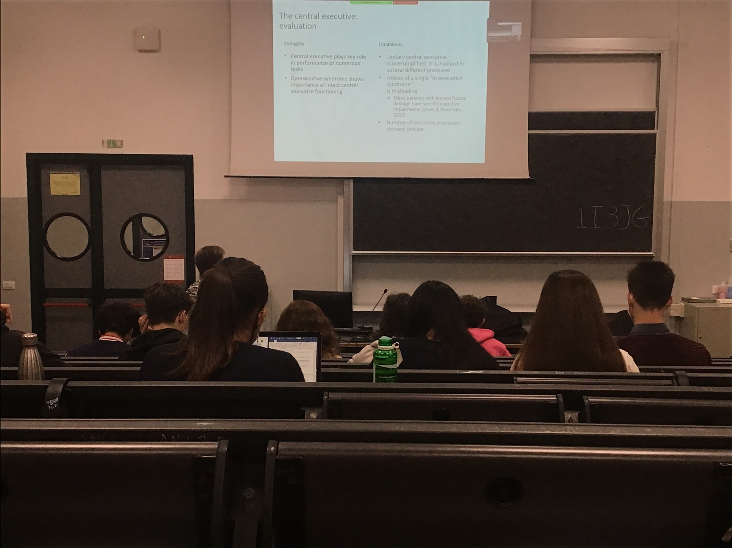

This **central executive have a very important role in many tasks we do**, without the central executive we can no function correctly (can function only for automatic and simple task)

You can have same problems specific executive function with lesion in other part of the brain

There are people that have single impairment in single specific executive process

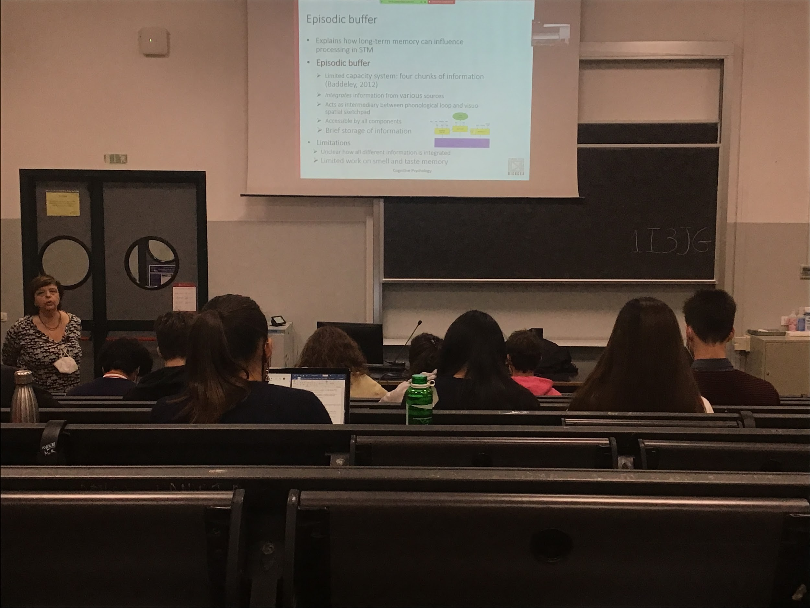

**Episodic buffer**:

Last part in the new version proposed by baddeley.

Original model: there was not a place for storing information (the central executive can not store information) where do they go together? Visual and phonological information are combined. Need to combine in a specific moment

Very limited capacity system, we store what we are thinking in this precise moment

Not clear how it works

Update our reasoning in different step

Missing in the general model, it consider only visual and acoustic information

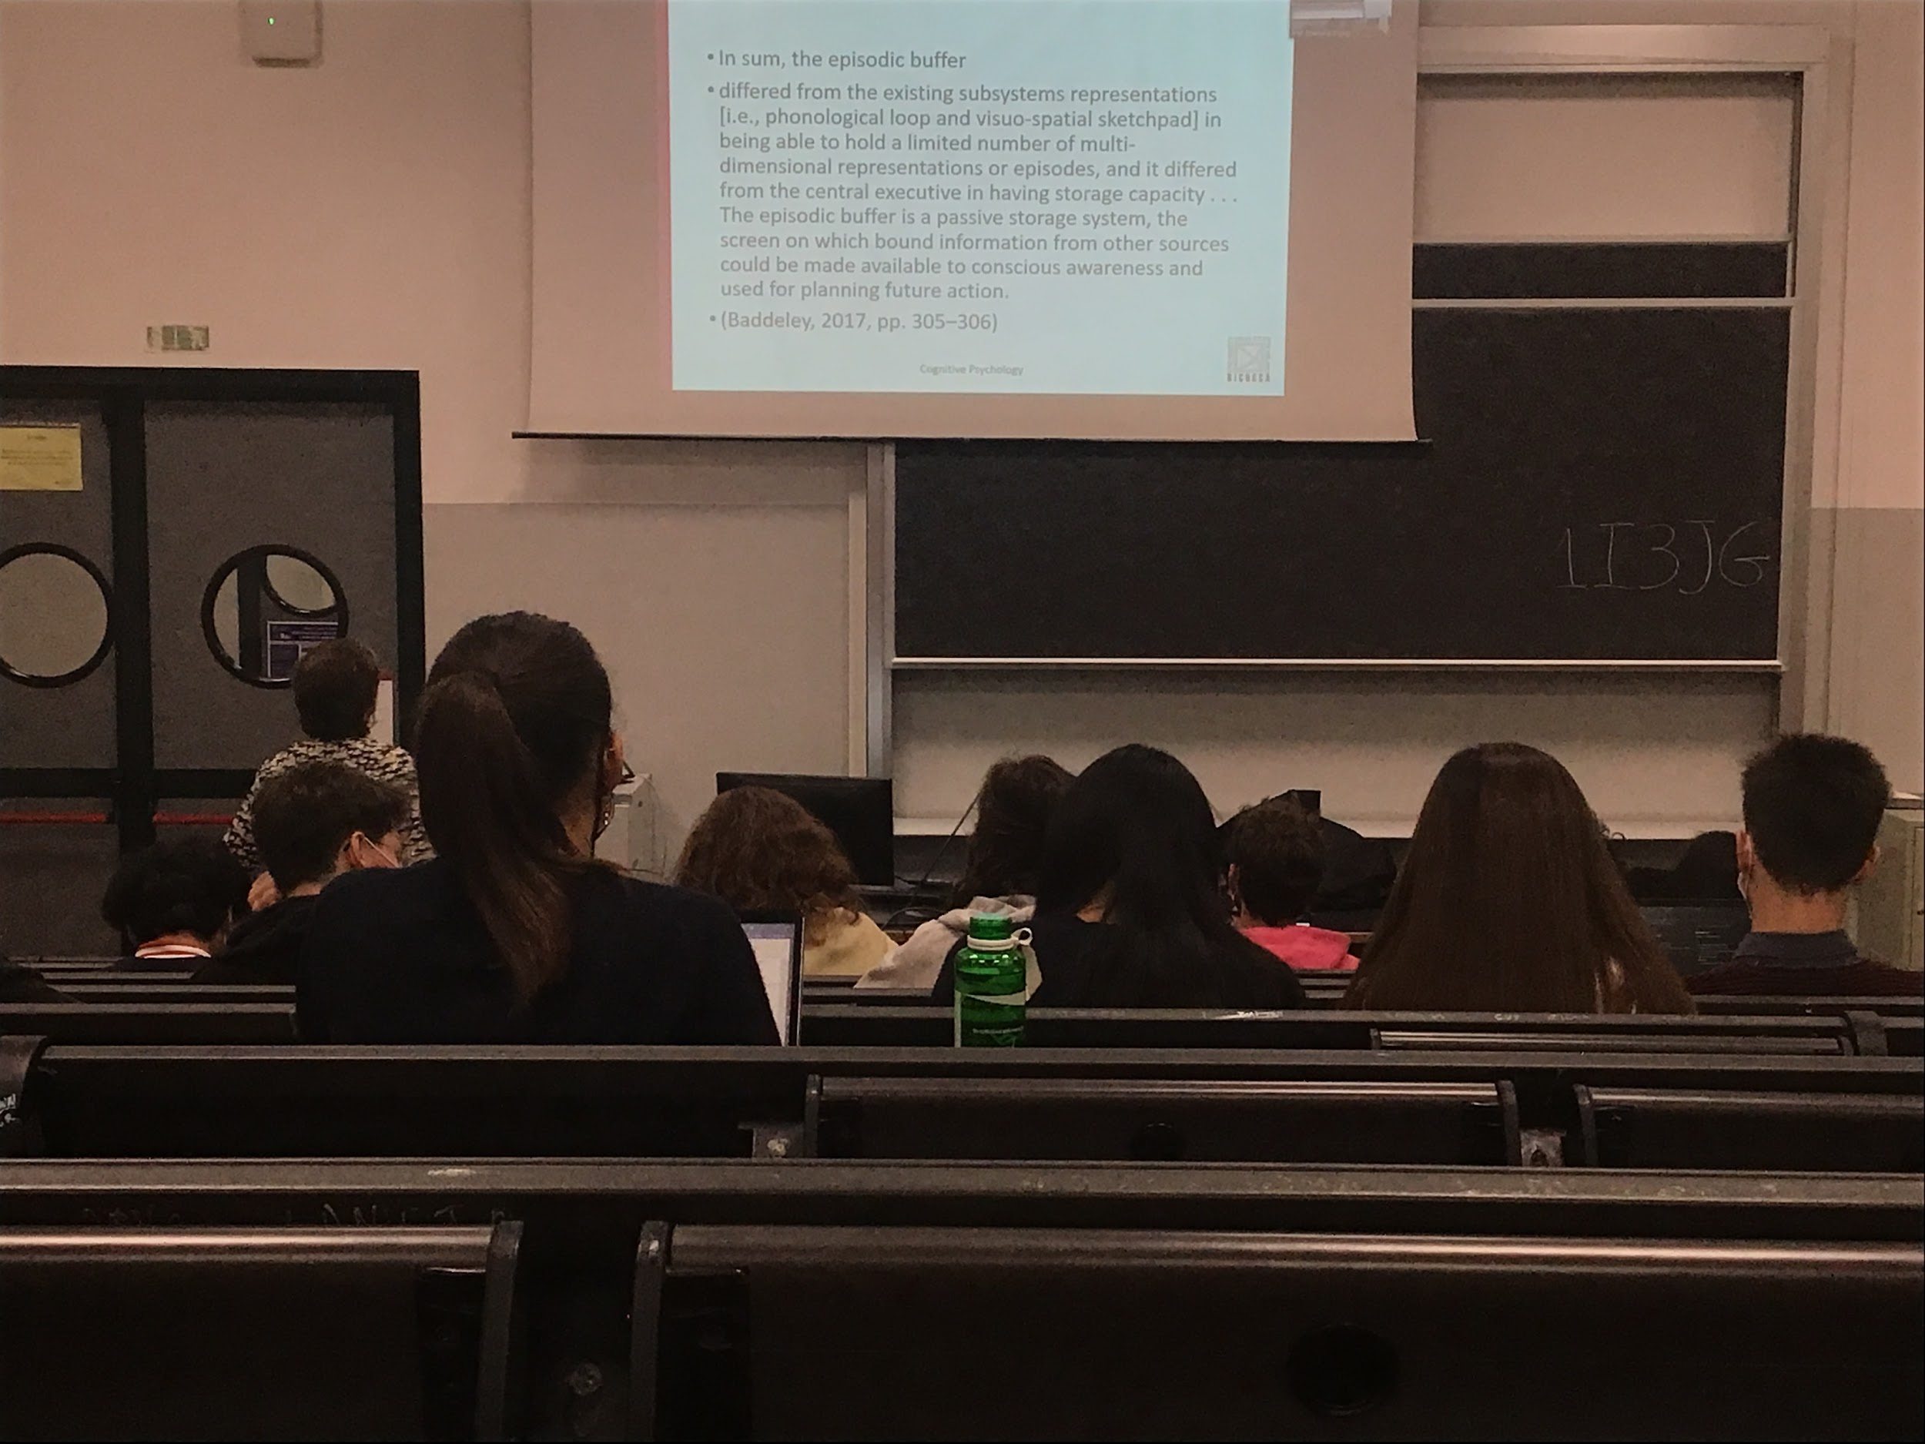

Contains information that has not only specific characteristic

No storage in the central executive

What we are aware in this moment is what we have in the episodic buffer

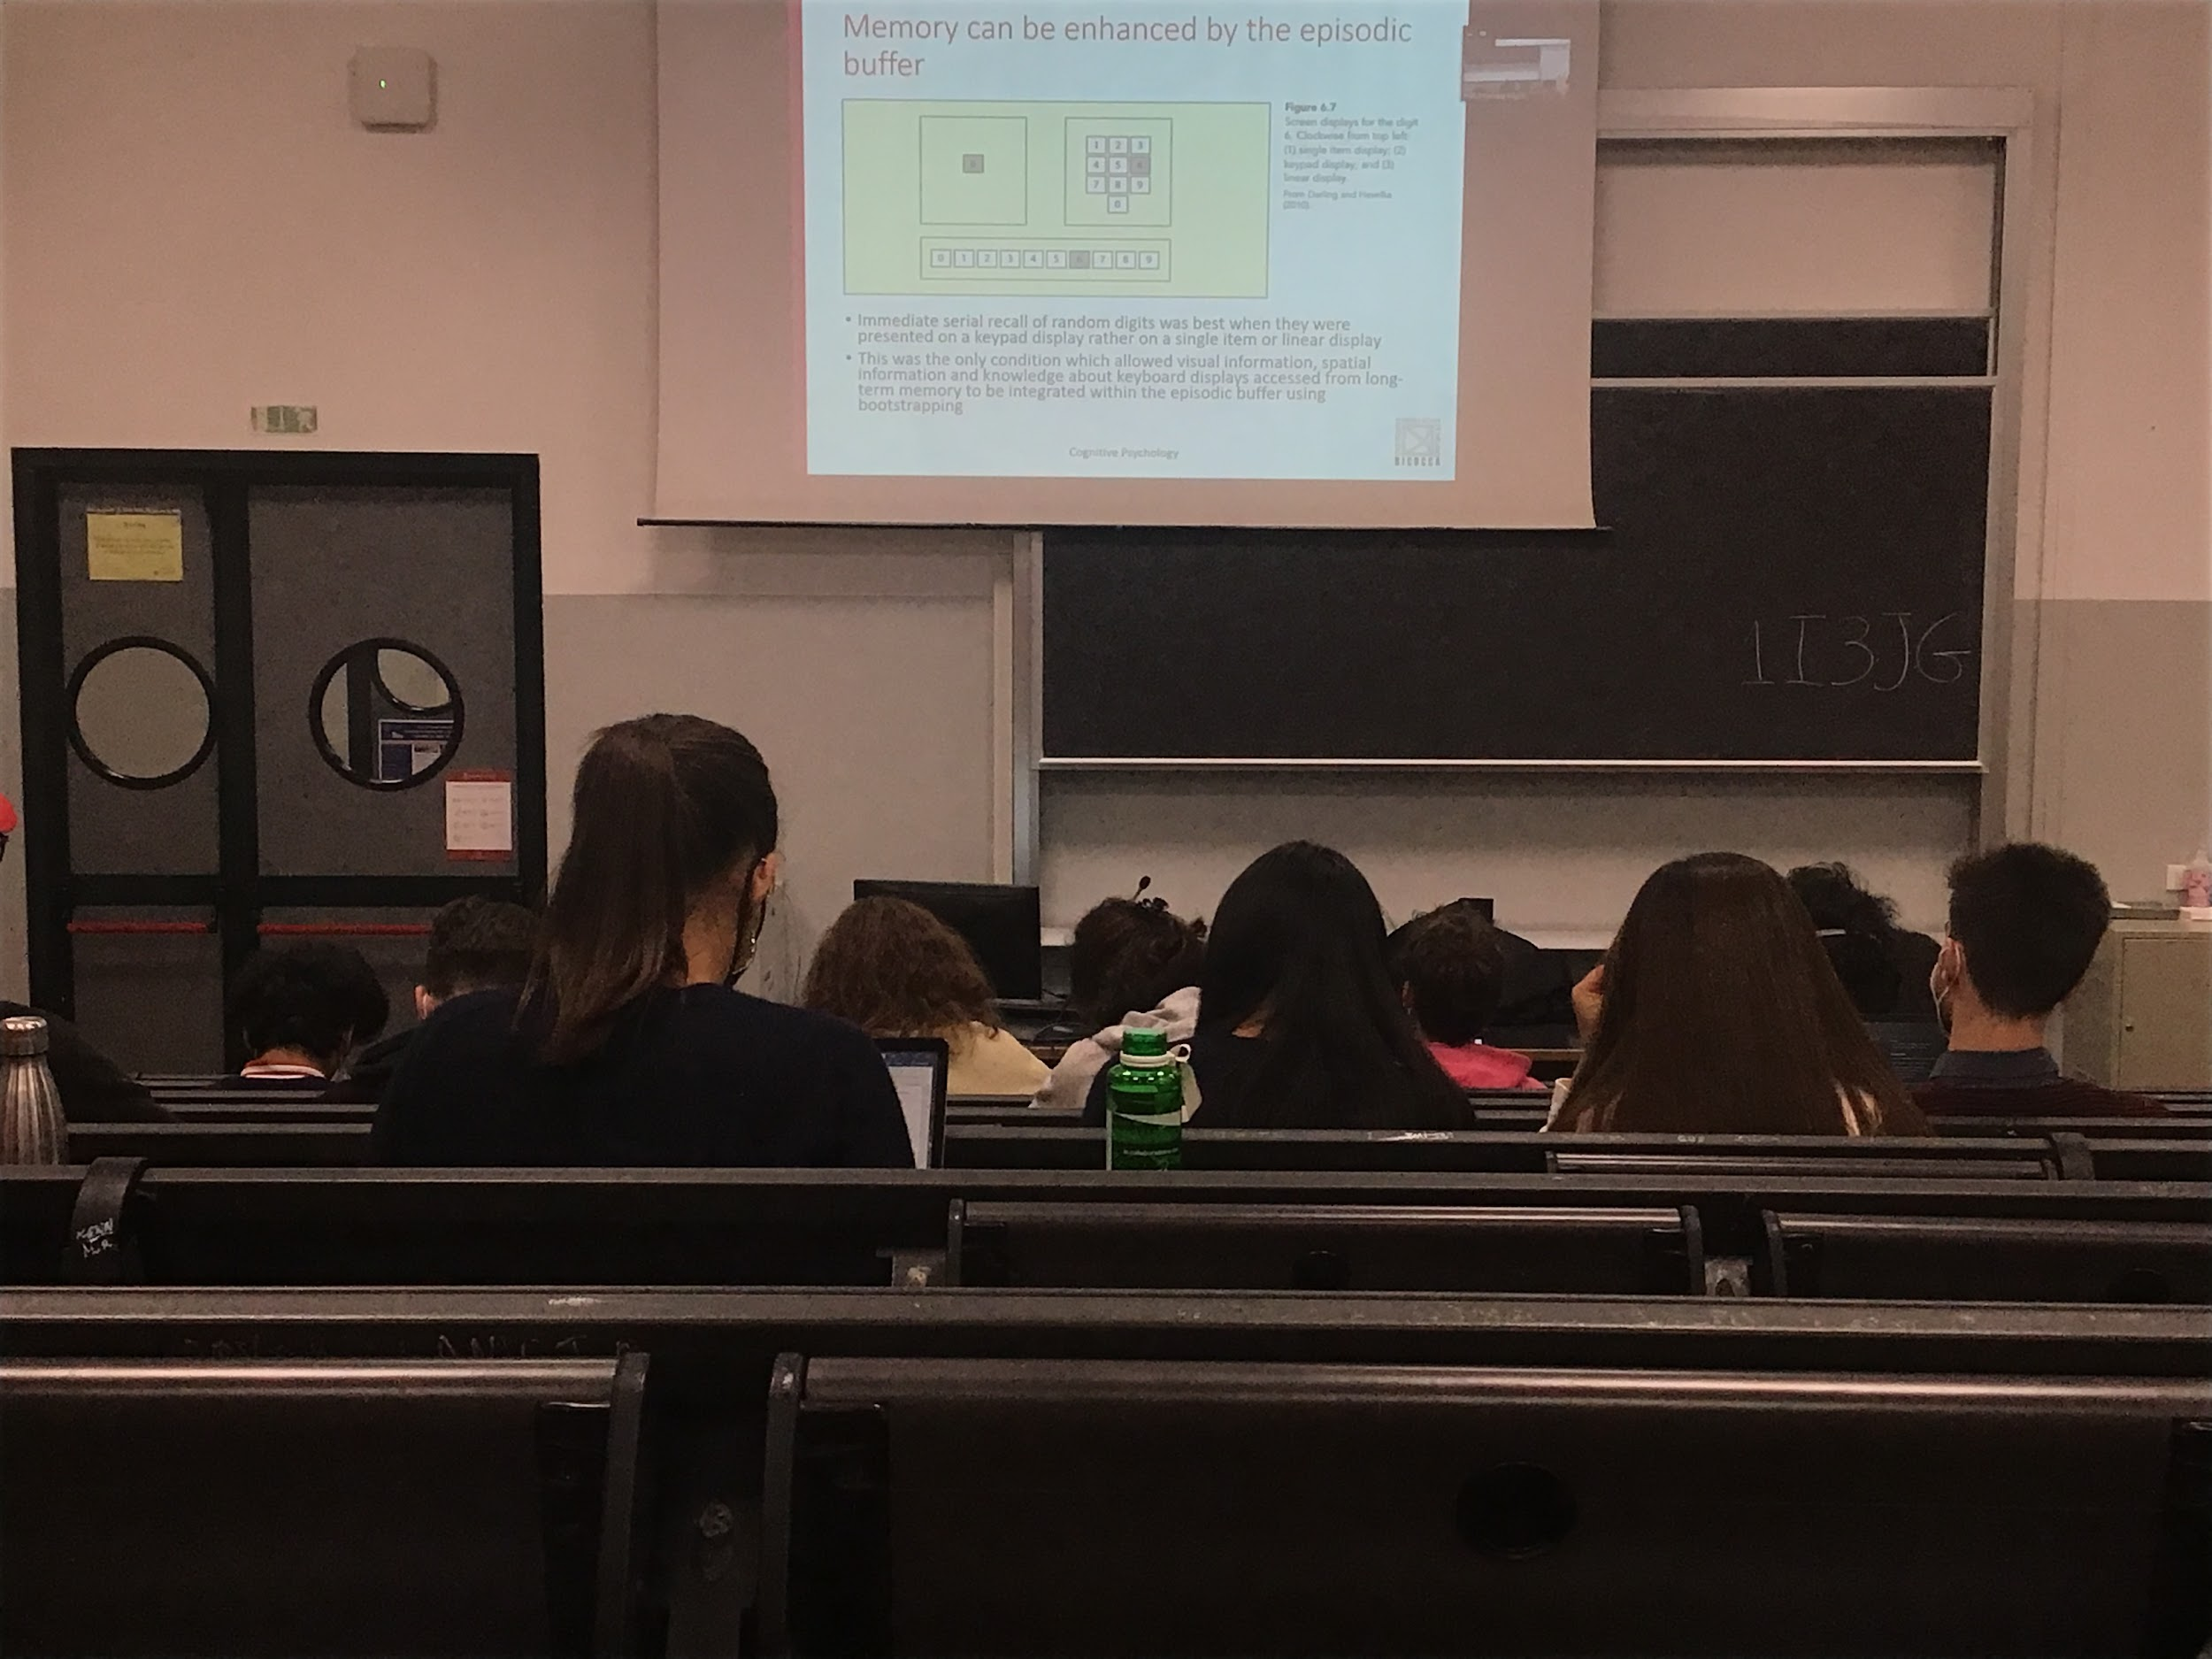

Episodic buffer helps to remember some kind of information, if I tell you a list of numbers to memorise. I can show you the numbers in different way:

* Show the number one by one
* I show them on a line
* I show them as the phone number displayed

You remember better the one that is similar to the dial phone. It **has a structure**, you can memorise the sequence of the sketchpad

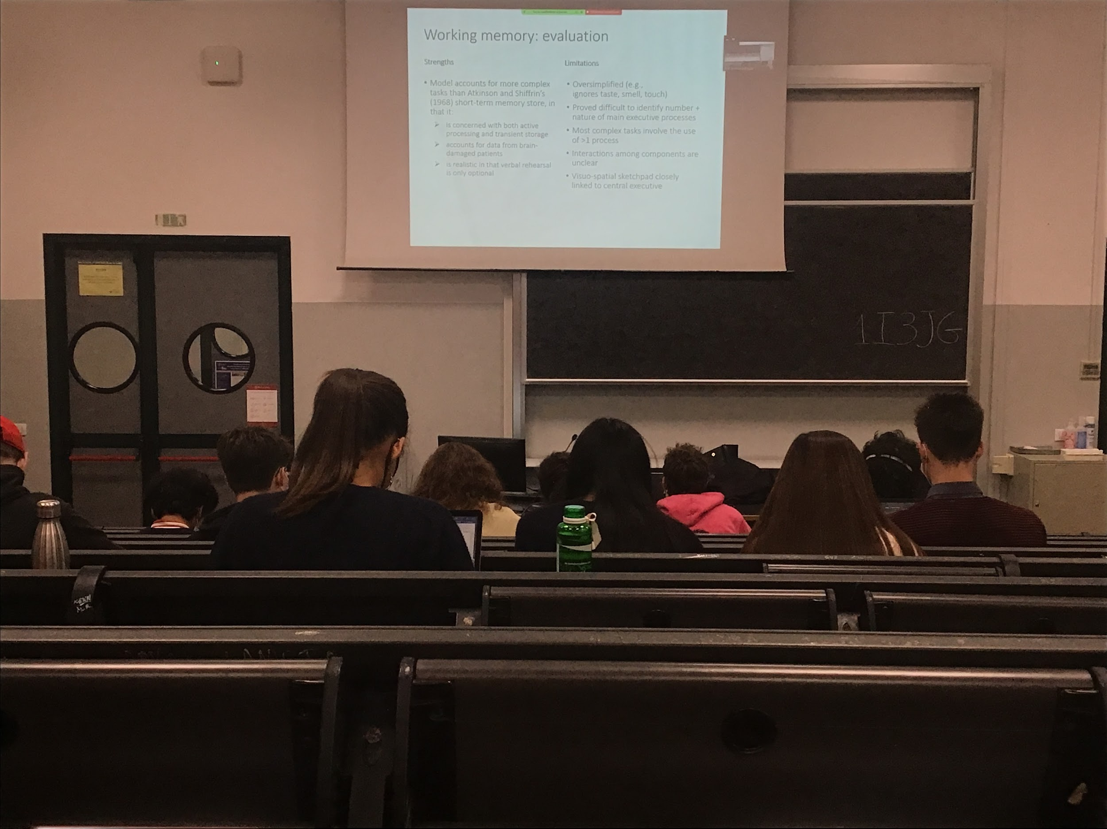

Damage to the central executive is not a damage to the visual system. If I put 4 cards in front of you and I ask you to close your eyes and remember it, you can still be able to do it with damage to the central executive, but you can not reason about them. They can do mental rotation can localise and identify objects but can not do other task

## Learning memory and forgetting

### Working memory: executive functions and individual differences

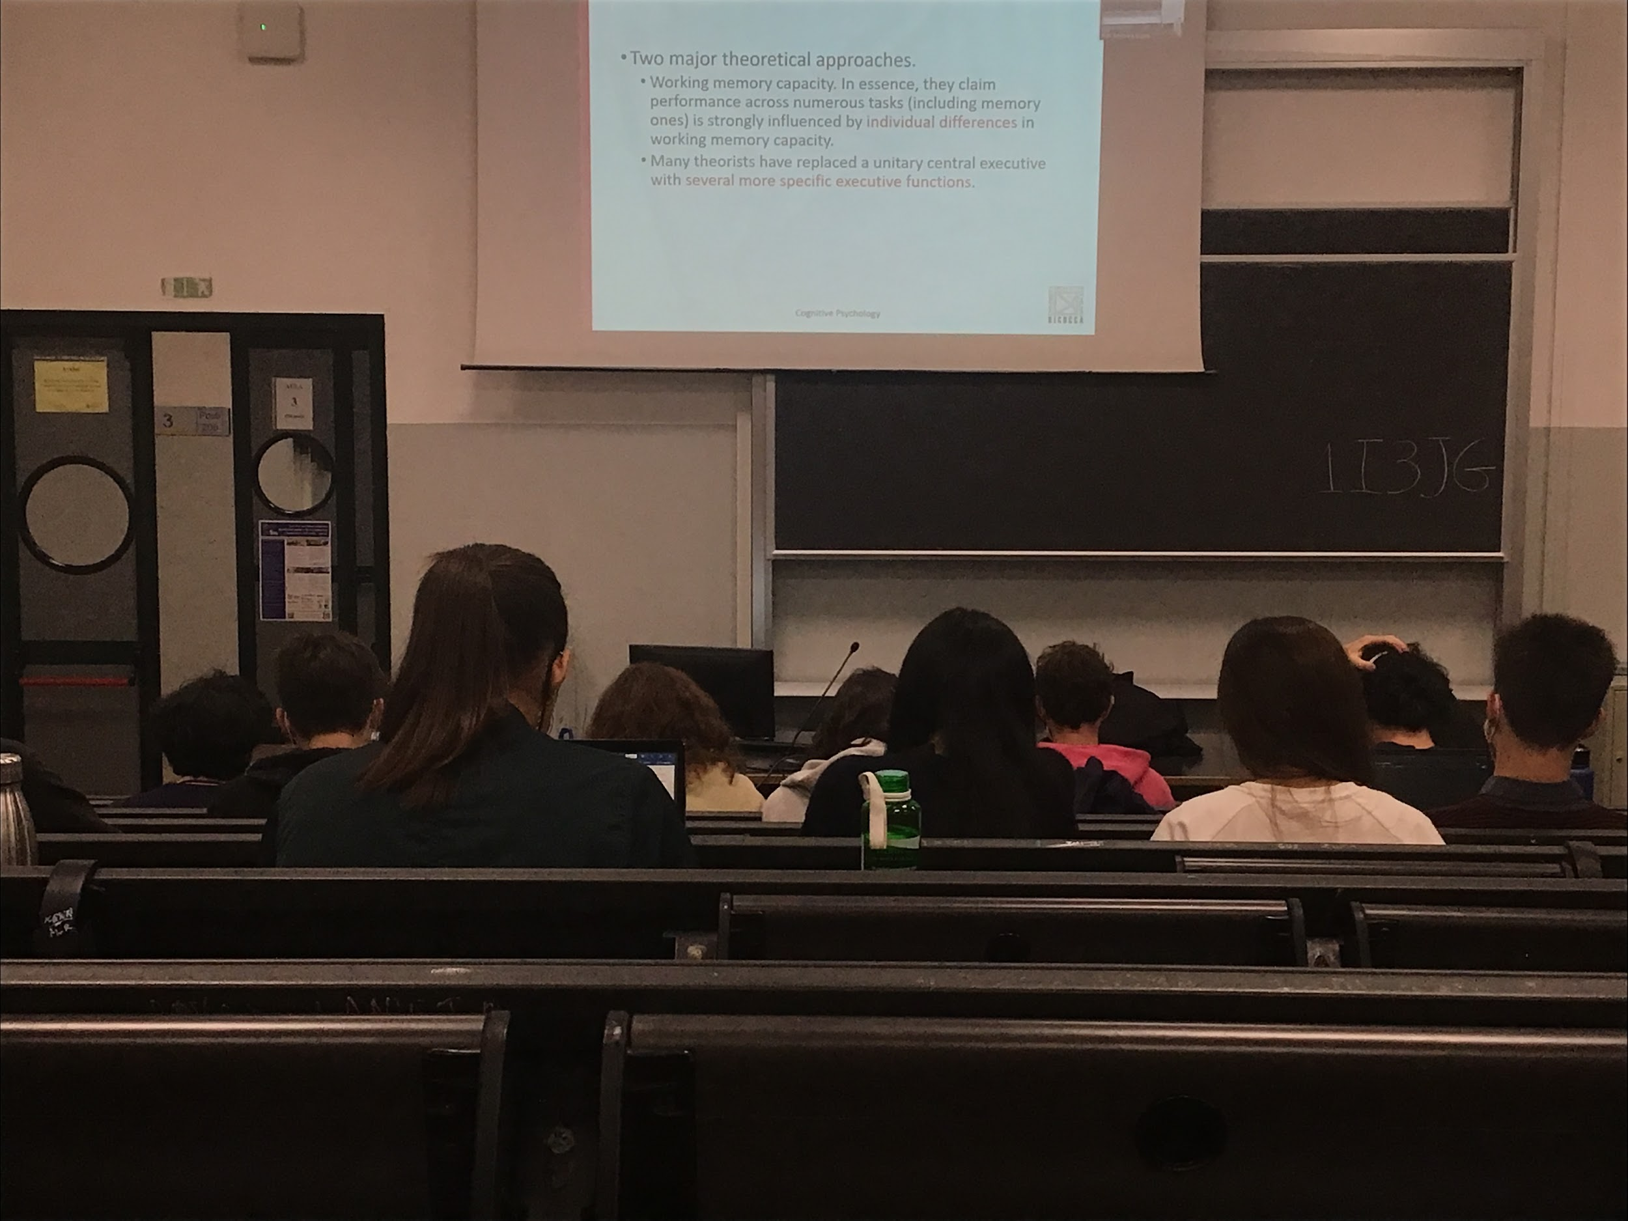

Two theories:

* Performance on a task depends on individual differences in working memory. Depending on the capacity of our working memory we can be better or worse at different tasks. People with high capacity have (most of the time) a better performance in cognitive task
* Different processing unit that implements different executive functions, not a unitary central executive

Try to find general rules that are satisfied but work in general, not much interested in individual differences with the exception of some cases

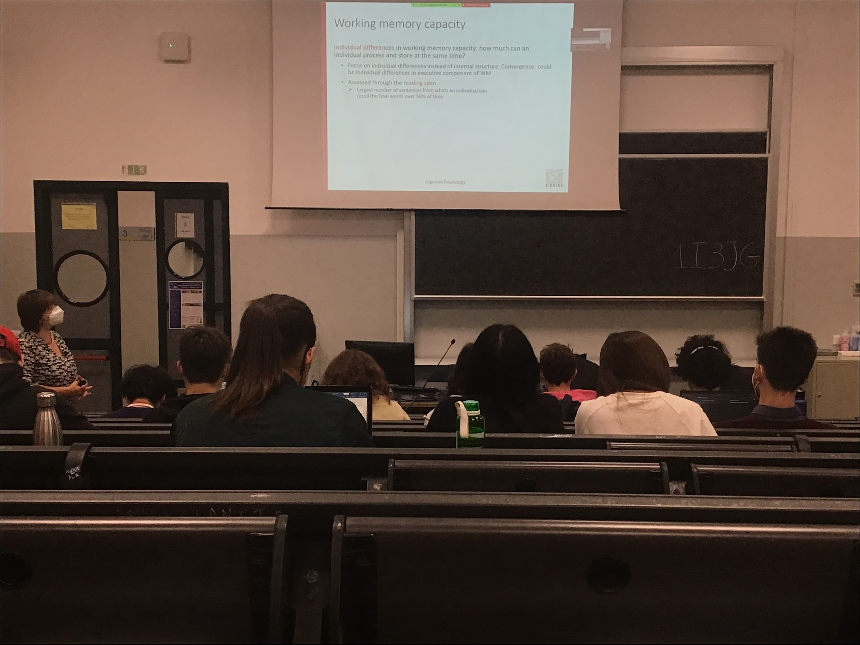

Different in working memory capacity. How much information we can store at any given time in working memory in the episodic buffer or in the two stores

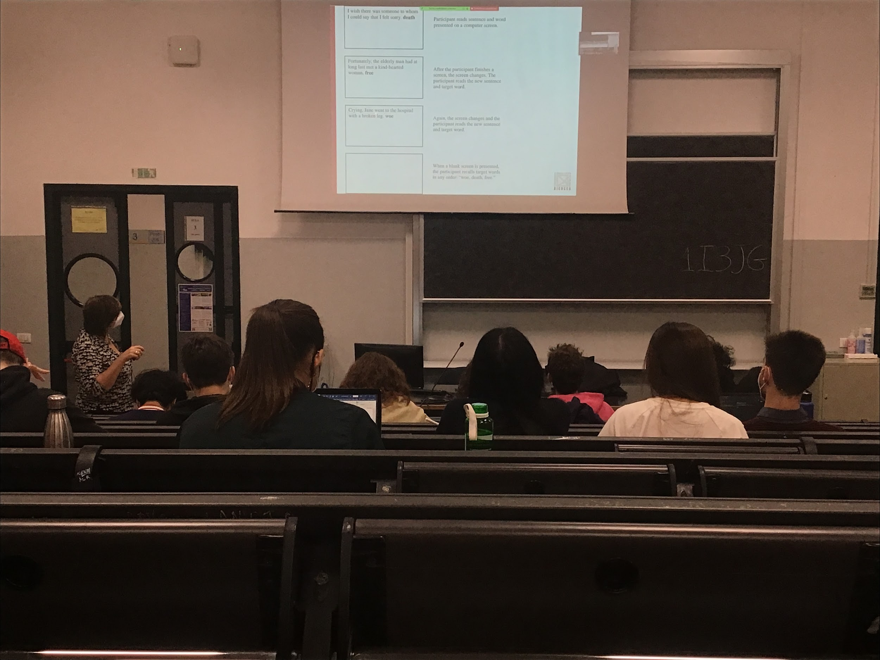

To test working memory capacity use two test:

* Reading spam
* Operation spam

Reading span: have to read sentences and words at the end of the sentences that have nothing to do with the sentence. When you read it is automated and you interpret what you read, unable to read without thinking of what you are reading at (if it is a language that you know). There is **interference between the sentence and the last word**. At the end when there is a blank screen you have to repeat the last words. Seems an easy task but there is **interference in the phonological loop.**

We present different number of sentences and the reading spam is the largest number of sentences from which an individual can remember 50% of the time

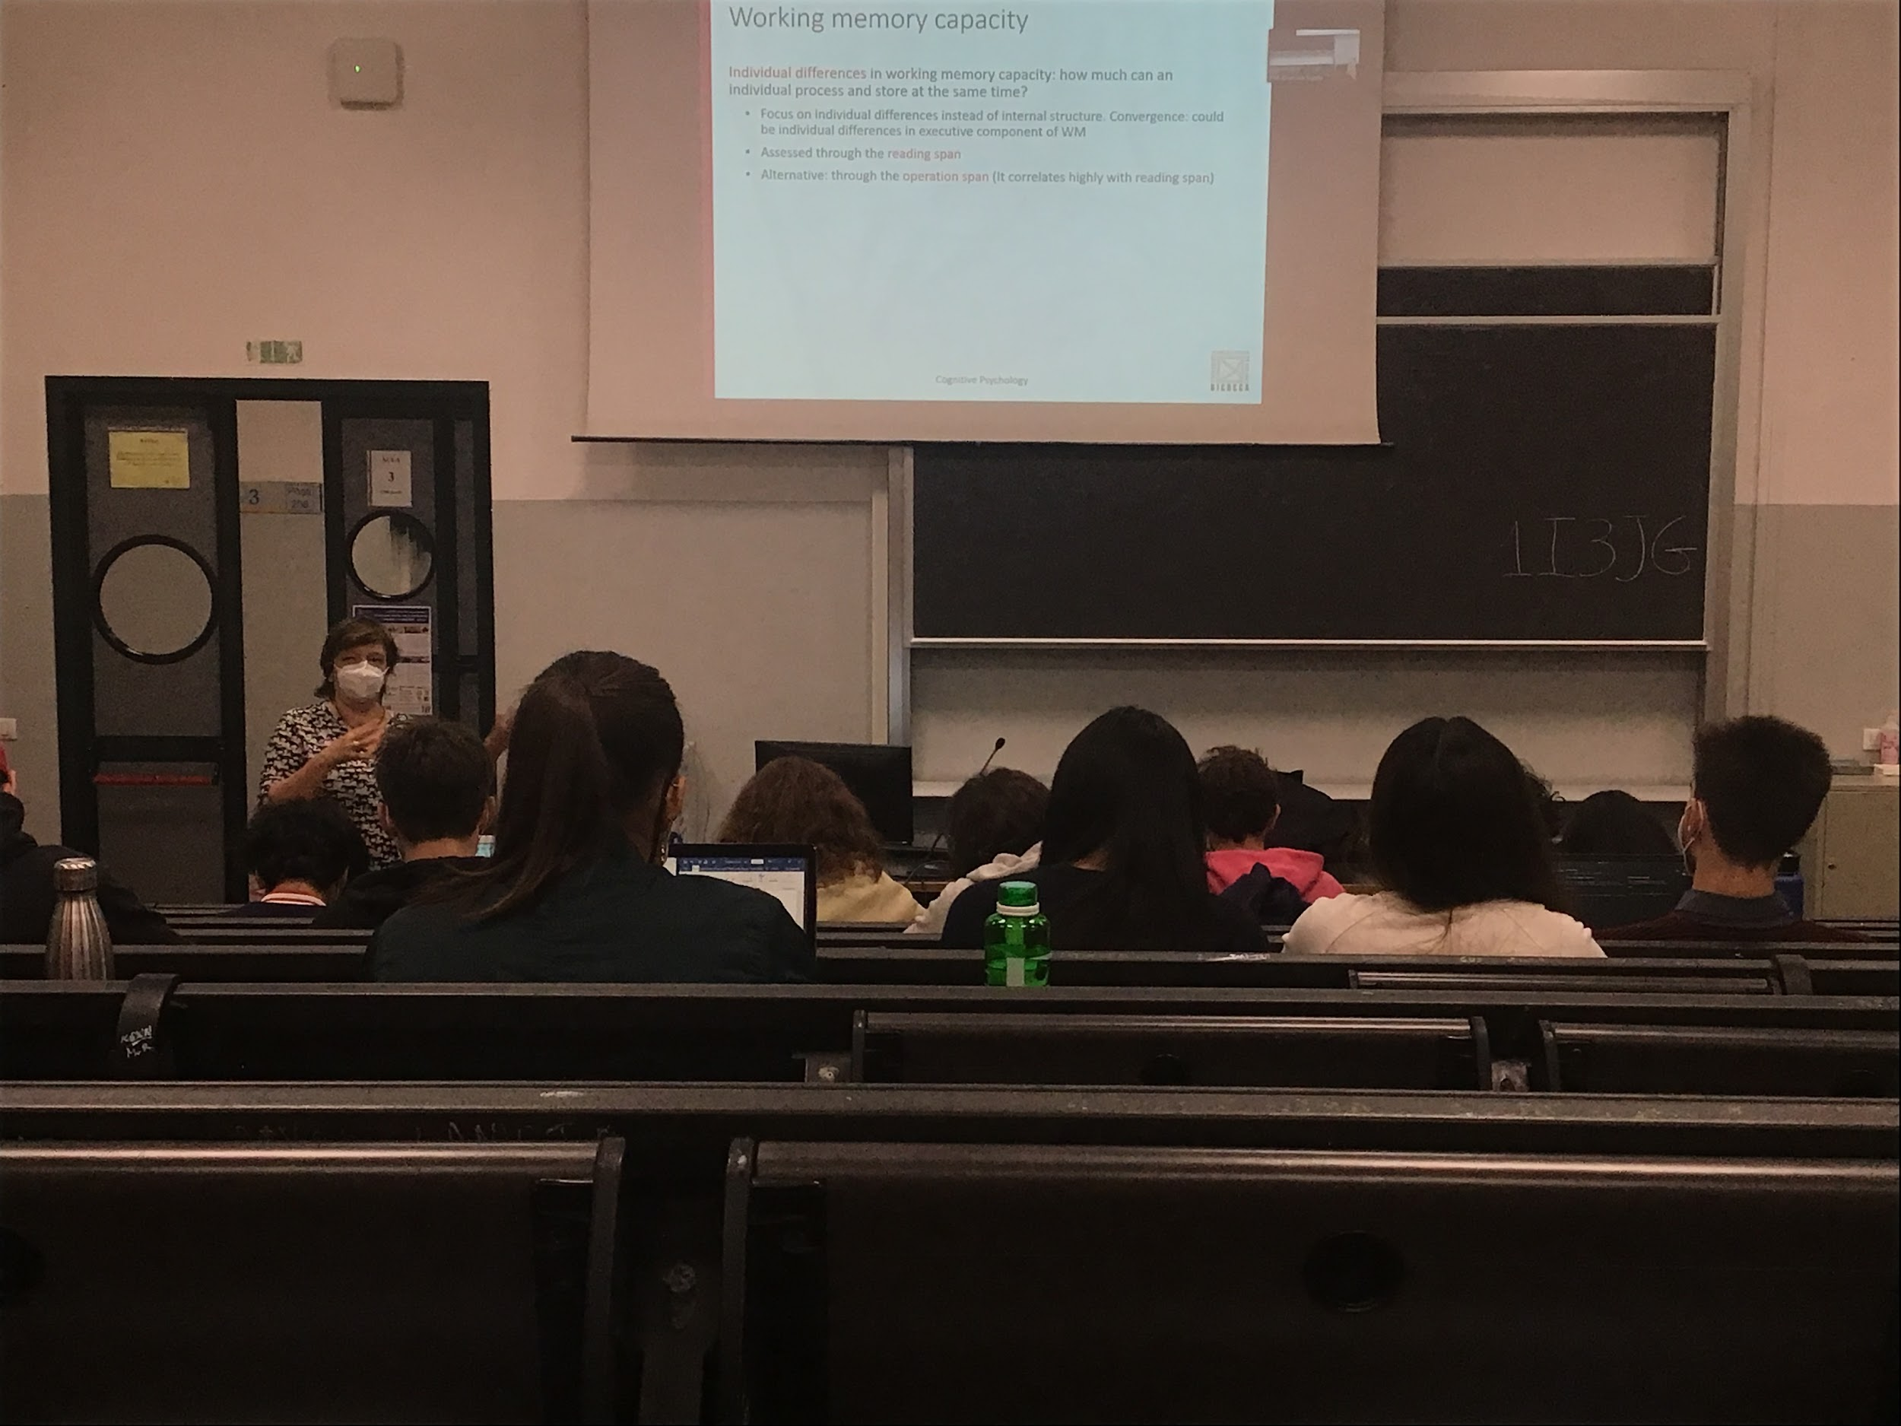

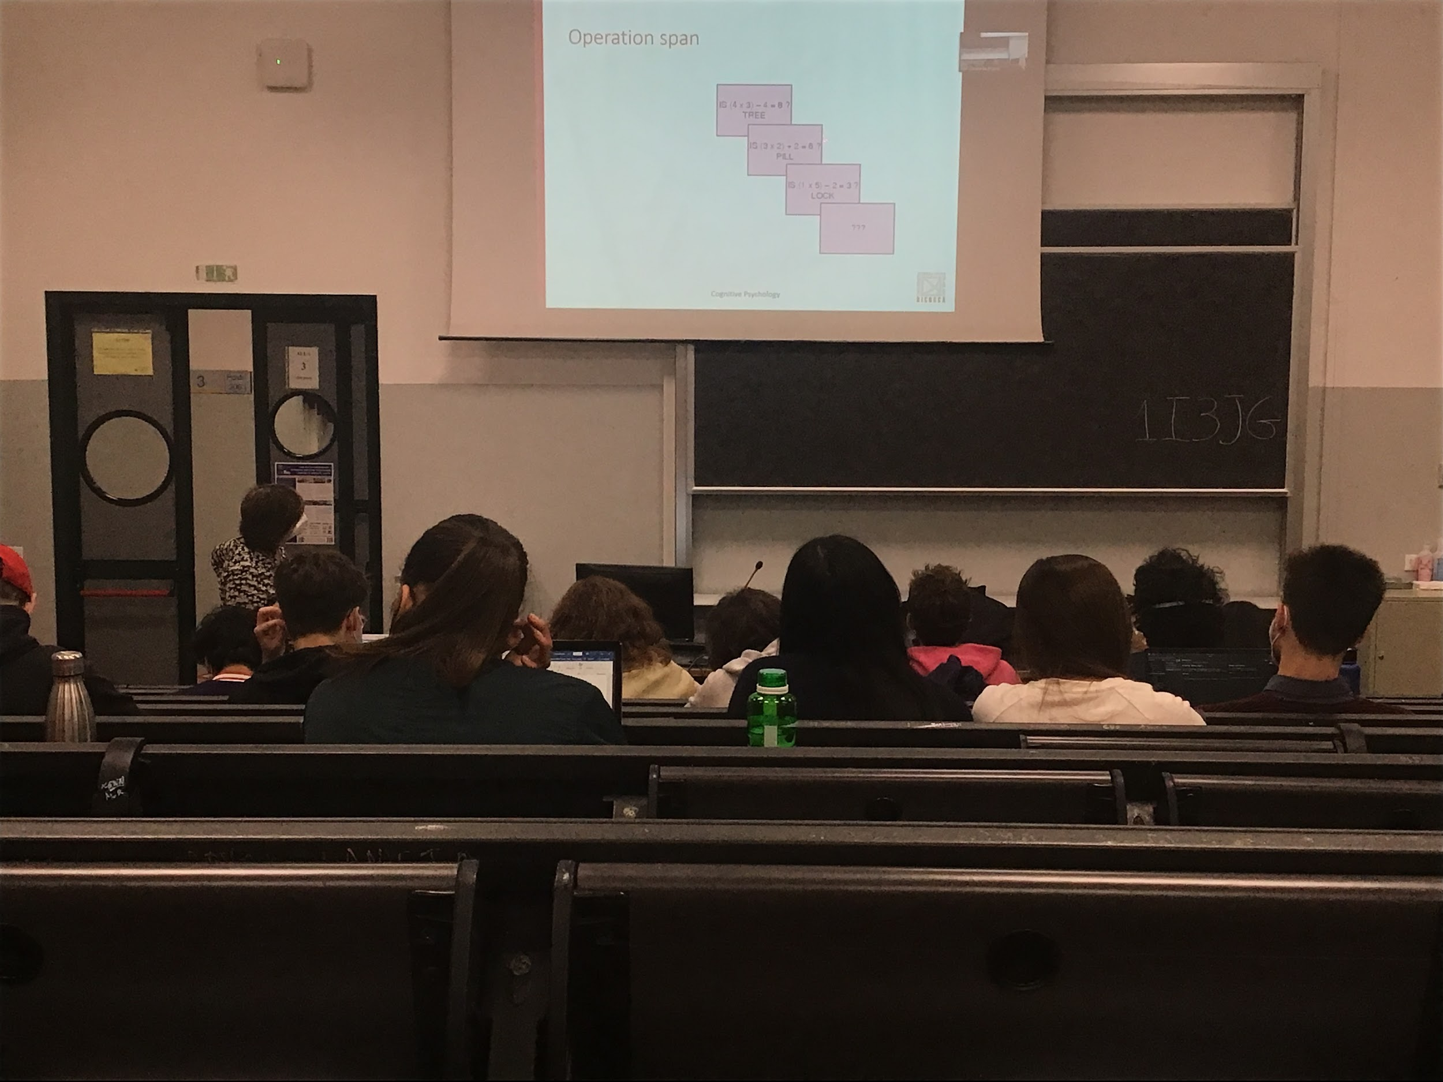

Operation spam:

Operation span and reading spam are correlated. If you are good in one you are also good in the other one, and vice versa

You have to do maths (use phonological loop and central executive) and you have to keep in the phonological loop the words. In both cases we can see people have smaller and larger capacities

There are different types of intelligence. Two big categories

* Fluid intelligence: helps you work with different new materials. Correlate a lot with working memory capacity
* Crystallised intelligence: depends a lot on what you know (knowledge skill and experience)

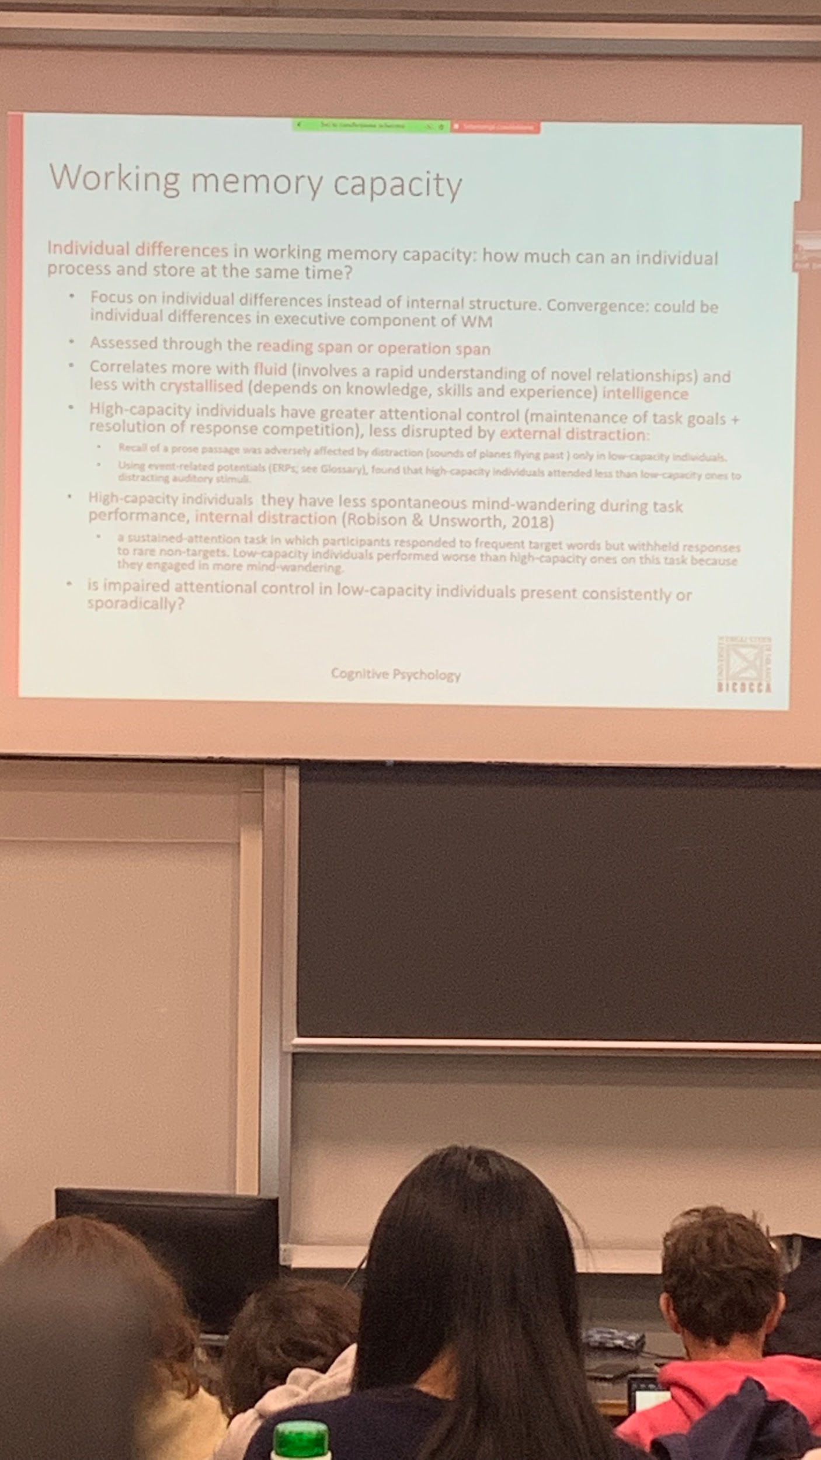

It has been shown that high capacity individuals can deal much better with external distraction. Maintain your task, keep doing what you are doing even if there is interference from the outside.

If I ask you to read a prose and there are noises when you are doing this task low capacity individuals perform worst

Unable to isolate the parts of the task they are doing and take away external distraction (something that happens in the environment and distract you, nose from a street, children crying…)

**High capacity individual have more focus attention** than low capacity individuals

**High capacity individual are better to avoid internal distraction** (mind wandering, not focus on your task)

To test internal distraction you have to do a boring task. A lot of words are presented and you have to respond to the animals' words. If an animal word appears often you are good, if it happens rarely you have to maintain concentration and avoid mind wandering.

People with high capacity are better than people with low capacity, High capacity people can stay more focus and perform the task faster

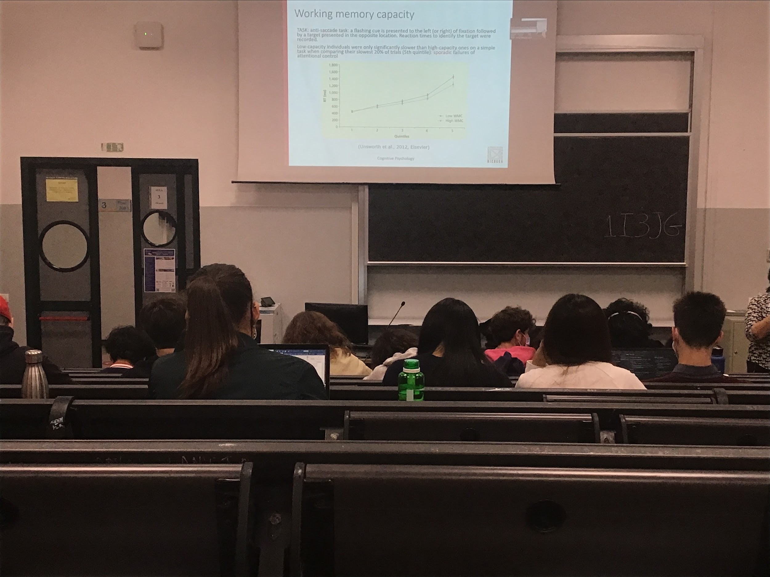

People with low capacity are worst (have more interference by distraction internal and external)

Is this a general consistent inability to avoid the distraction or every once in a while you get distracted. Is it a consistent or sporadical problem?

To test distraction and concentration in this task they use an **anti saccade task**. When we see attention we know that a brief movement attracts your attention automatically. If you are looking at the centre of a screen and there is a flash laterally you tend to move your eyes toward the flash. But if your task is “flash on the left, go in the right” is an anti saccade task, you have to **get control, block the automatic movement, and perform the opposite movement**. Boring and difficult task

Difference from the low and high capacity people happens only rarely, low capacity people are not always slower, 20% are worst

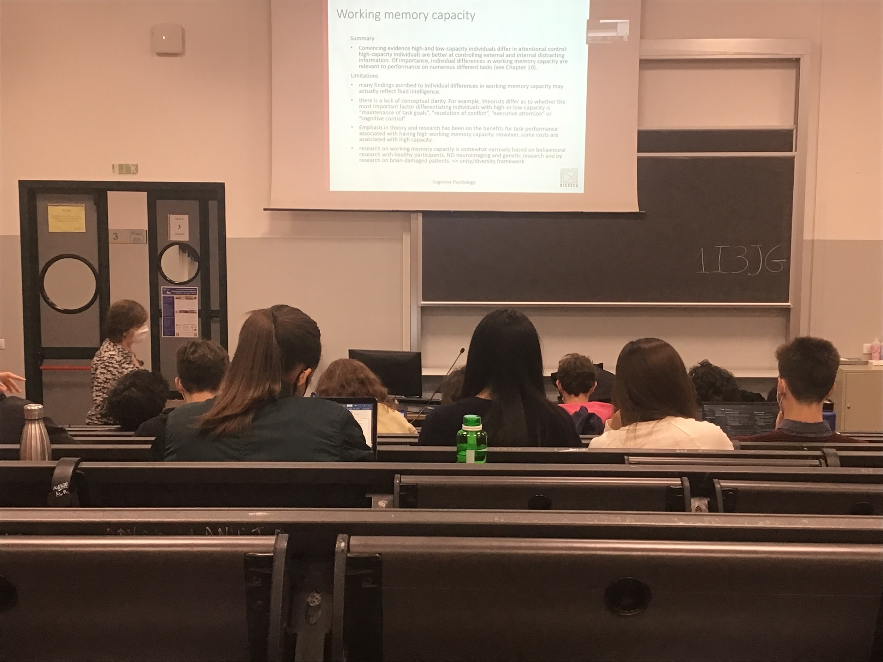

We have to consider the fact that working memory capacity is connected with our fluid intelligence. Different ability in attentional control

Measure in capacity can indicate if a person can perform different tasks better than others.

Not clear what the differences are between the individuals, can not identify specific neuropsychological differences.

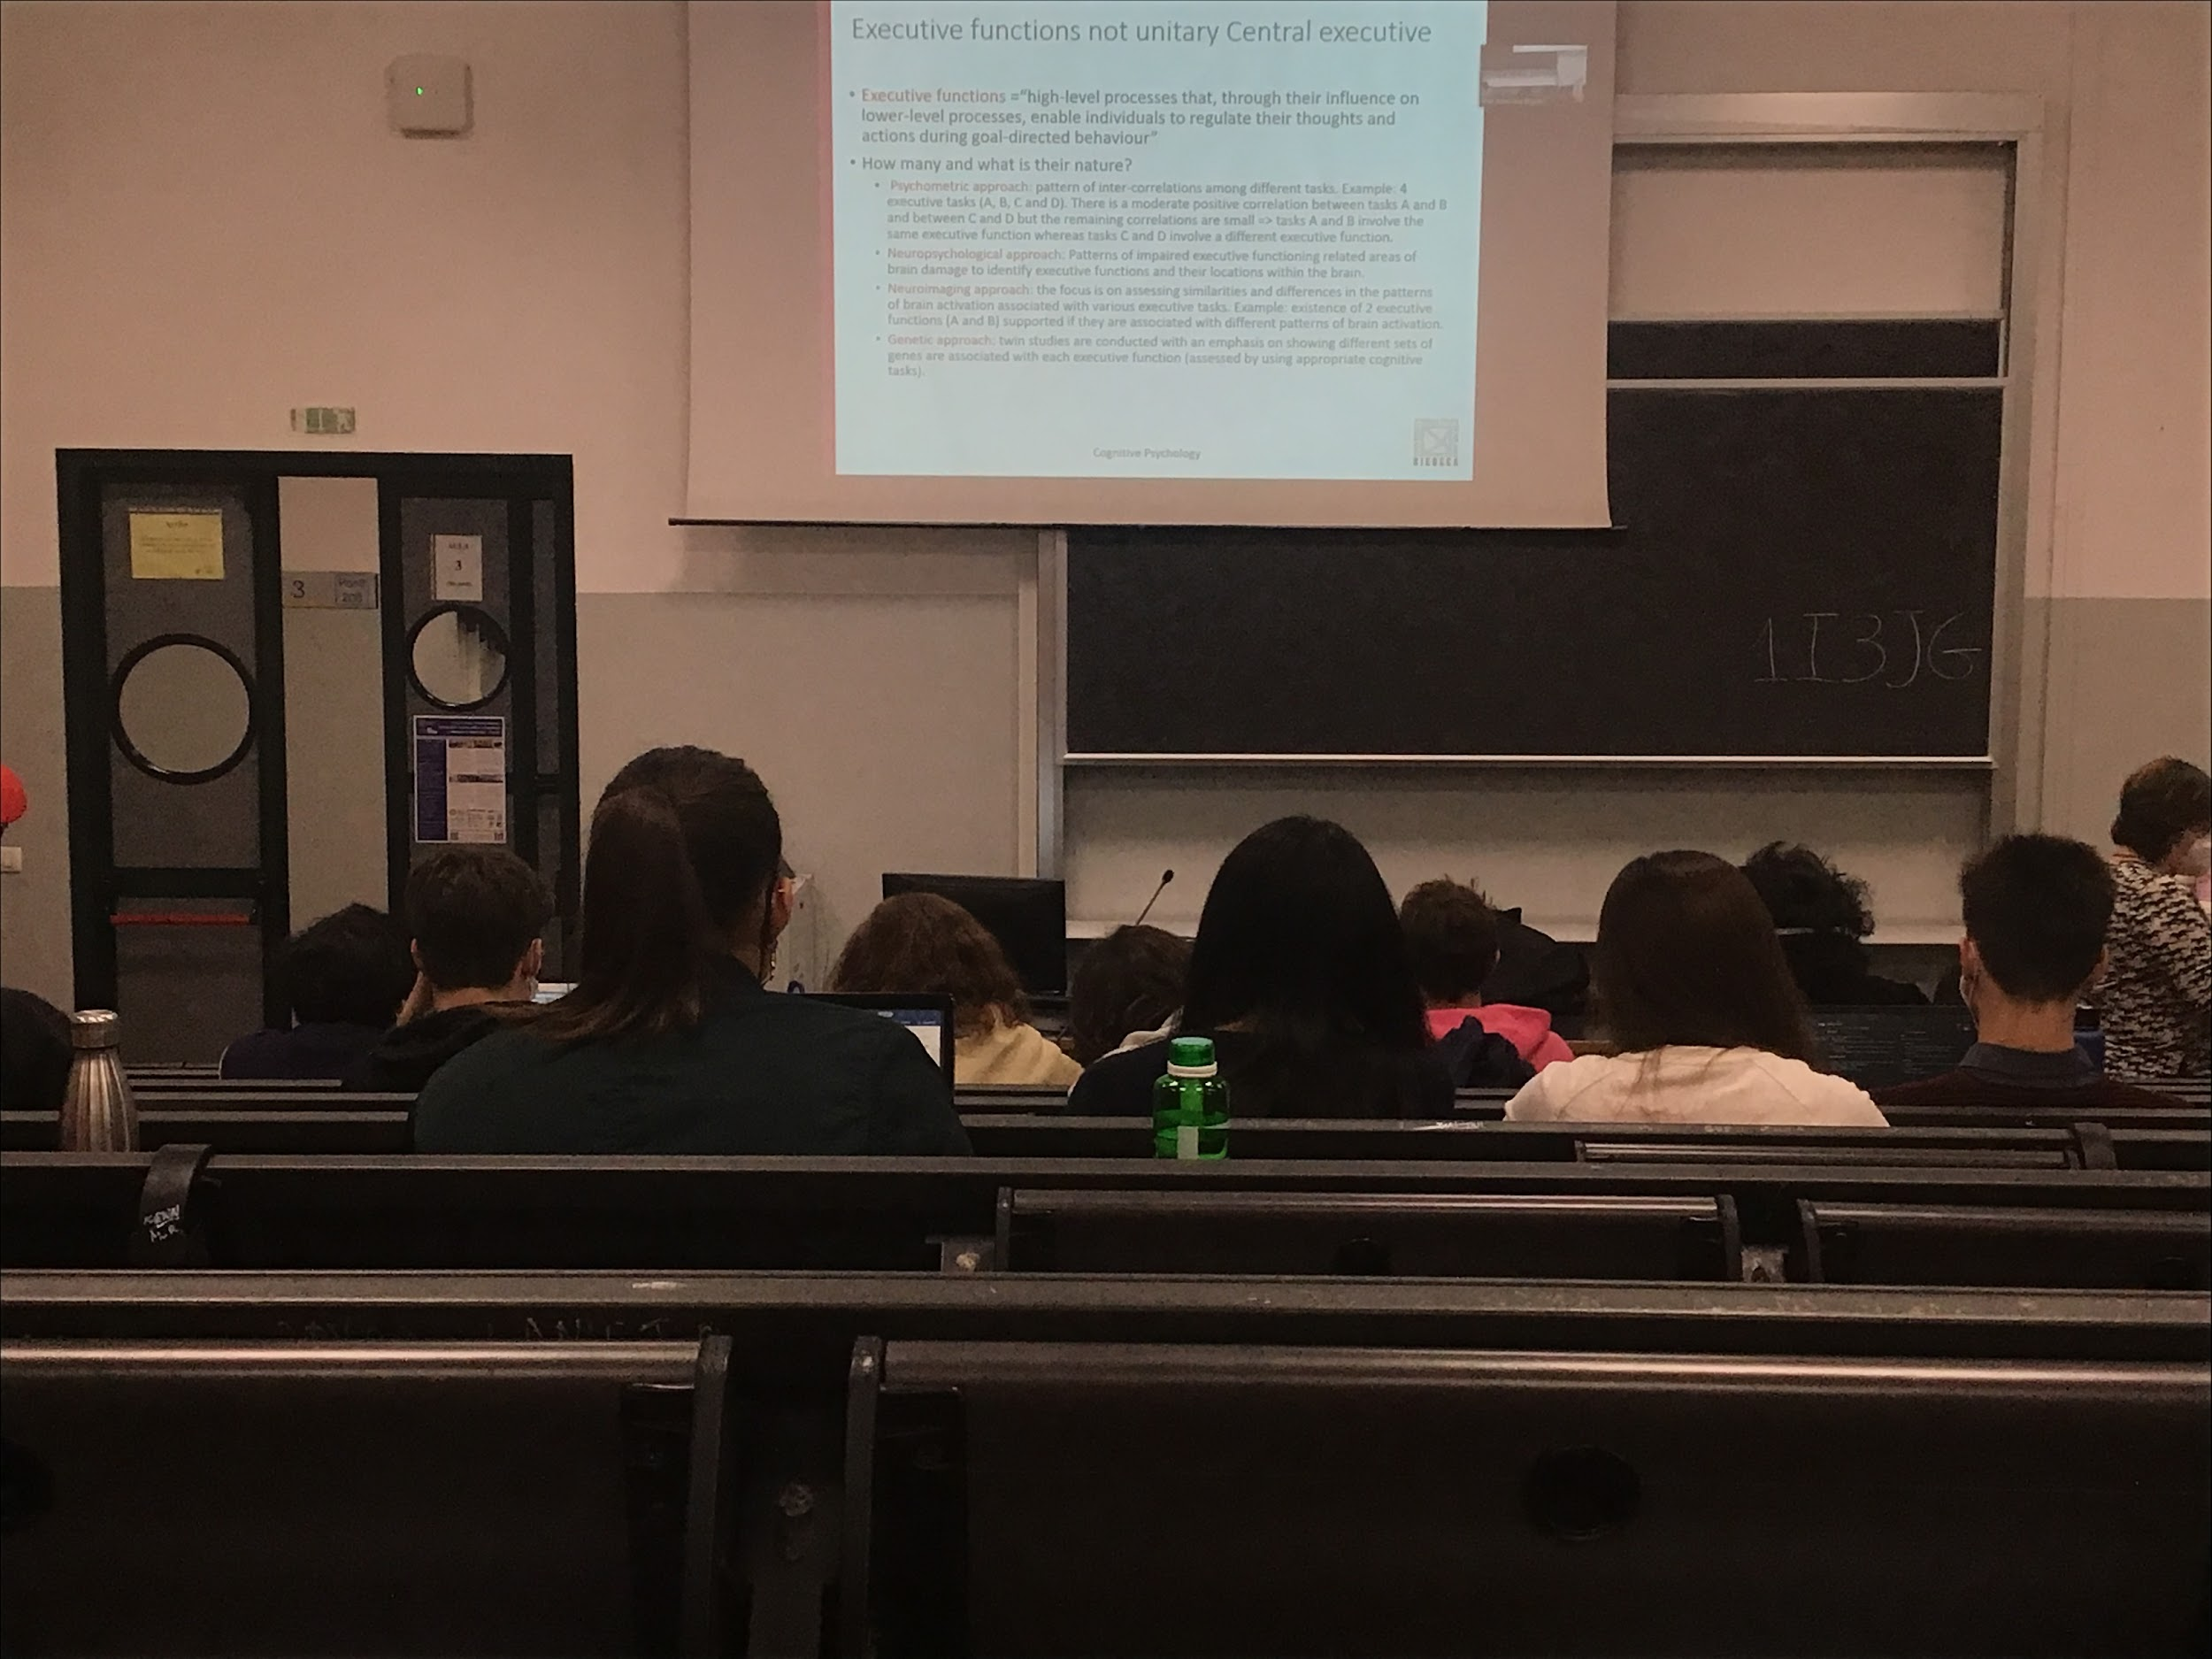

Should not consider the central executive as an unite thing present in the central lobe, there are different types of executive functions

Different executive functions help you to reach this goal, how many?

First proposal of a number of different executive functions the identification of this function

According to this author:

Actually the executive function (what the central executive realty executes). **three different executive function**

* Updating information is working memory, everytime you need more information you have to get it
* Shift between tasks, have to store partial information and update the information. Shifting the information
* Inhibition of automatic responses. Control our behaviour. Inhibition not always work, if the task is extremely automatize

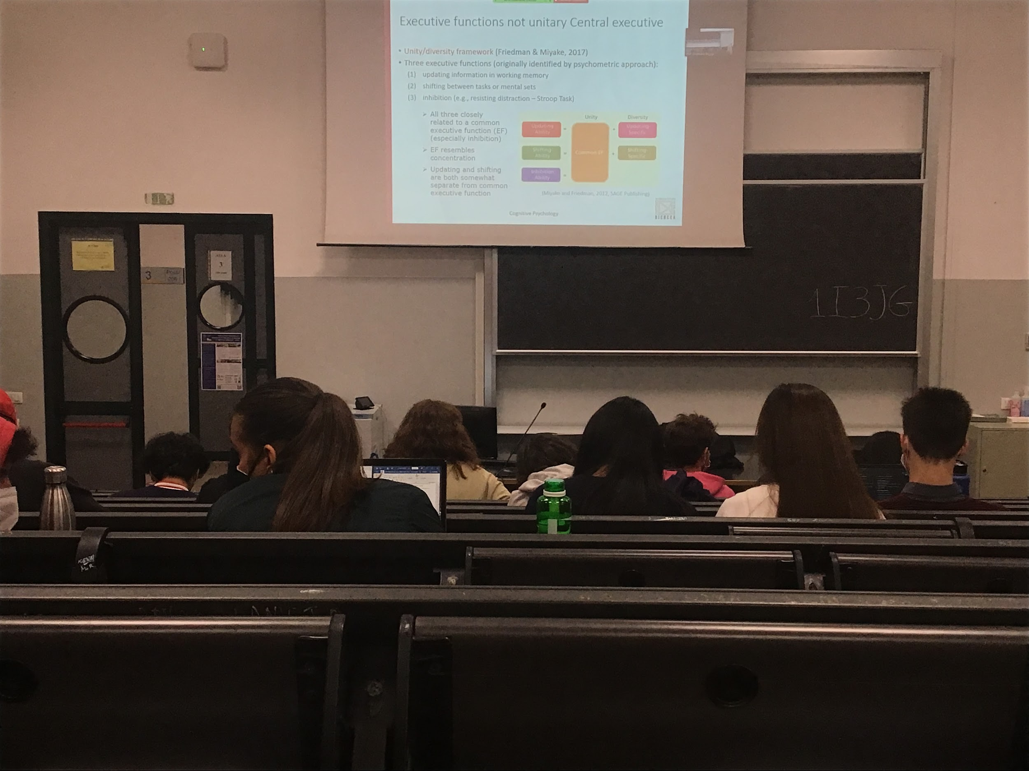

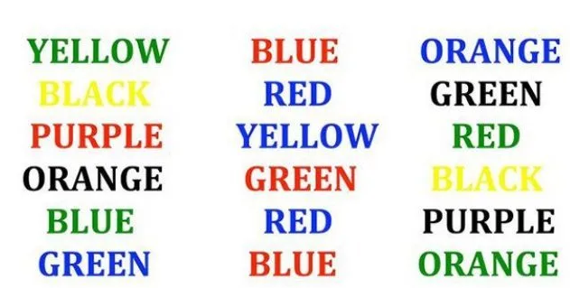

Stroop task. Name the colour write and not the colour of the letters

To do this task (tell colour or worlds) you have to inhibit an automatic response (reading). If the word has nothing to do with colour you are much better, also if I write it in Swedish you don’t have the stroop effect. We need inhibit response

There are 3 different executive function

* Updating
* Shifting
* Inhibition

These abilities have a common component and some sub components that make it different.

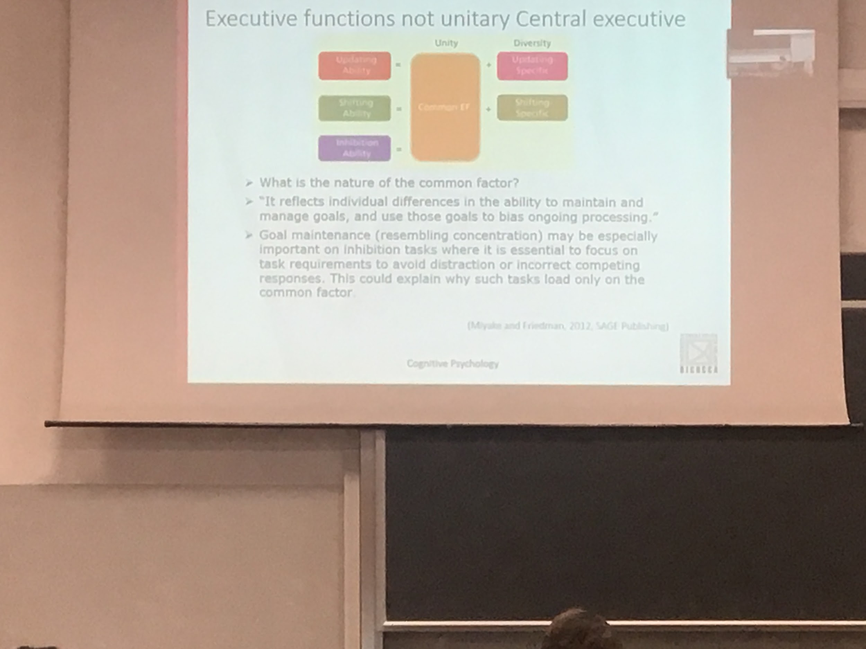

Unity diversity function, there is a unitary underline process that you use for all the three types of executive functions, plus there are specific one just for two (uploading and shifting) of the three executives ability

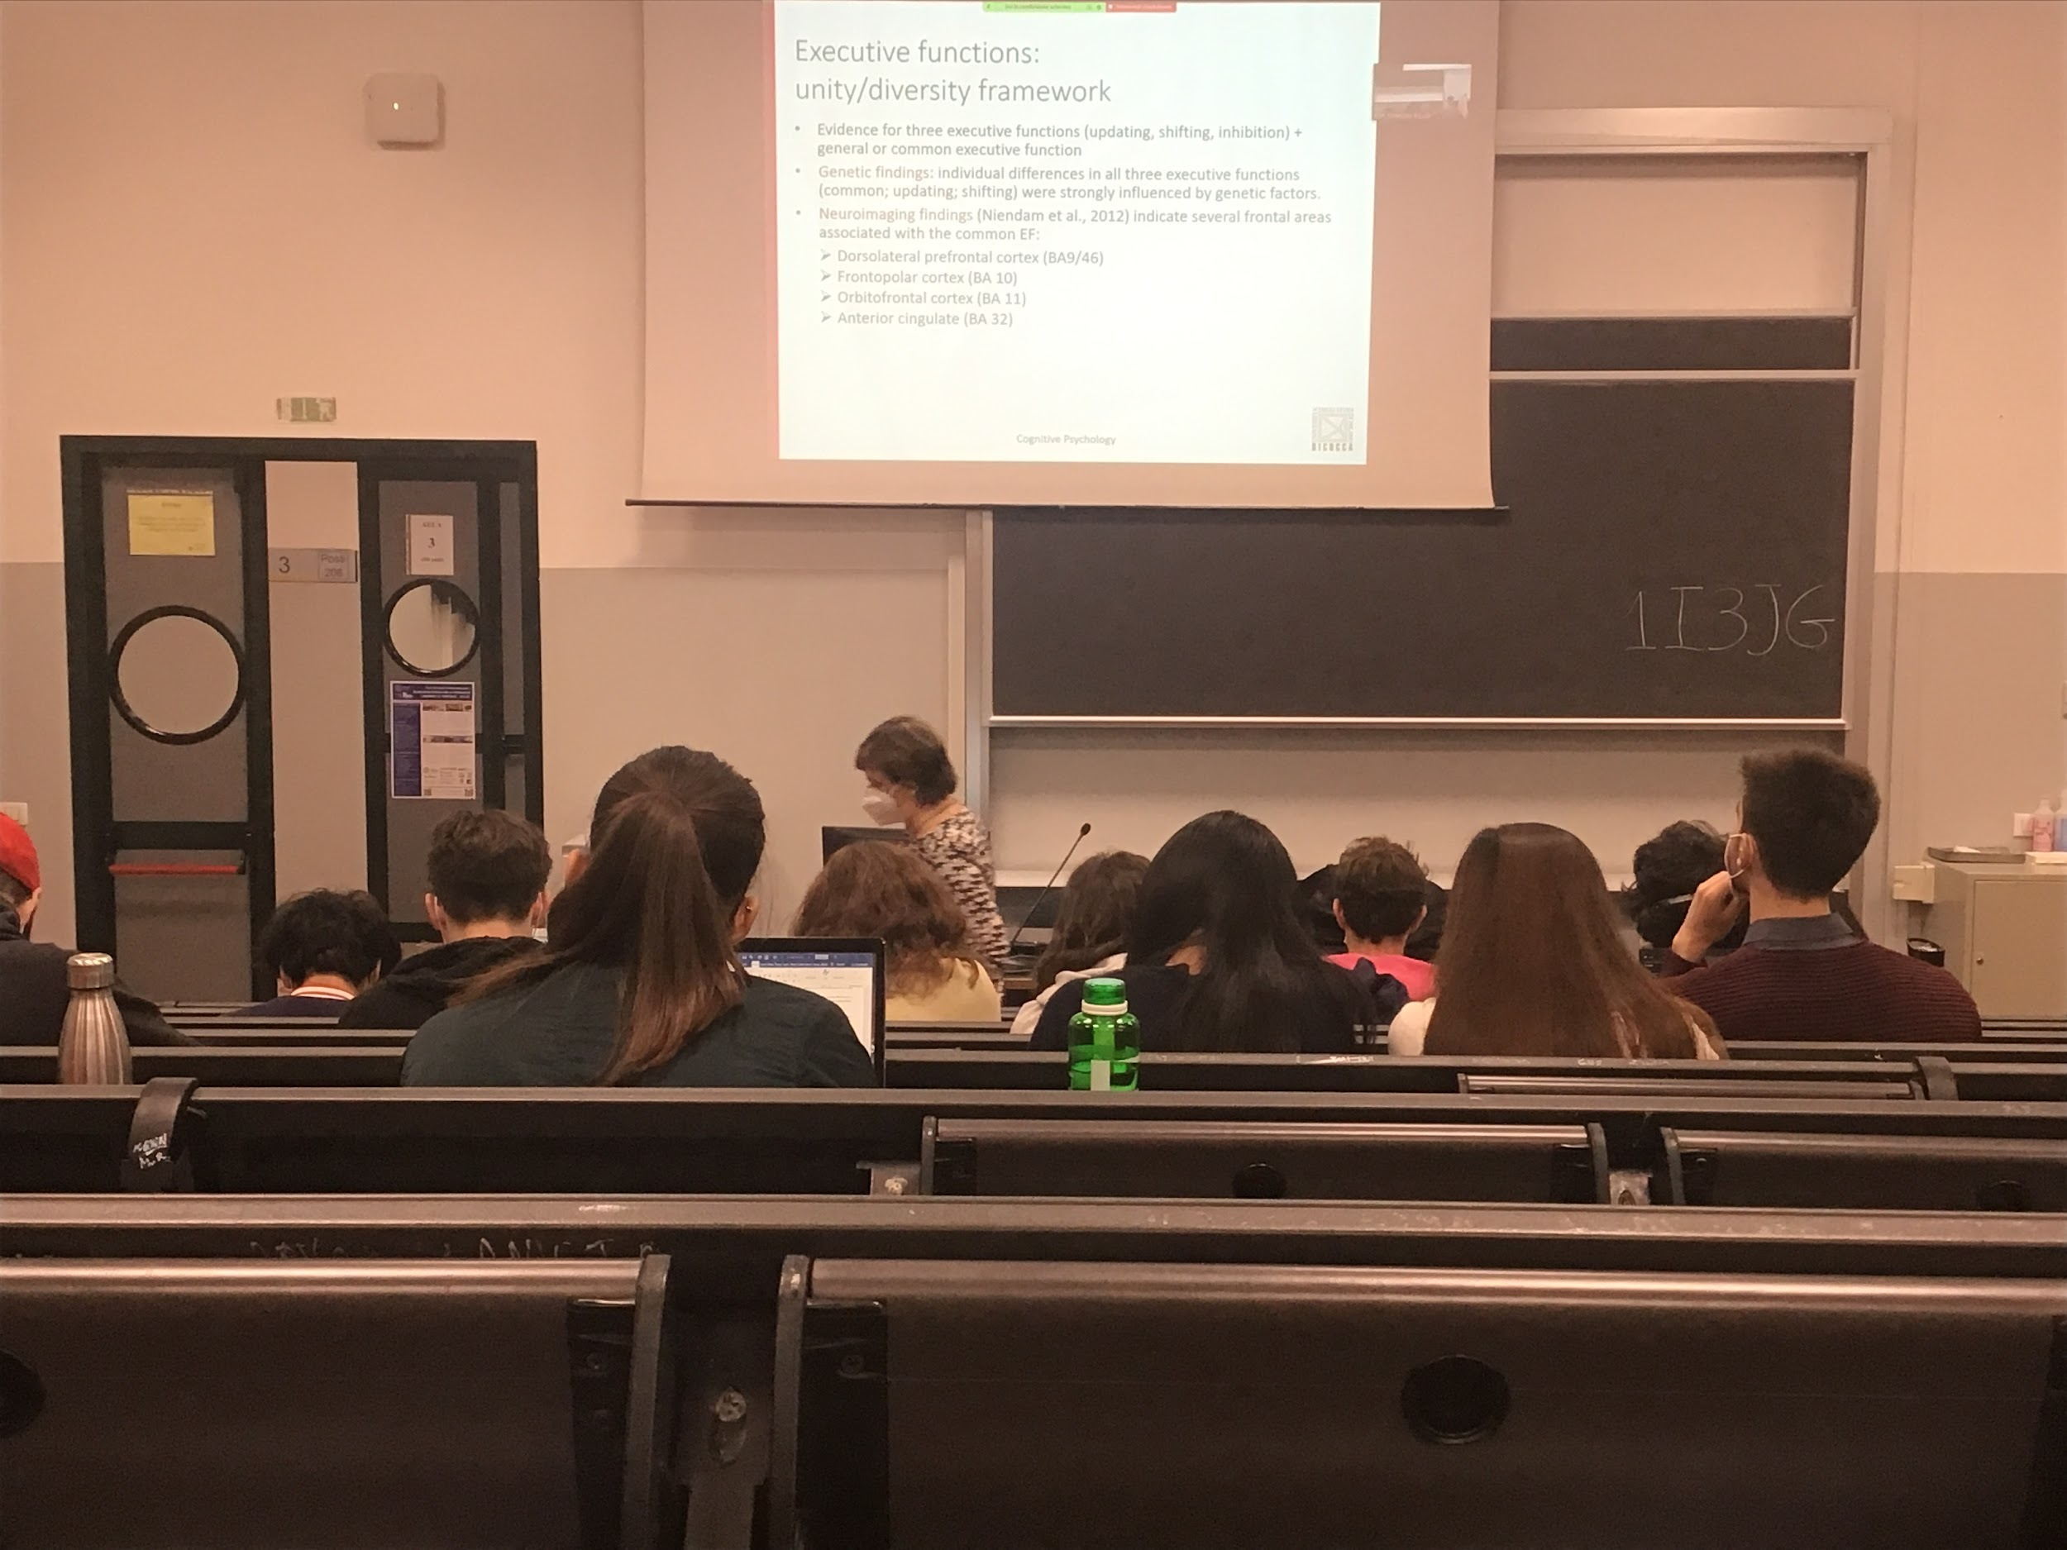

There are **genetic findings:** if you group people by their ability to control, update or to shift you can identify some genetic structure similarities

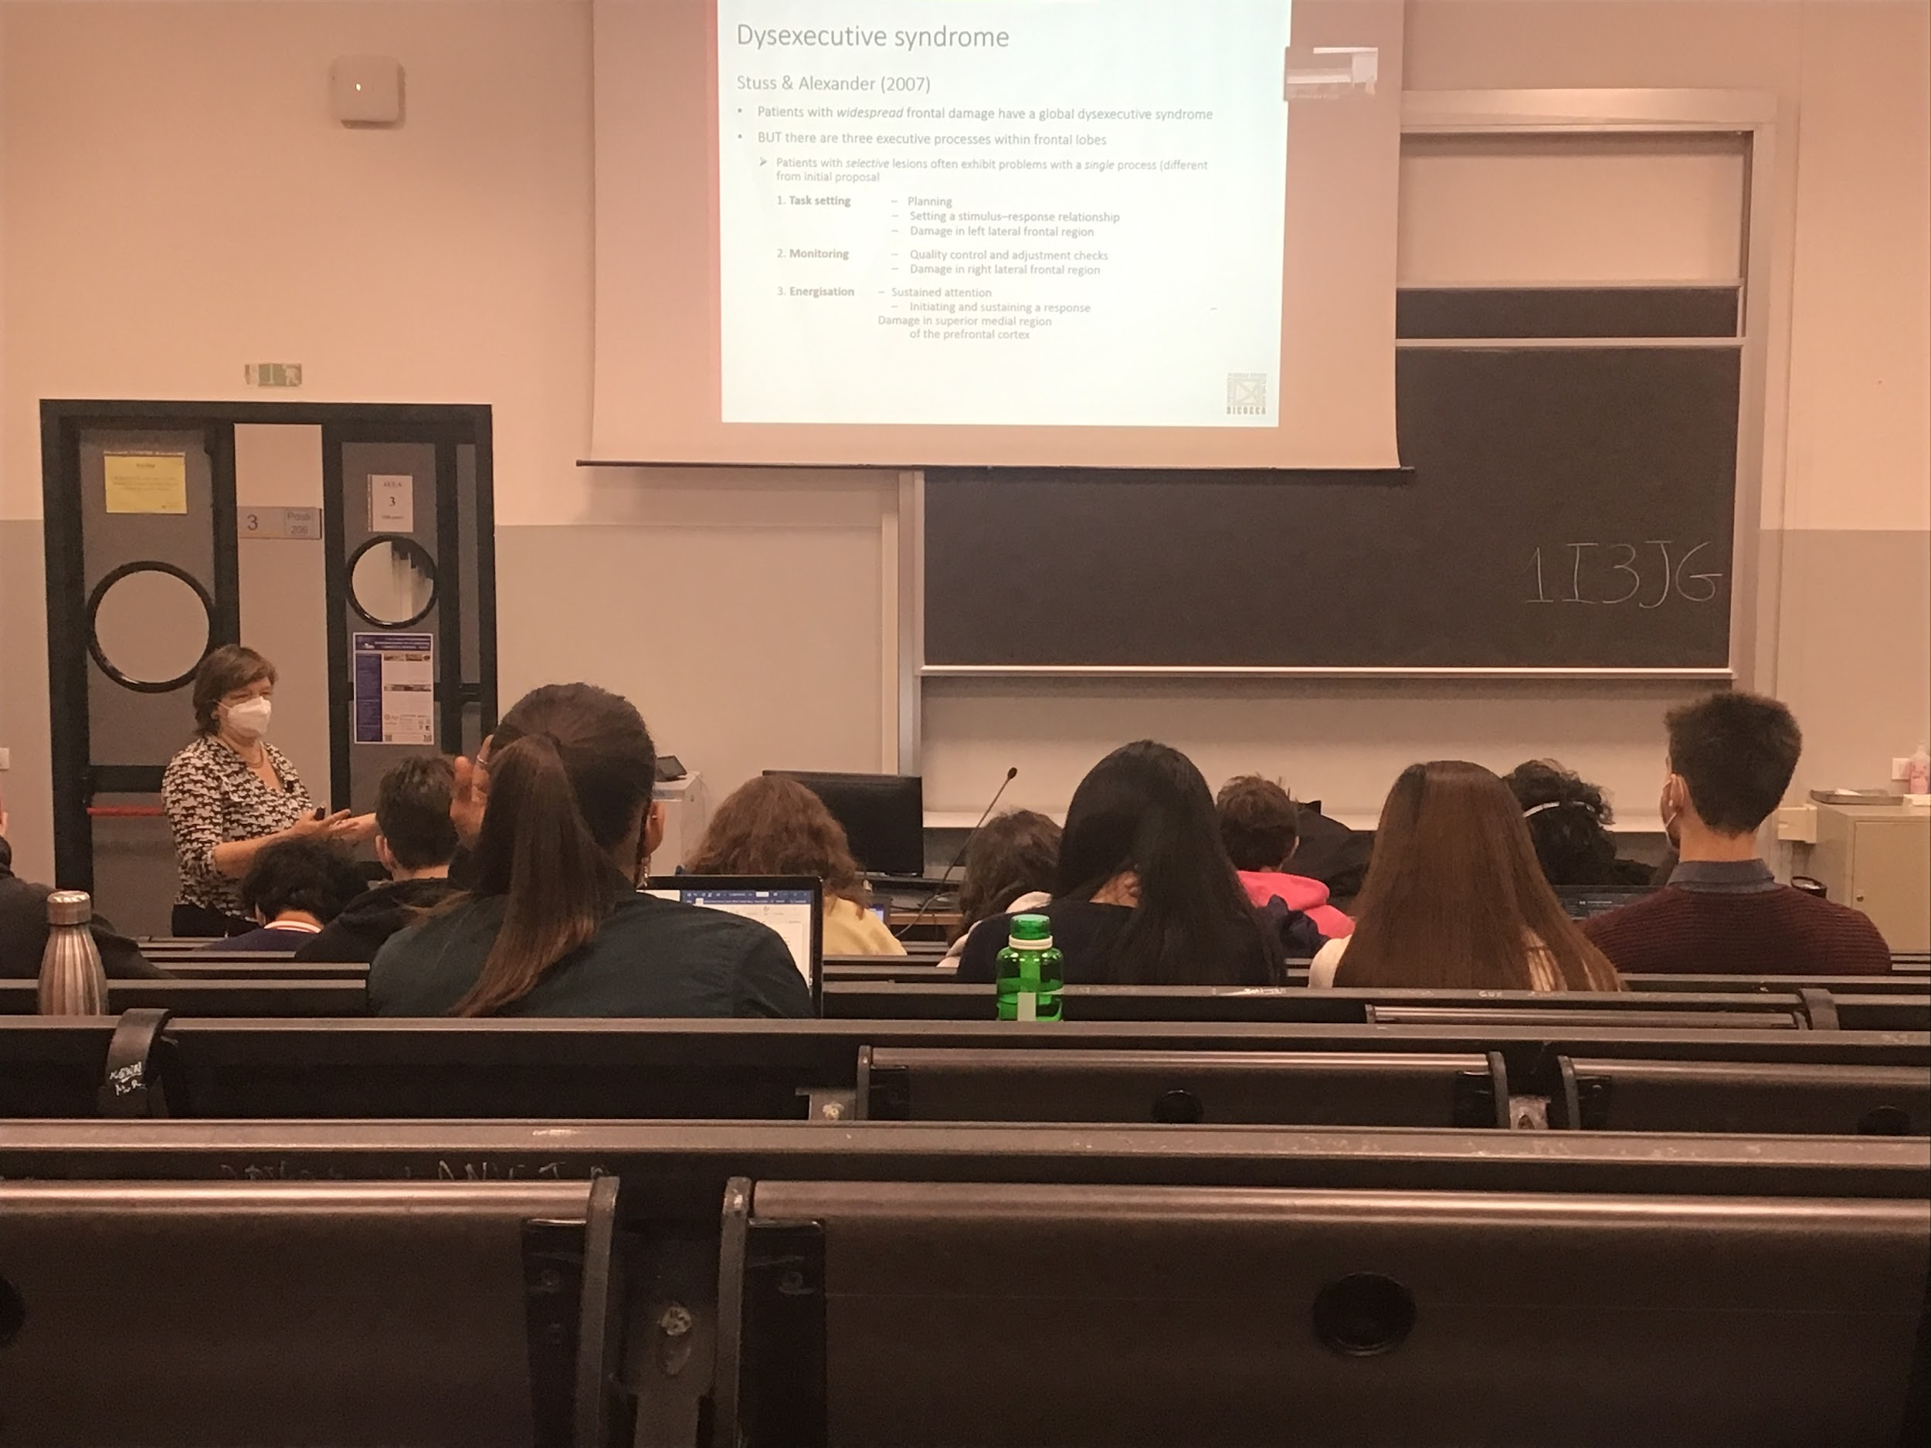

You can find different people with smaller lesion that have problems in the single components

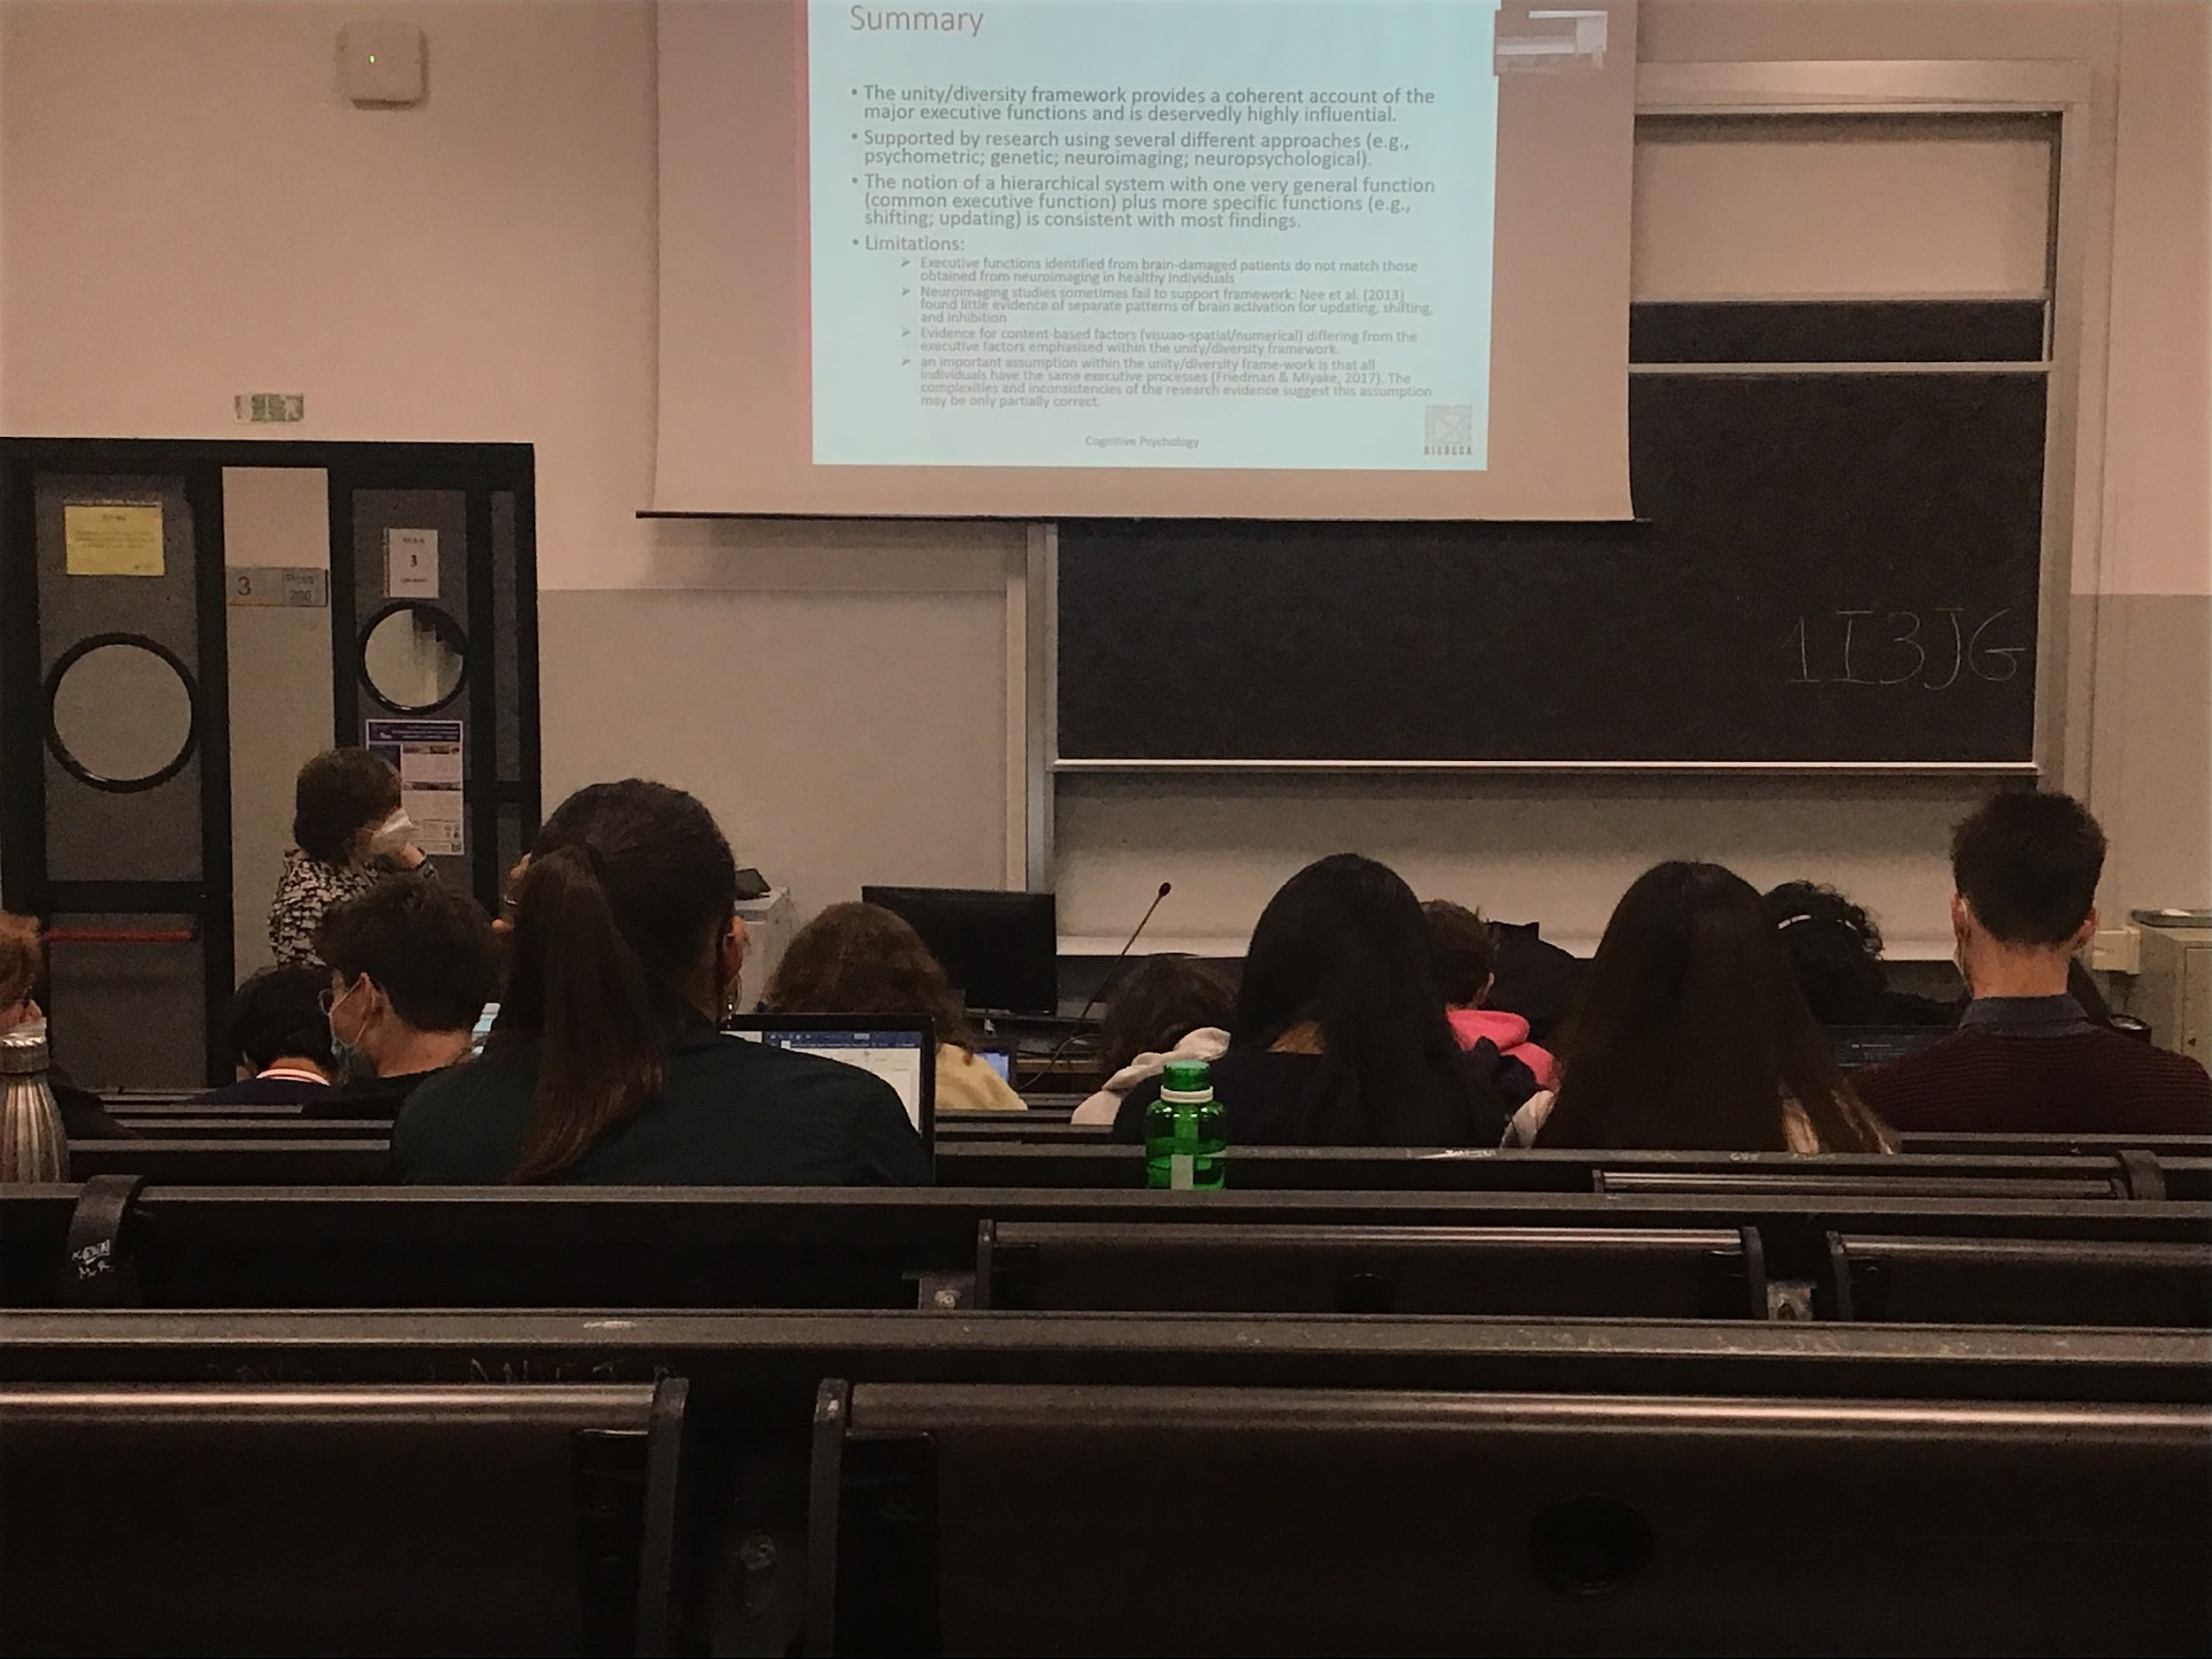

Some limitations: we have some ideas but nothing is completely supporterted

Possible also that different individuals have different executive processing

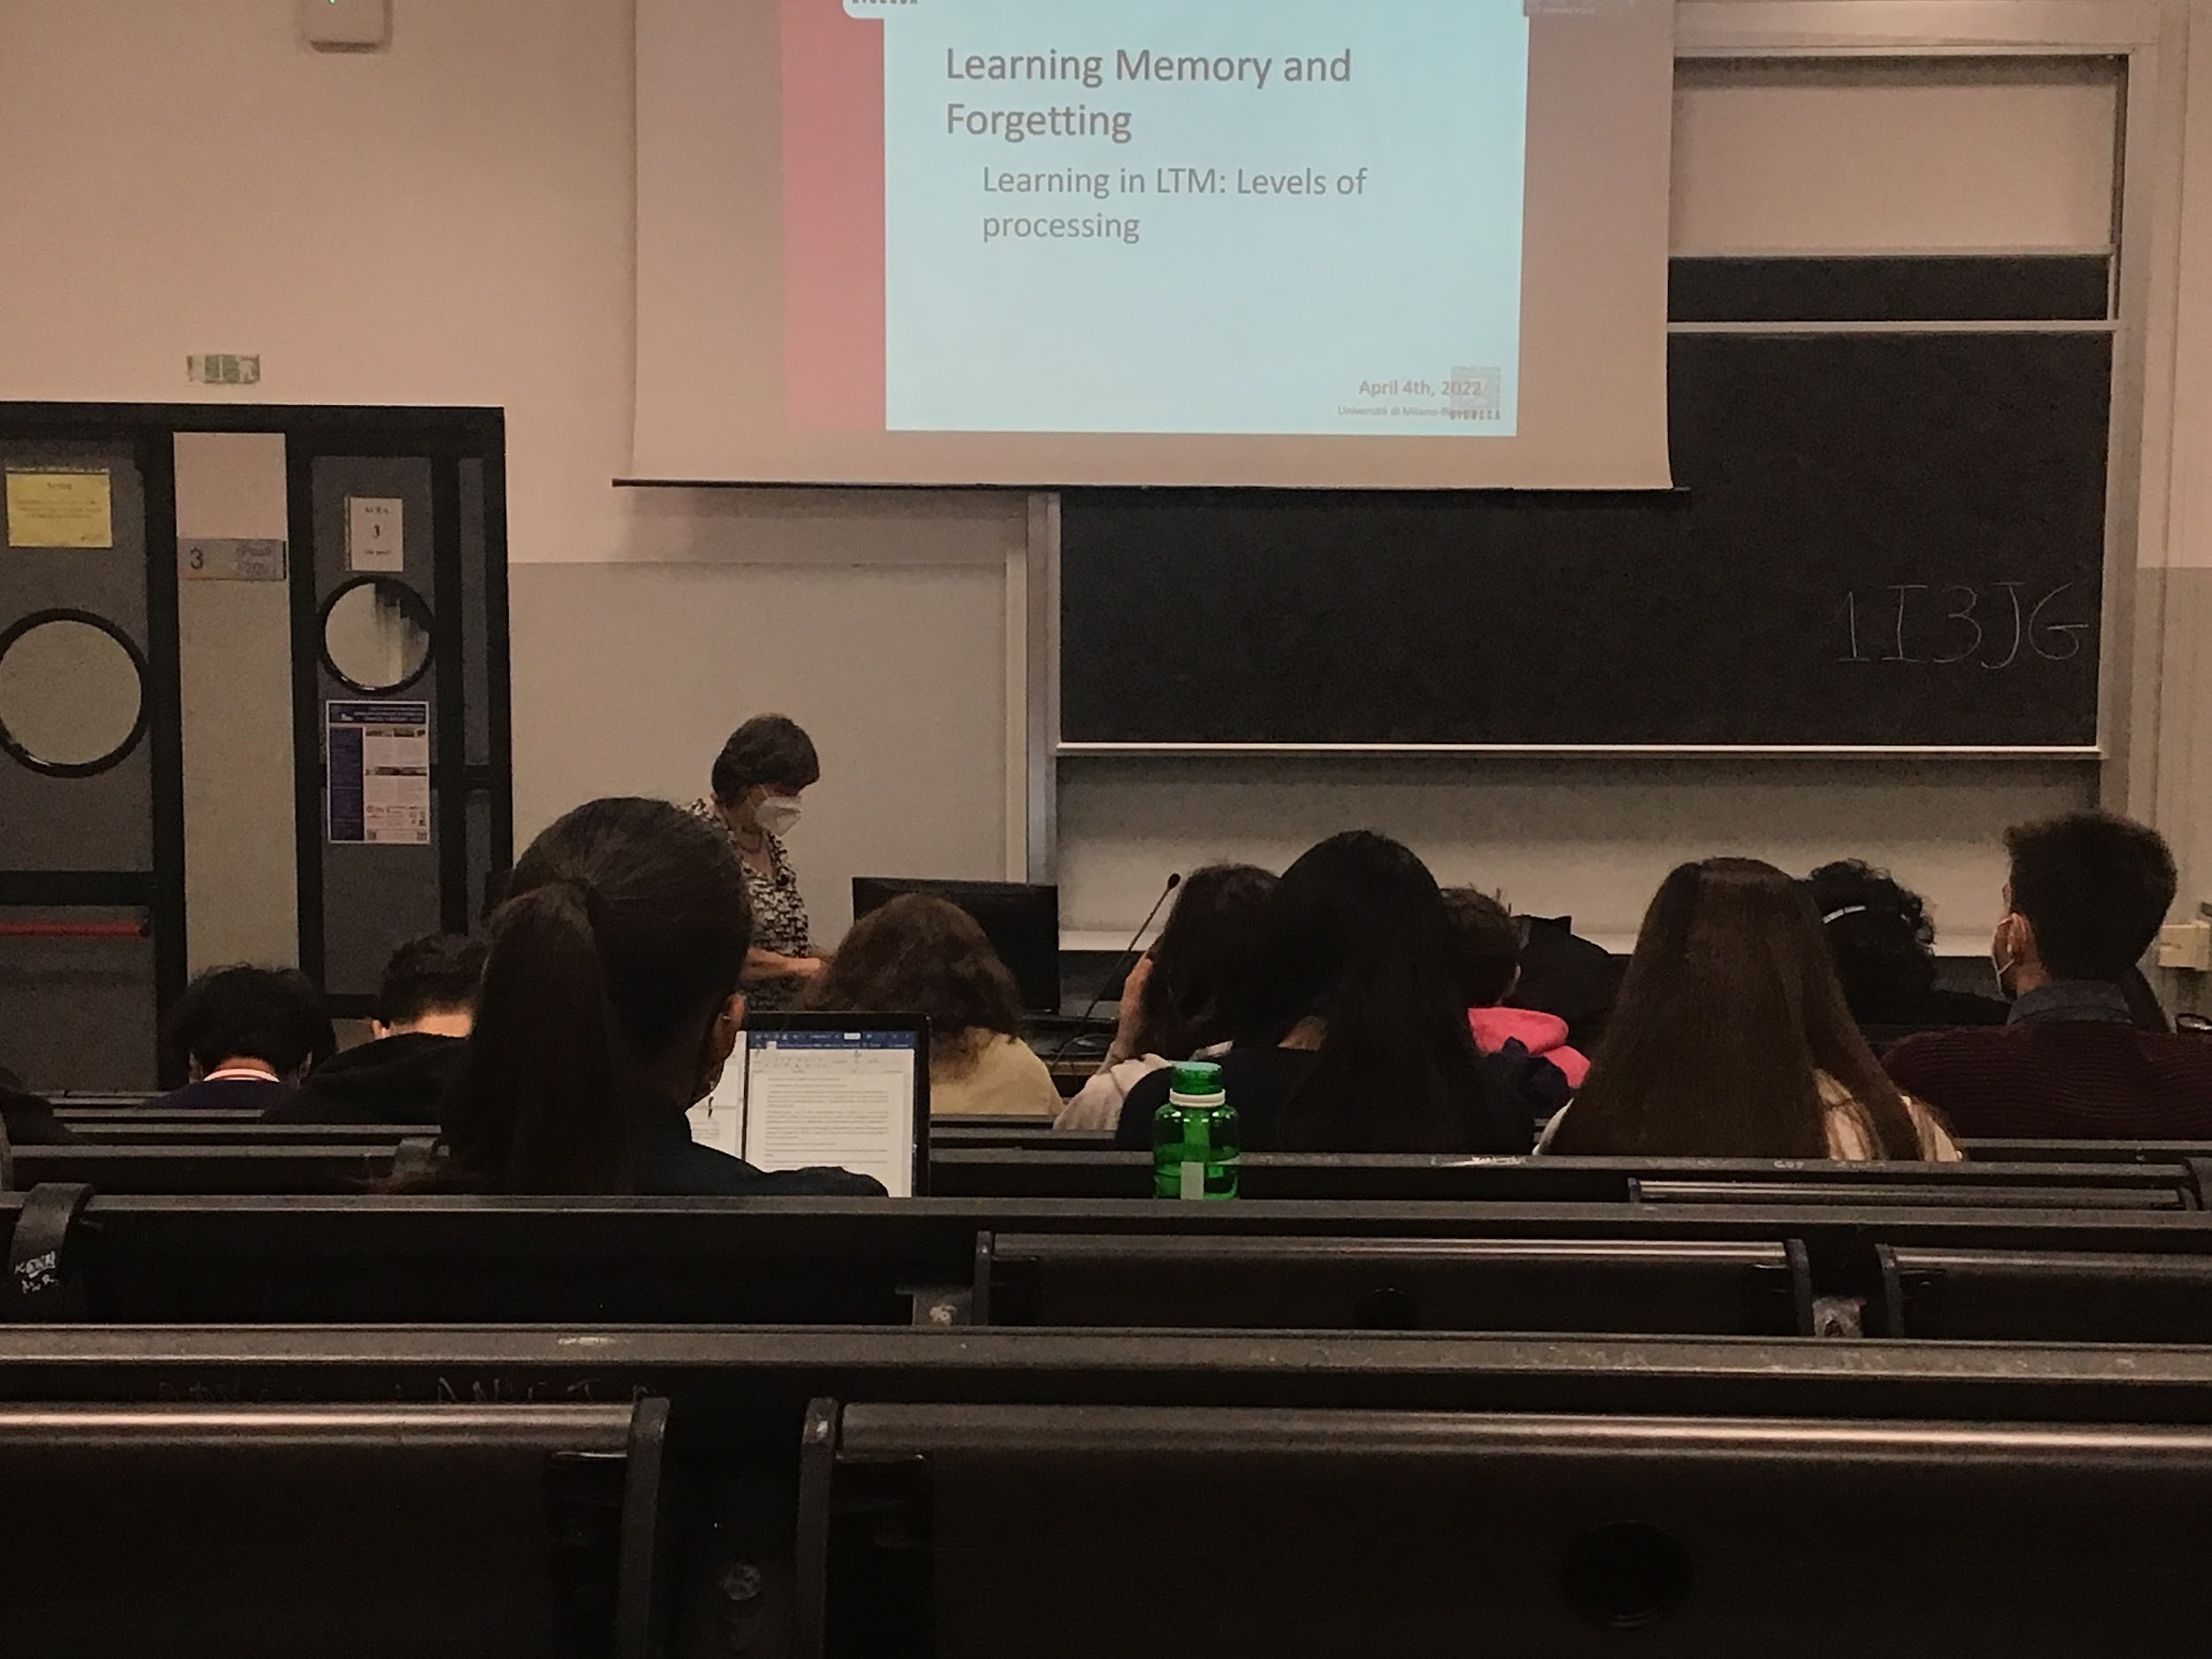

## Learning Memory and forgetting

### Learning in LTM: Levels of processing

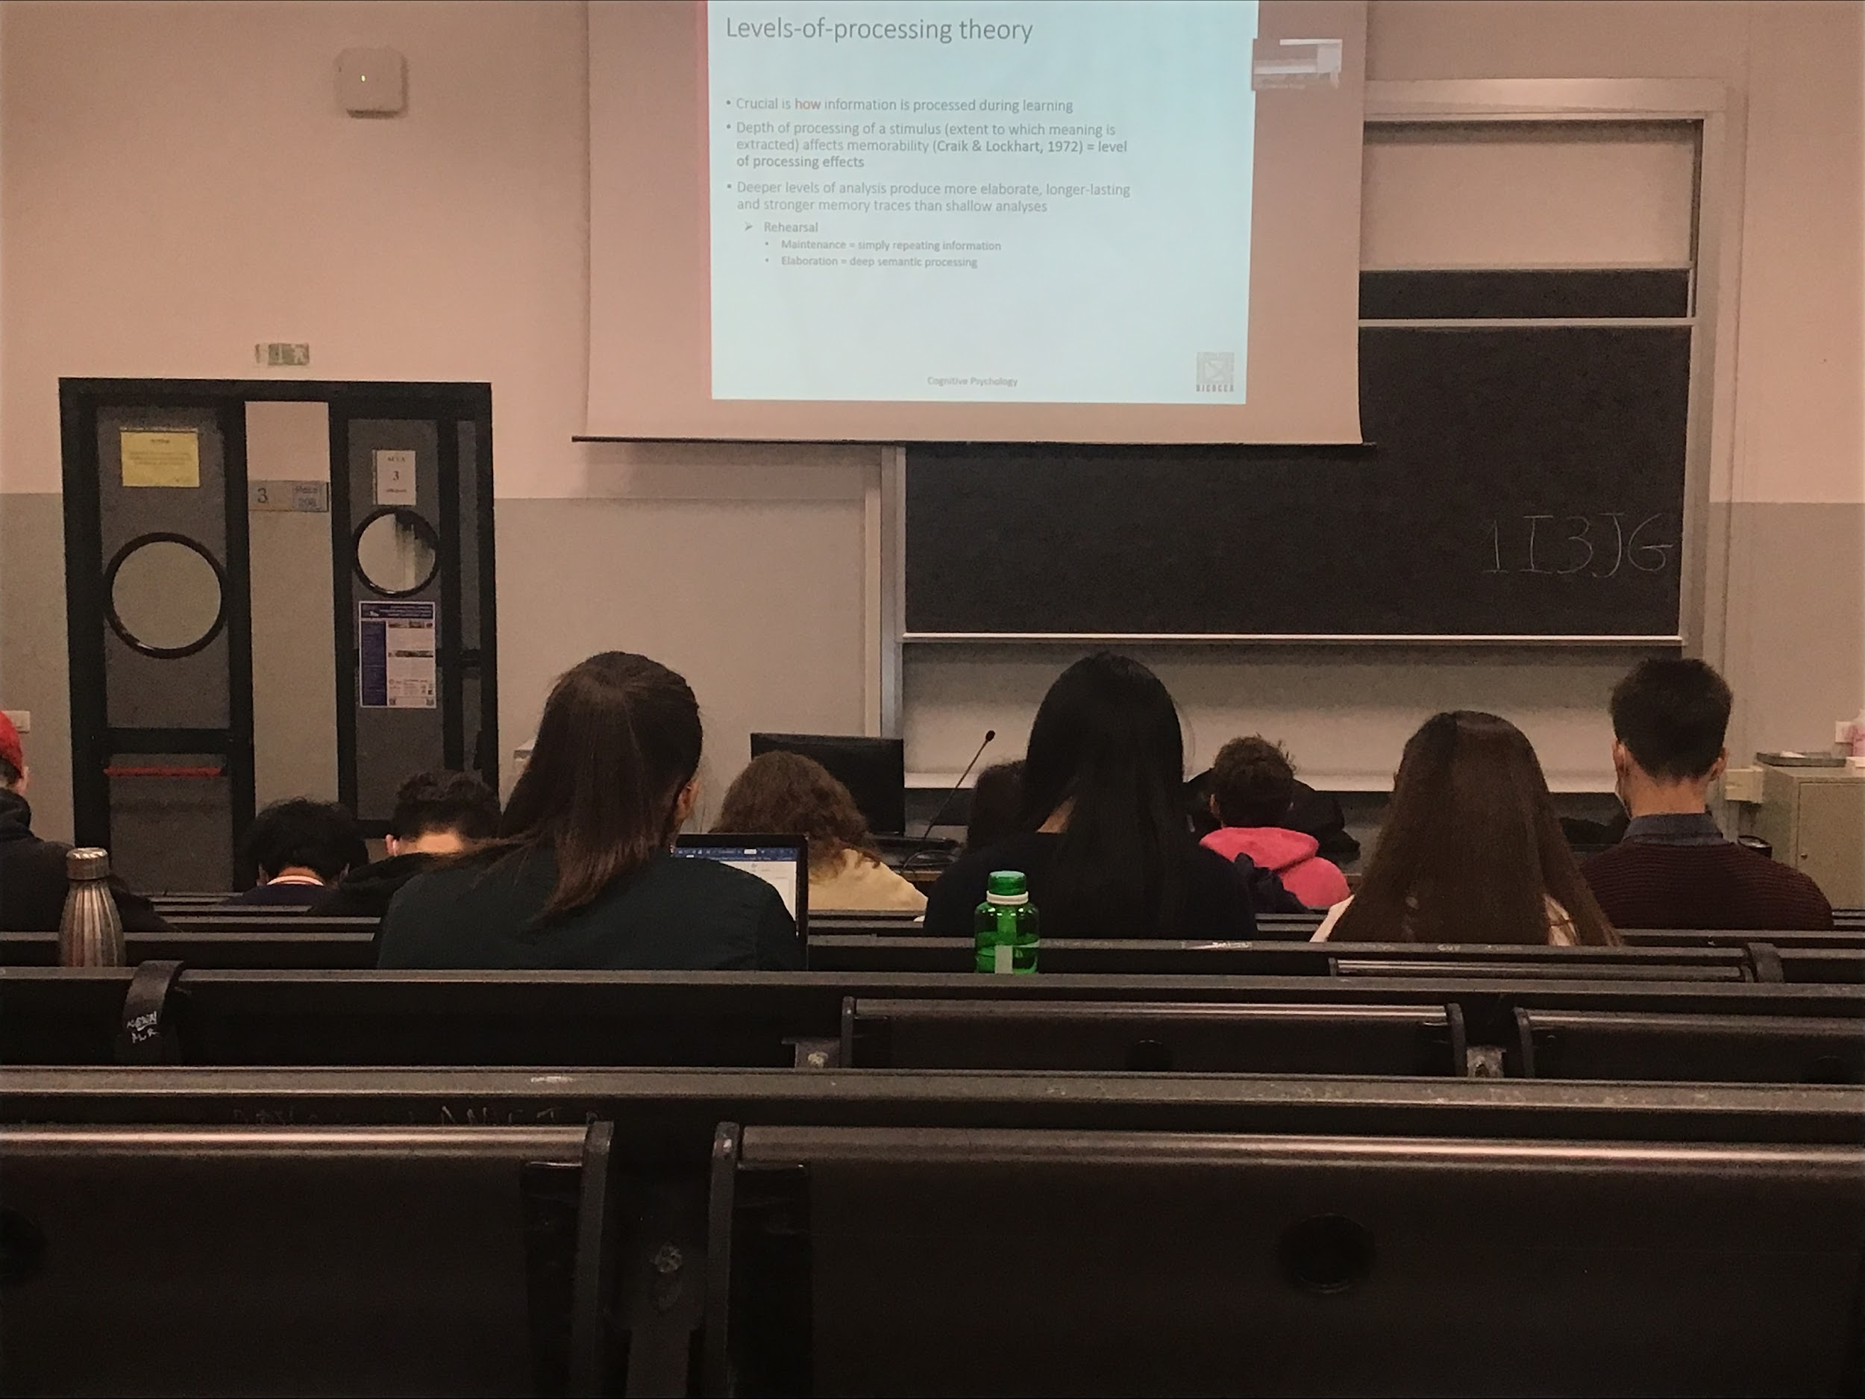

Important proposal:

When we try to learn something and transfer it to LTM (Long Time Memory) is important the way we process information before storing

To be able to remember some kind of information better we have to use a deeper process of elaboration, if I simply ask a person to read a list of words without doing any operation the information does not get stored very strongly in your LTM.

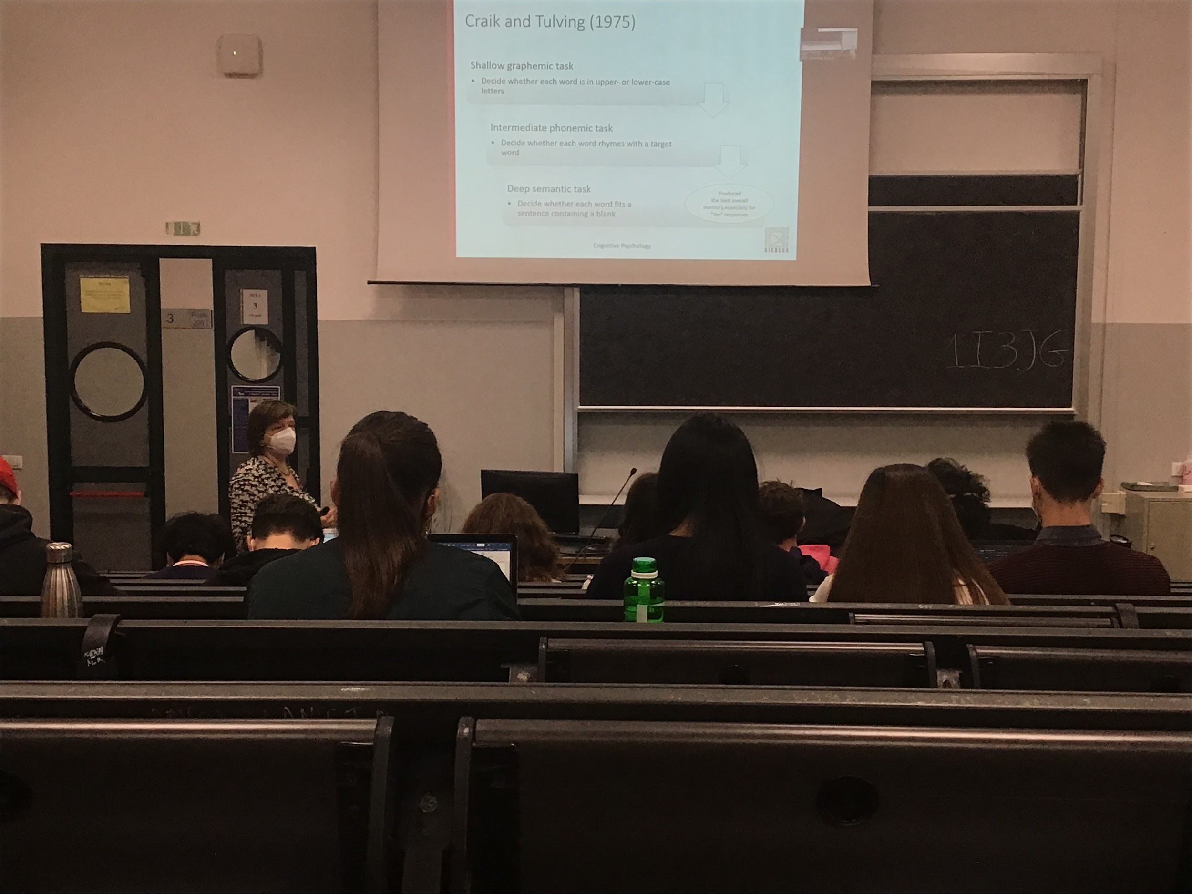

Experiment shallow graphemic task:

Shallow = not actually coding well the information, very superficial information coding

Show people a list of words and you have to read and tell if they are upper or lower case words.

If you use an intermediate task, ask if it rhymes with another word. Also show blank and you fill. Need to make deep processing and connection, in this case you are much better at remembering later the words (even if you didn’t know you had to remember them)

Using a deeper processing, the better you remember later

Deeper level of analysis produce more elaborate, longer lasting than shallow analysis

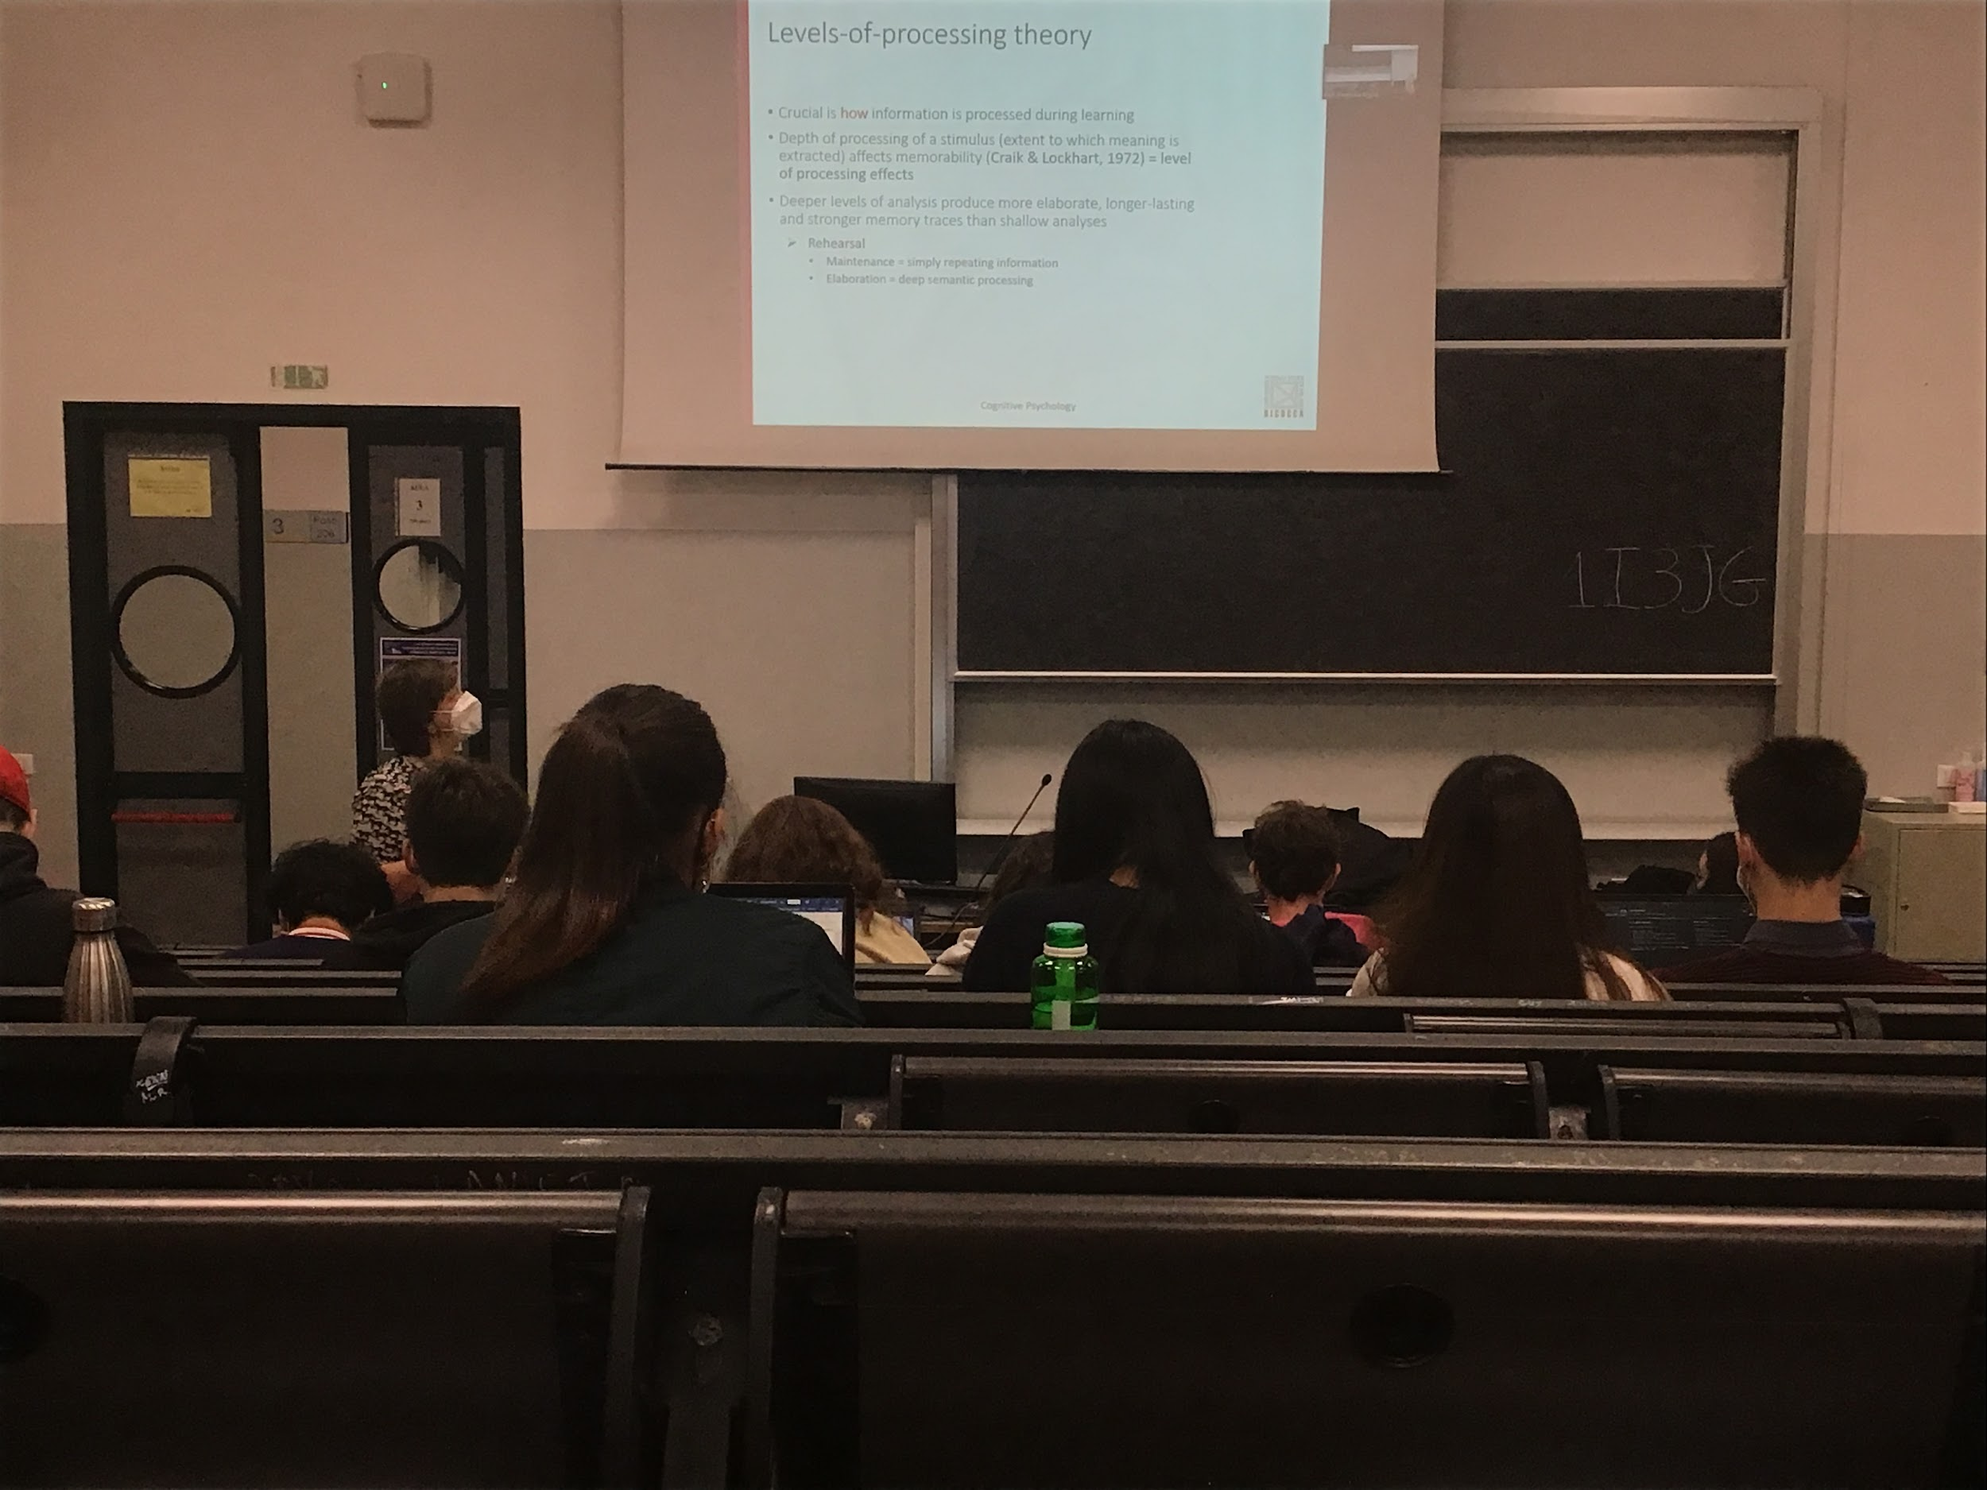

**Rehearsal** (repairing the same word multiple times) the same kind of information is simply **maintaining the information on a shallow level**.

**Elaboration** means processing and connecting informations does a **deeper semantic process** that help to have a stronger memory and help you extract the information better

If you ask people to remember an image you can find people are better remember when they have a deeper processing than a shallow processing

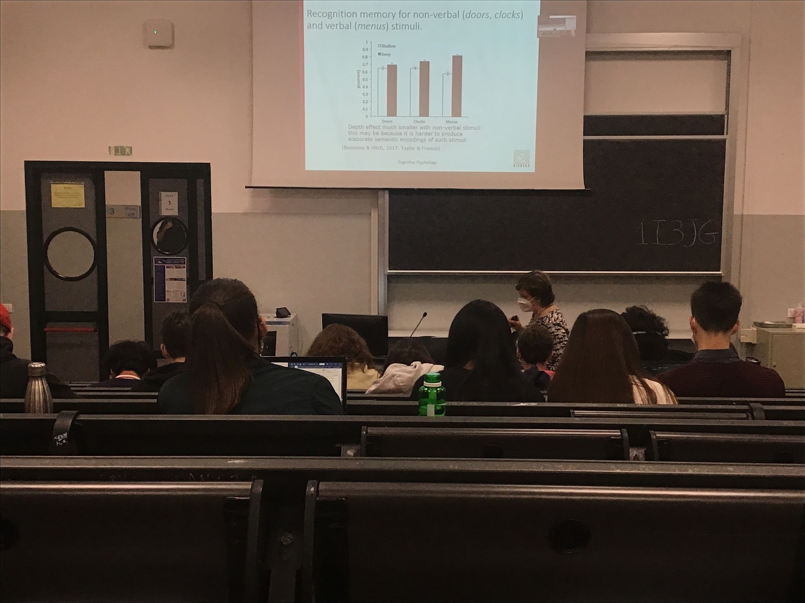

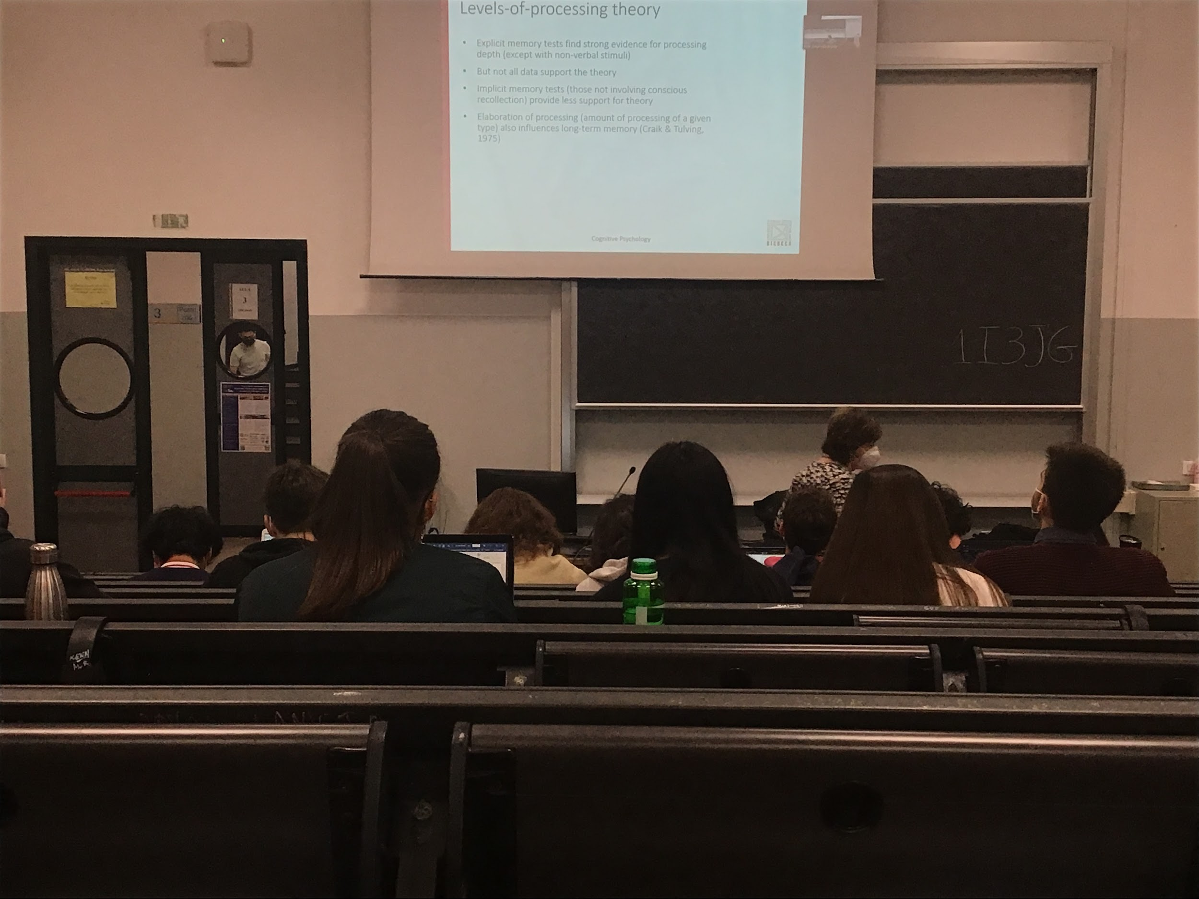

The difference in shallow and deep processing on memory work with explicit memory

Explicit memory: you know that you want to remember, to be able to extract it later

Implicit memory: tell you something and you memorise it, even if you are not interested in it

This elaboration of processes influences long time memory

Deeper coding = when you store this information in memory you connect it with a lot of other information that you have already in LTM. This facilitates retrieval. You can access that information from different parts and it is integrated with all your database

Shallow coding: for each item that you have to memorise it you just have one way to get there

Deeper coding: you have many ways to get there, you can retrieve the information much easier

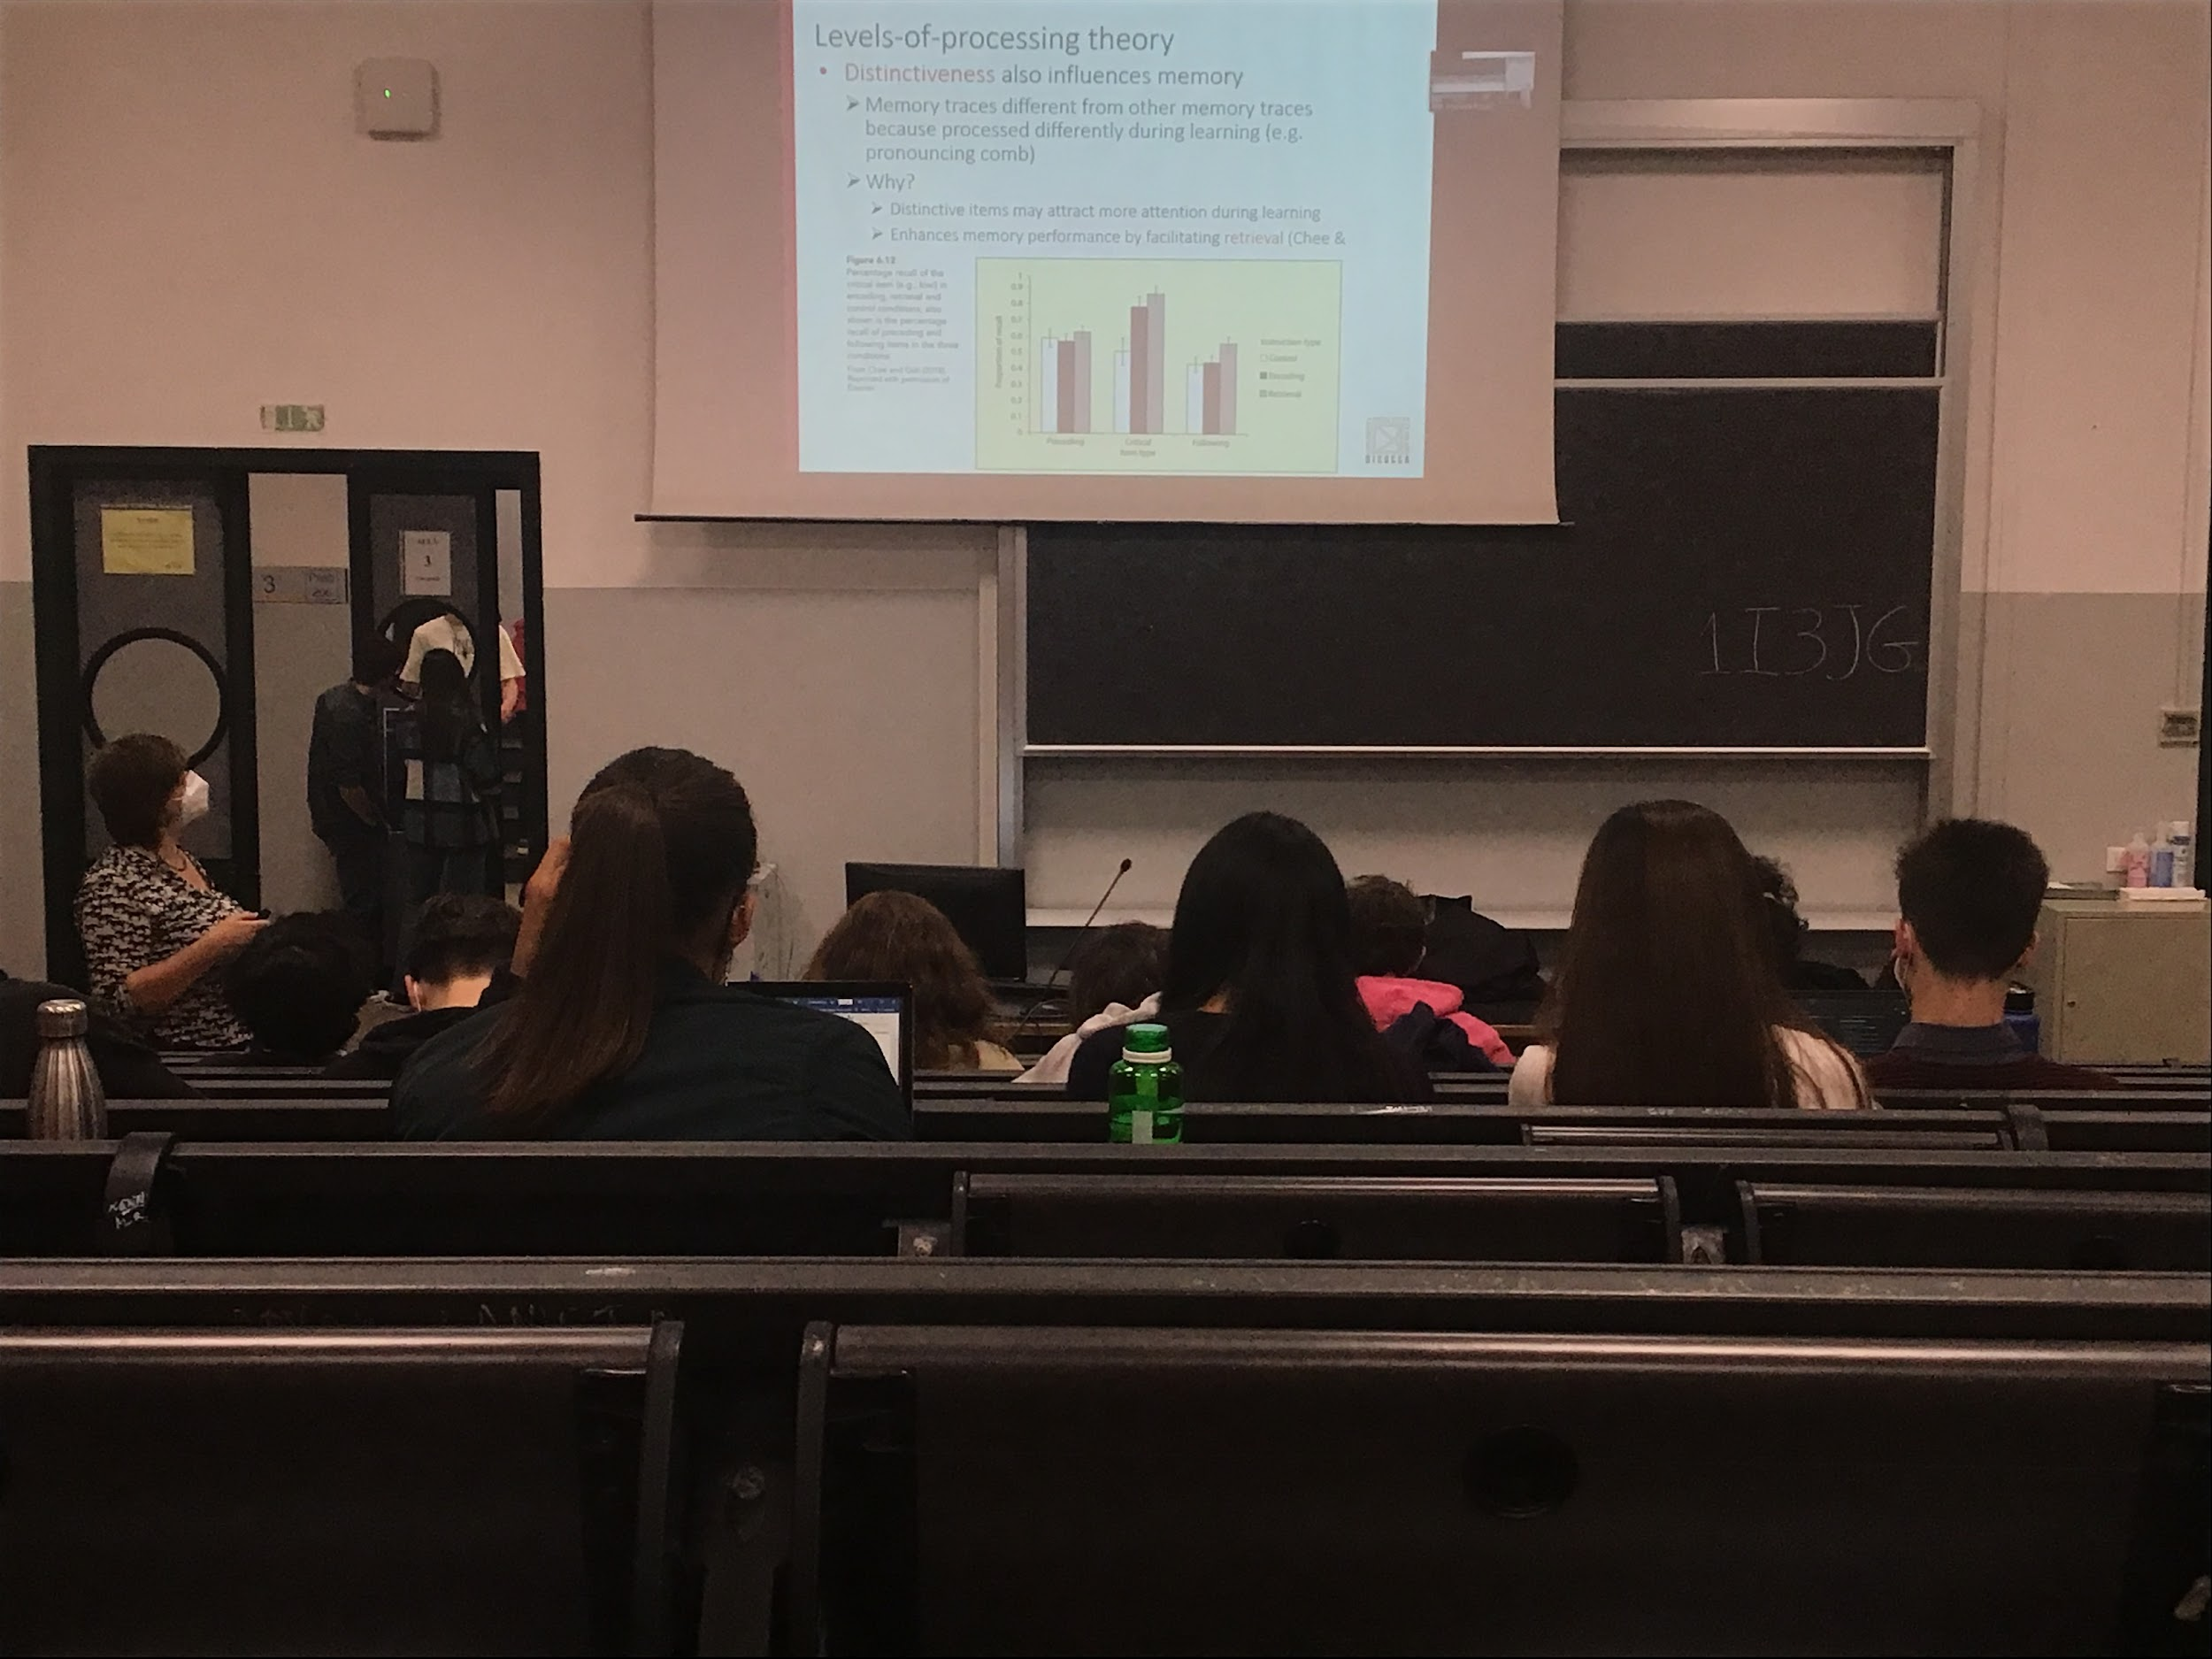

**Distinctiveness**: if there is something strange when you are coding that information you remember it better

Strange things (or distinctive for some characteristic) are remember better because they attract attention when learning

Specific words (kiwi, the animal and the fruit) if you present a list of animals and you say there is a fruit inside the list it tells them that something strange is going to happen, there are differences in the way they remember the information. If they know at the beginning before coding that there is one thing that they code different from the others they remember much better

The way we learn (= the way we try to store things in LTM) influences a lot our ability to remember and to retrieve later that information. Storage in LTM is defined by the learning process. Influences of perception attention and memory are all interconnected and they are all needed to be able to store and code informations deeply = to be able to retrieve it faster

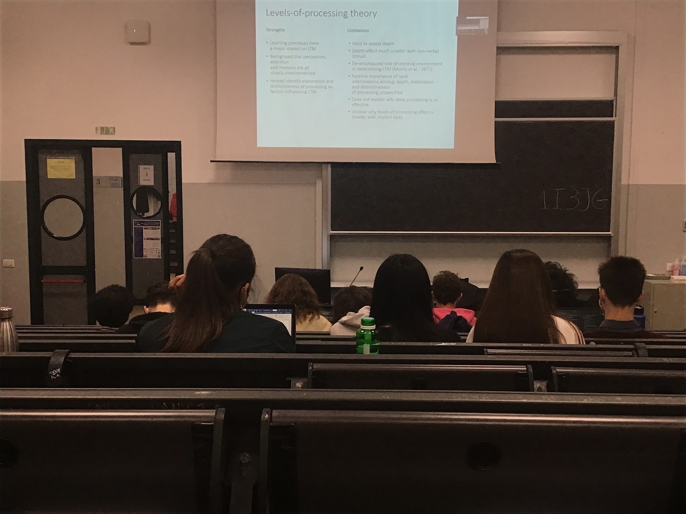

If you are sitting on the beach and I ask you to learn some words and I ask you to repeat, you perform well. If you put on scuba diving under the sea, I present the list of words and I ask them when you are still under you perform as before. But if I take you on the beach you remember less. **The place where you code information helps you retrieve the informations**

**If I ask you something in the place where you have coded that information you are better at retrieving it**, not explained how different characteristic are related to each other